Lesson 3: Ways to Look at Quadrilaterals
- Let’s sort and identify quadrilaterals.

Warm-up: How Many Do You See: Brick Pattern
How many bricks have 2 pairs of parallel sides?
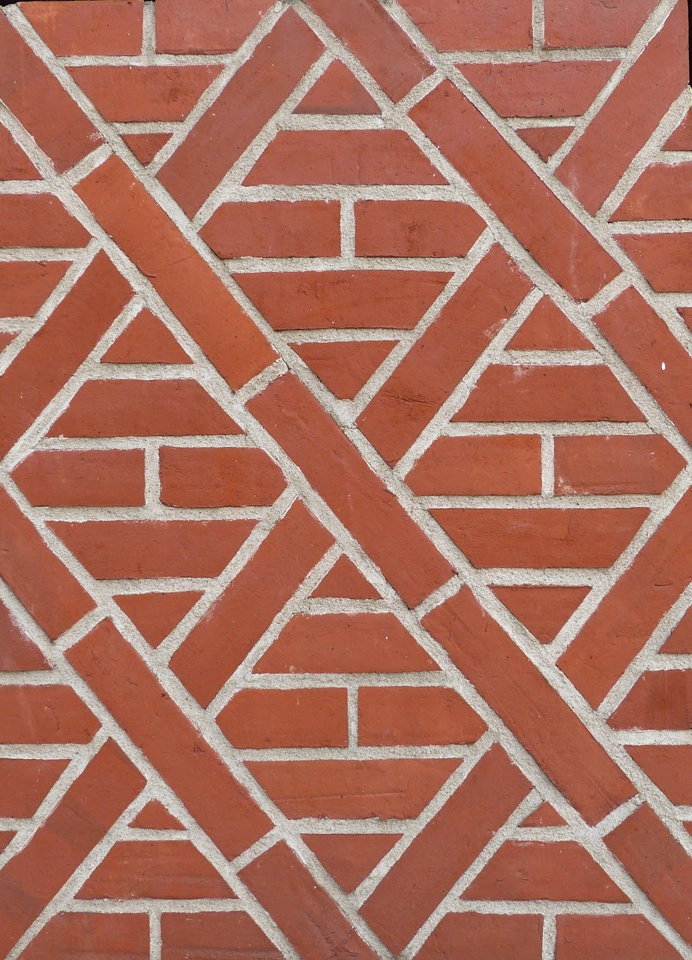

3.1: Quadrilateral Hunt
- Find the quadrilaterals that have each of the following attributes. Record their letter names here.
- attribute | - quadrilaterals with the attribute
- a. no right angles
- b. one pair of parallel sides
- c. one pair of perpendicular sides
- d. same length for all sides
- e. same size for all angles
- f. same length for only two sides
- g. no parallel sides
- h. two obtuse angles
- Choose one sentence to complete based on your work.
  - I noticed some quadrilaterals . . .
  - I noticed that all quadrilaterals . . .
  - I noticed that no quadrilaterals . . .
If you have time: Do you think it is possible for a quadrilateral to have:
- More than 2 acute angles?
- More than 2 obtuse angles?
- Exactly 3 right angles?
If you think so, sketch an example. If you don’t think so, explain or show why you think it is impossible.

3.2: What’s True about These Quadrilaterals?
Here are four sets of quadrilaterals.
Quadrilaterals D and AA are squares.
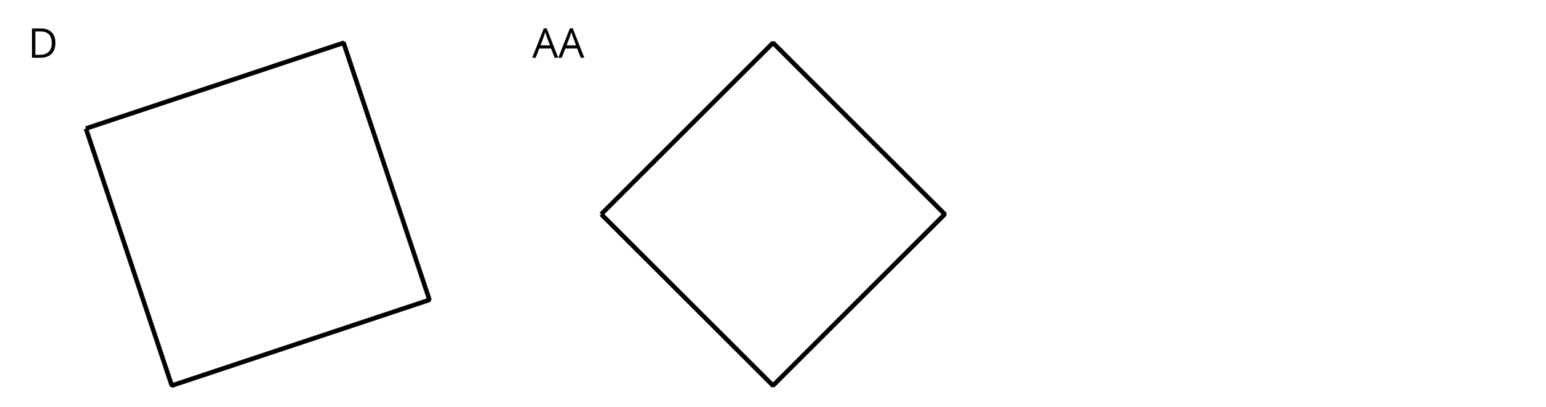
Quadrilaterals K, Z, and AA are rectangles.
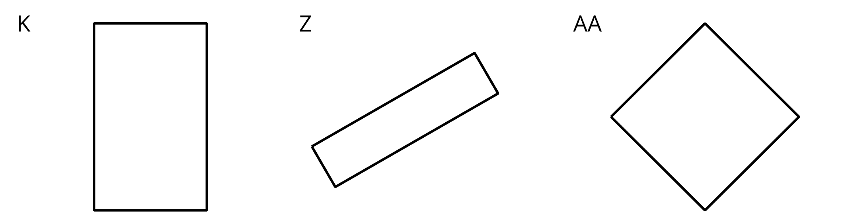
Quadrilaterals N, U, and Z are parallelograms.
Quadrilaterals AA, EE, and JJ are rhombuses.
Write 4–5 statements about the sides and angles of the quadrilaterals in each set. Each statement must be true for all the shapes in the set.

3.3: Guess Again
Partner A:
- Write down an attribute that a quadrilateral could have. Don’t show it to your partner.
- Find 3 quadrilaterals that have that attribute and 3 that don’t. Place them in the columns of the table.
Partner B:
- Study the quadrilaterals chosen by your partner.
- Pick another quadrilateral from the set. Ask: “Does this quadrilateral have the attribute?”
- Find at least 1 quadrilateral that has the attribute and 1 that doesn’t.
- Guess the attribute. If your guess is off, ask more questions before guessing again.
Switch roles after the attribute is guessed correctly.
- Partner A’s attribute:
- $\underset{_}{}$
have the attribute | do not have the attribute
- Partner B’s attribute:
- $\underset{_}{}$
have the attribute | do not have the attribute
© CC BY 2021 Illustrative Mathematics®

