Lesson 15: Build and Count with Solid Shapes
- Let’s build with and count solid shapes.

Warm-up: Estimation Exploration: How Many Cubes?
- Record an estimate that is:
- too low | - about right | - too high
- Record an estimate that is:
- too low | - about right | - too high

15.1: A Tall Tower
How many solid shapes did you use in your tower?
_______________

15.2: What Can You Make With These Shapes?
- 5 cubes
- 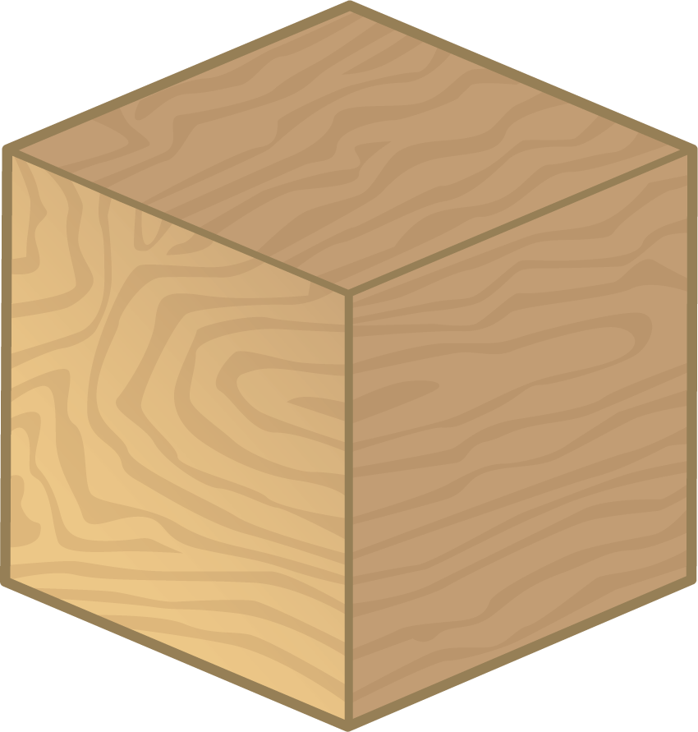
- 4 cylinders
- 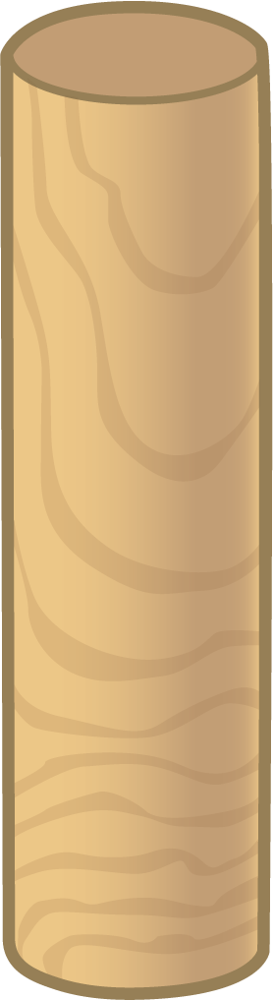
- 6 cones
- 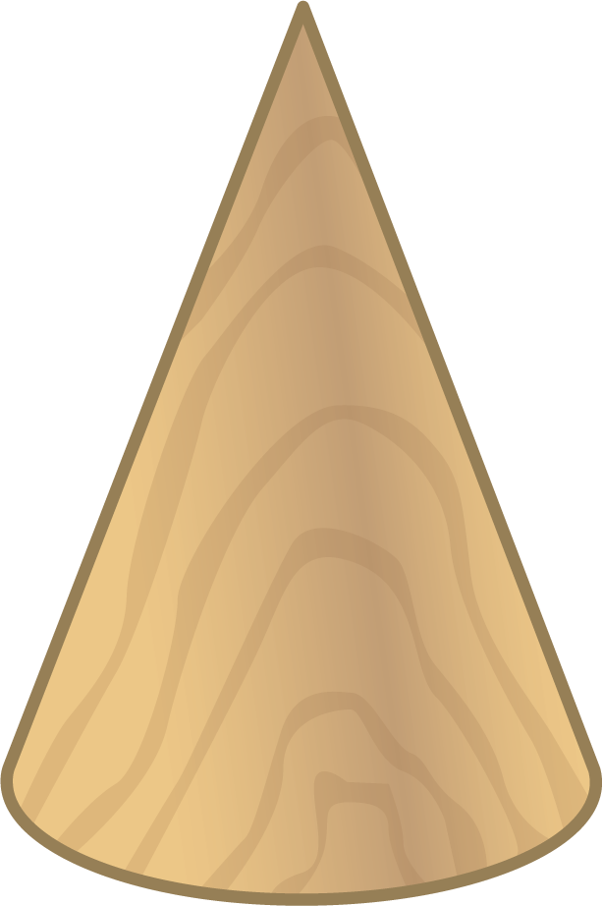
- How many shapes did you use all together?
- _______________
- 3 cones
- 4 cubes
- 5 cylinders
- How many shapes did you use all together?
- _______________

15.3: Centers: Choice Time
Choose a center.
Build Shapes
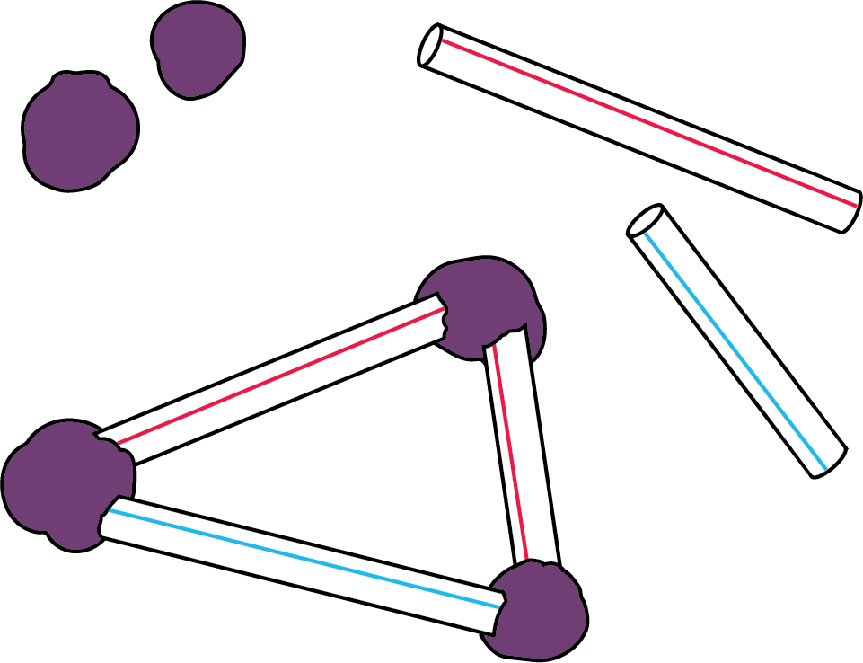
Geoblocks
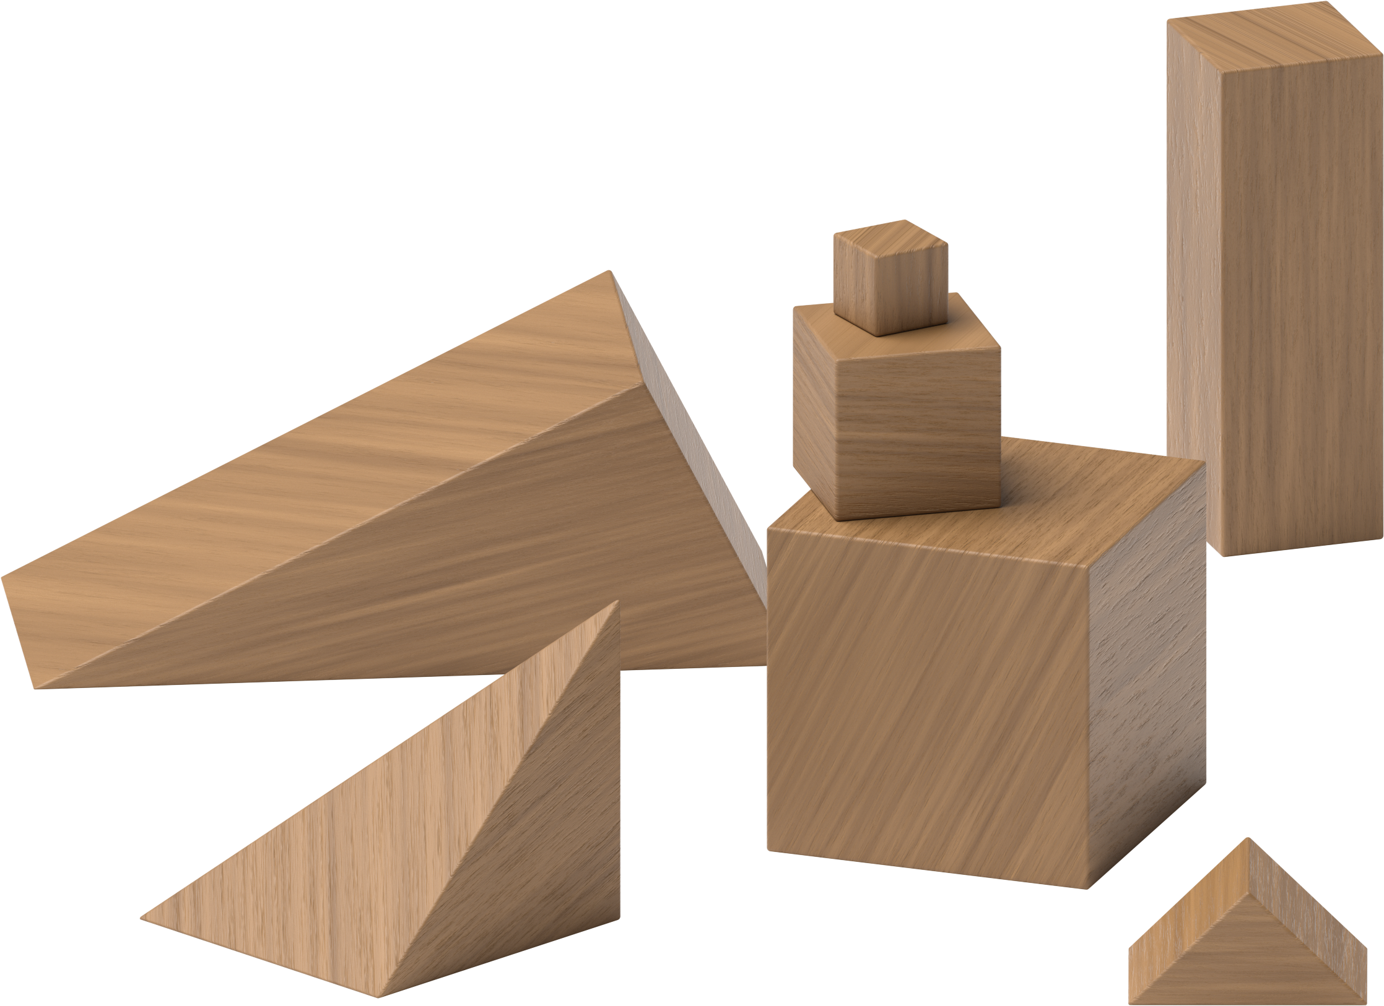
Counting Collections
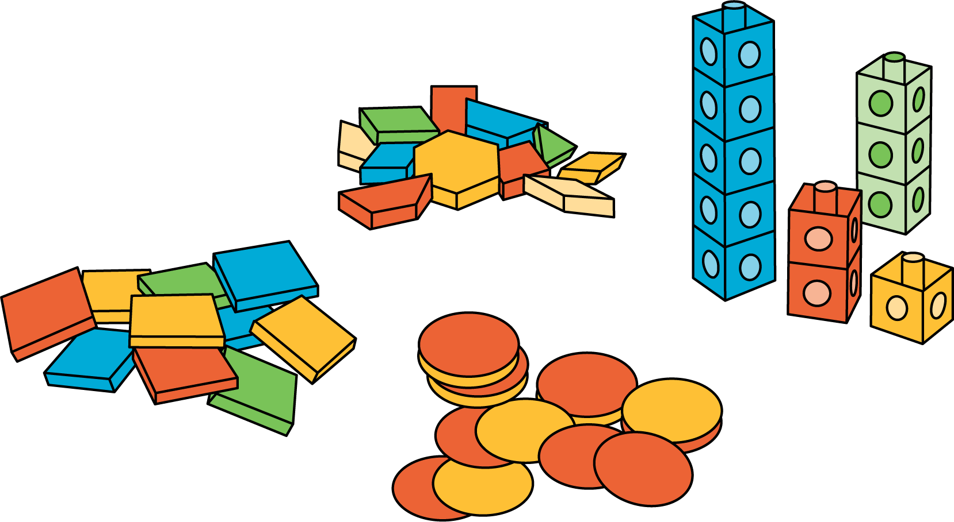
Match Mine
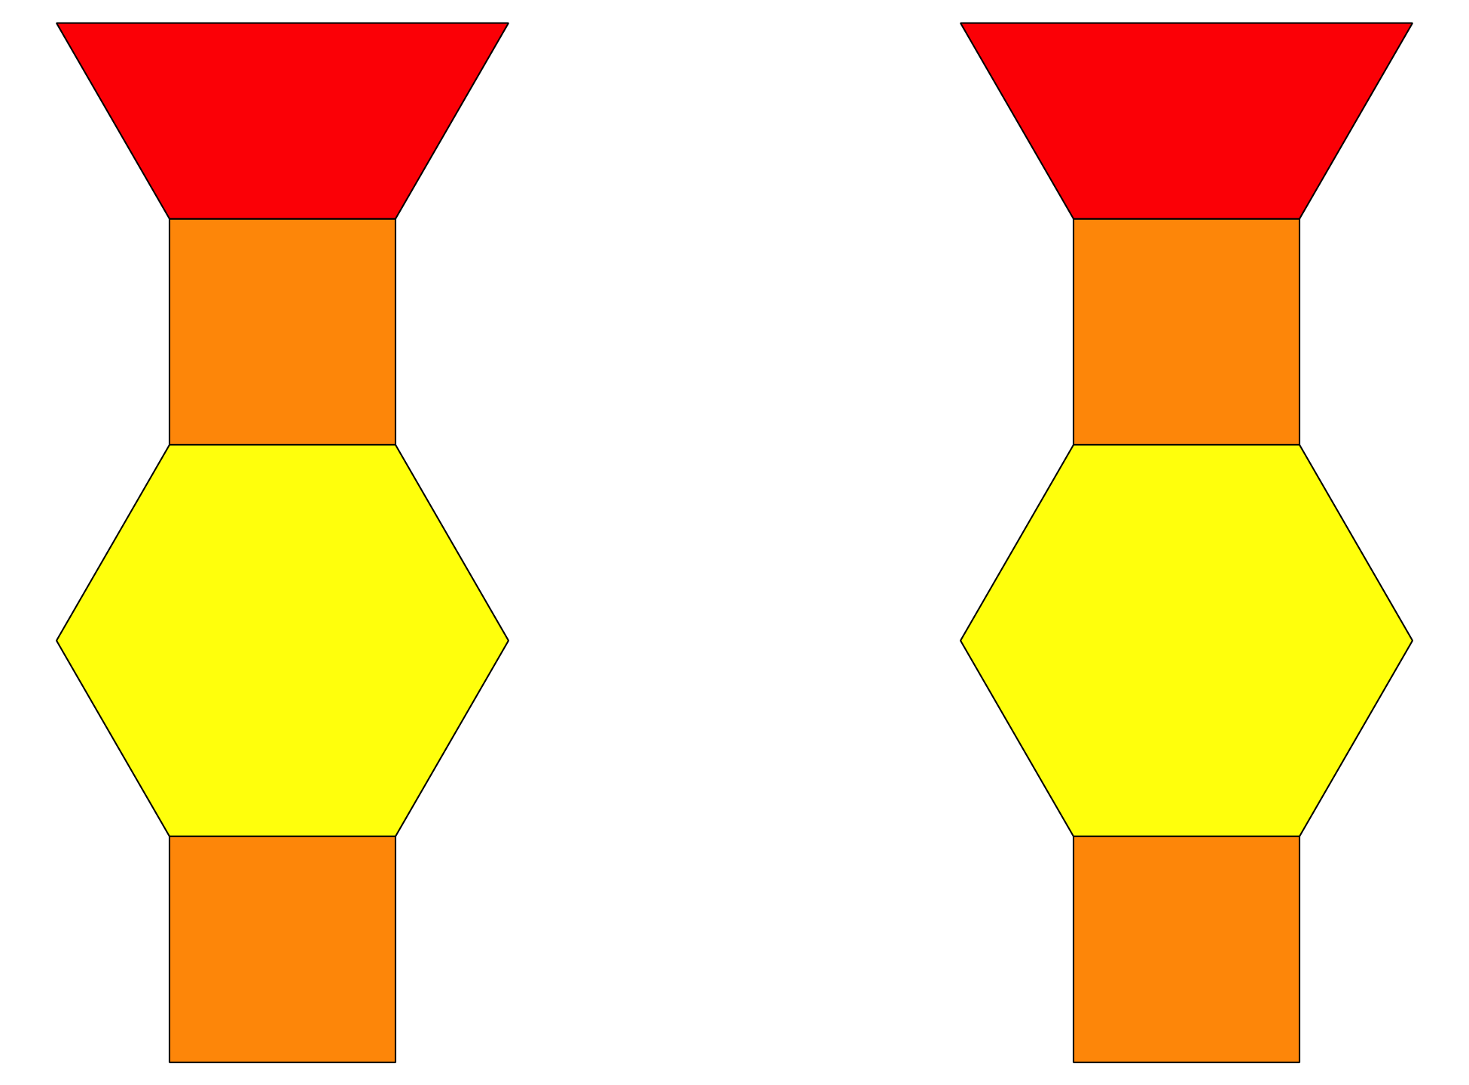
Shake and Spill
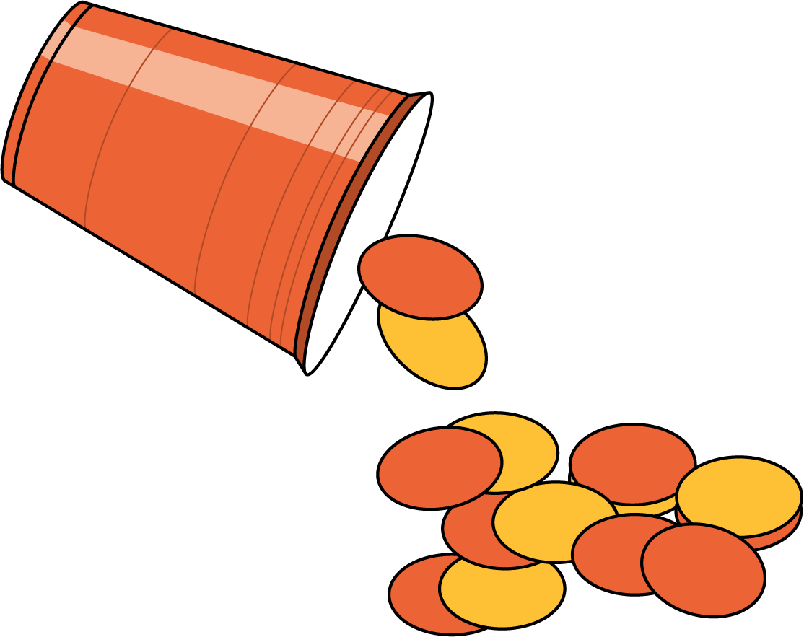
© CC BY 2021 Illustrative Mathematics®

