Unit 6 Lesson 14: Volume of Right Prisms

1 Three Prisms with the Same Volume (Warm up)

Student Task Statement
Rectangles A, B, and C represent bases of three prisms.
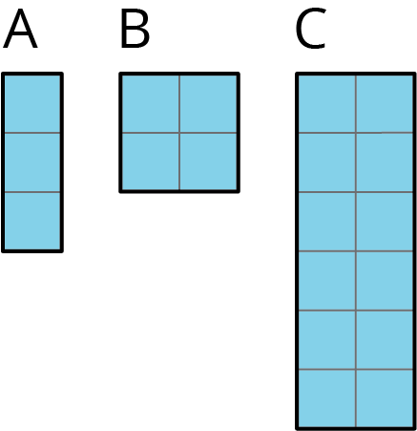
- If each prism has the same height, which one will have the greatest volume, and which will have the least? Explain your reasoning.
- If each prism has the same volume, which one will have the tallest height, and which will have the shortest? Explain your reasoning.

2 Finding Volume with Cubes

Student Task Statement
Your teacher will give you a paper with a shape on it and some snap cubes.
- Using the face of a snap cube as your area unit, what is the area of the shape? Explain or show your reasoning.
- Use snap cubes to build the shape from the paper. Add another layer of cubes on top of the shape you have built. Describe this three-dimensional object.
- What is the volume of your object? Explain your reasoning.
- Right now, your object has a height of 2. What would the volume be:
  - if it had a height of 5?
  - if it had a height of 8.5?

3 Can You Find the Volume?

Student Task Statement
Your teacher will give you a set of three-dimensional figures.
- For each figure, determine whether the shape is a prism.
- For each prism:
  - Find the area of the base of the prism.
  - Find the height of the prism.
  - Calculate the volume of the prism.
 | Is it a prism? | area of prism base (cm²) | height (cm) | volume (cm³)
figure A
figure B
figure C
figure D
figure E
figure F

4 What’s the Prism’s Height? (Optional)

Student Task Statement
There are 4 different prisms that all have the same volume. Here is what the base of each prism looks like.
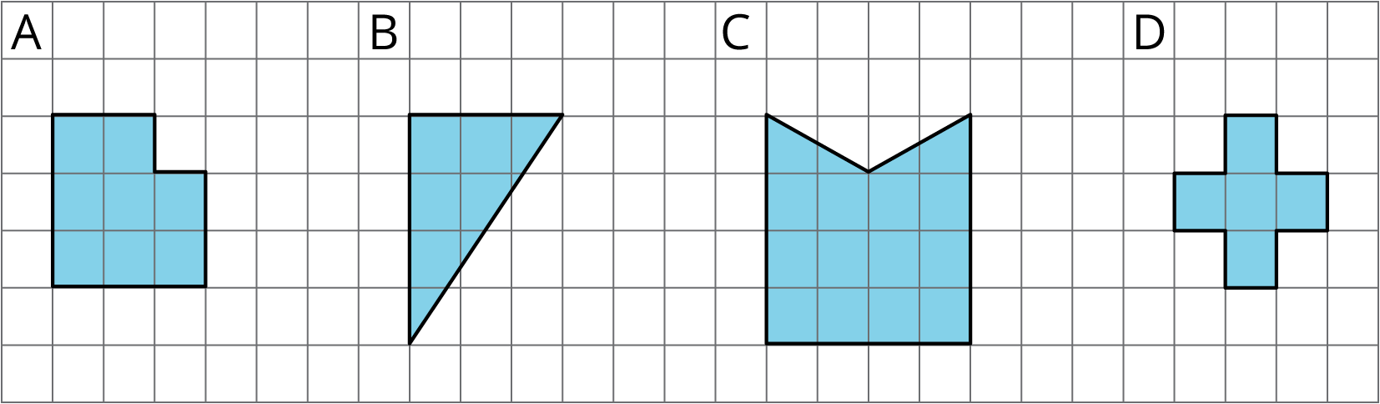
- Order the prisms from shortest to tallest. Explain your reasoning.
- If the volume of each prism is 60 units³, what would be the height of each prism?
- For a volume other than 60 units³, what could be the height of each prism?
- Discuss your thinking with your partner. If you disagree, work to reach an agreement.
© CC BY Open Up Resources. Adaptations CC BY IM.

