Unit 1 Lesson 5: Describing Transformations

1 Finding a Center of Rotation (Warm up)

Student Task Statement
Andre performs a 90-degree counterclockwise rotation of Polygon P and gets Polygon P’, but he does not say what the center of the rotation is. Can you find the center?
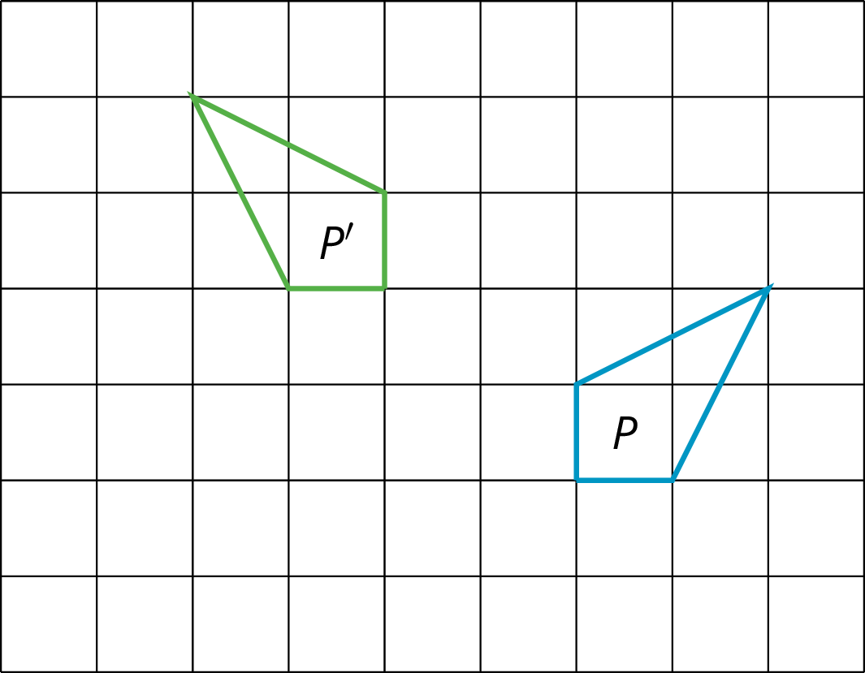

2 Info Gap: Transformation Information

Student Task Statement
Your teacher will give you either a problem card or a data card. Do not show or read your card to your partner.
If your teacher gives you the problem card:
- Silently read your card and think about what information you need to be able to answer the question.
- Ask your partner for the specific information that you need.
- Explain how you are using the information to solve the problem.
- Continue to ask questions until you have enough information to solve the problem.
- Share the problem card and solve the problem independently.
- Read the data card and discuss your reasoning.
If your teacher gives you the data card:
- Silently read your card.
- Ask your partner “What specific information do you need?” and wait for them to ask for information.
- If your partner asks for information that is not on the card, do not do the calculations for them. Tell them you don’t have that information.
- Before sharing the information, ask “Why do you need that information?” Listen to your partner’s reasoning and ask clarifying questions.
- Read the problem card and solve the problem independently.
- Share the data card and discuss your reasoning.
Pause here so your teacher can review your work. Ask your teacher for a new set of cards and repeat the activity, trading roles with your partner.
© CC BY Open Up Resources. Adaptations CC BY IM.

