Unit 8 Lesson 12: Edge Lengths and Volumes

1 Ordering Squares and Cubes (Warm up)

Student Task Statement
Let $a$, $b$, $c$, $d$, $e$, and $f$ be positive numbers.
Given these equations, arrange $a$, $b$, $c$, $d$, $e$, and $f$ from least to greatest. Explain your reasoning.
- $a^{2}=9$
- $b^{3}=8$
- $c^{2}=10$
- $d^{3}=9$
- $e^{2}=8$
- $f^{3}=7$

2 Name That Edge Length!

Student Task Statement
Fill in the missing values using the information provided:
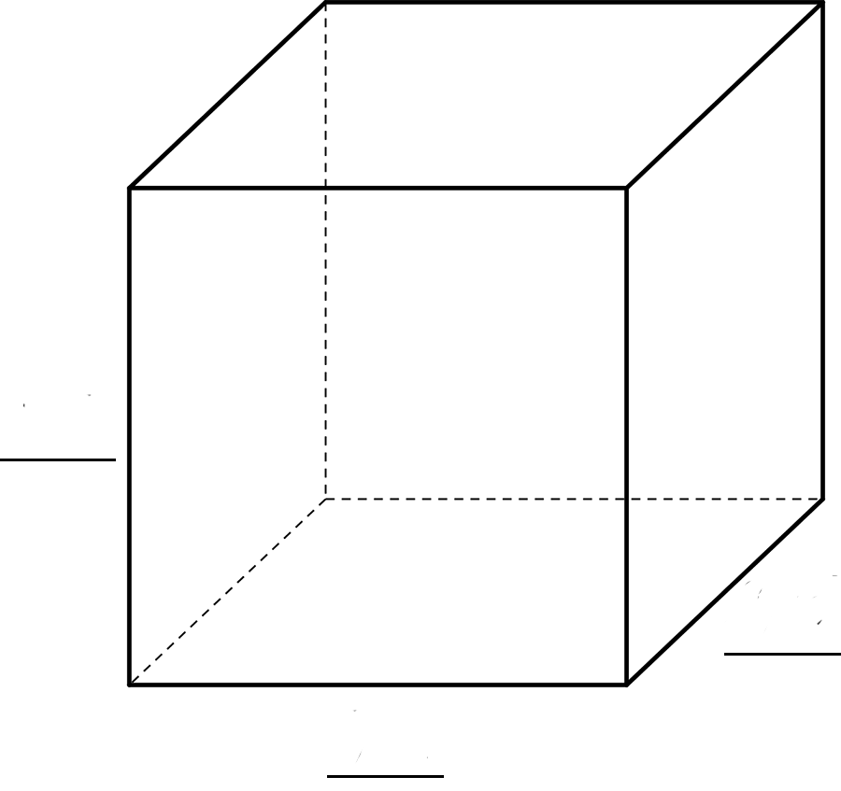
sides | volume | volume equation
 | $27 {\text{in}}^{3}$
$\sqrt[3]{5}$
 |  | ${\left(\sqrt[3]{16}\right)}^{3}=16$

3 Card Sort: Rooted in the Number Line

Student Task Statement
Your teacher will give your group a set of cards. For each card with a letter and value, find the two other cards that match. One shows the location on a number line where the value exists, and the other shows an equation that the value satisfies. Be prepared to explain your reasoning.
© CC BY Open Up Resources. Adaptations CC BY IM.

