## Unit 4 Lesson 8: Expanding and Factoring

### 1 Number Talk: Parentheses (Warm up)

#### Student Task Statement

Find the value of each expression mentally.

### 2 Factoring and Expanding with Negative Numbers

#### Student Task Statement

In each row, write the equivalent expression. If you get stuck, use a diagram to organize your work. The first row is provided as an example. Diagrams are provided for the first three rows.

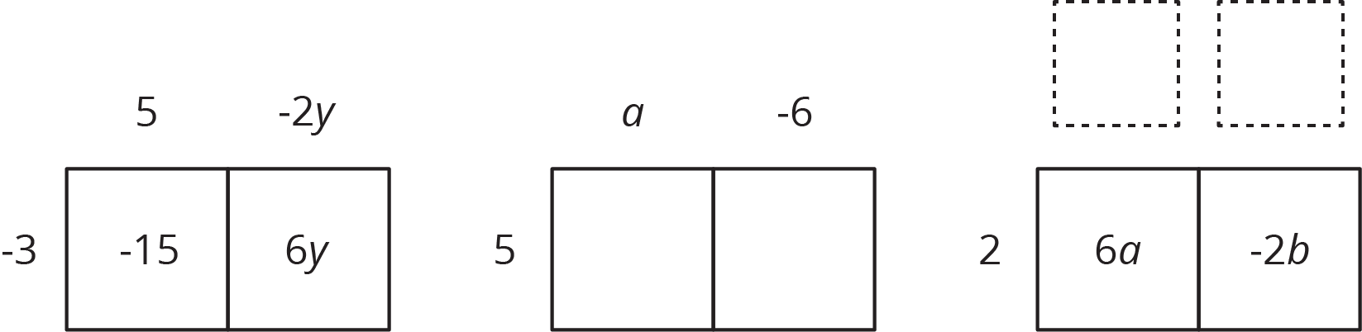

| factored | expanded |
| --- | --- |
|  |  |
|  |  |
|  |  |
|  |  |
|  |  |
|  |  |
|  |  |
|  |  |
|  |  |
|  |  |
|  |  |



© CC BY Open Up Resources. Adaptations CC BY IM.