Lesson 2 Practice Problems
- The diagonal of a rectangle is shown.
- 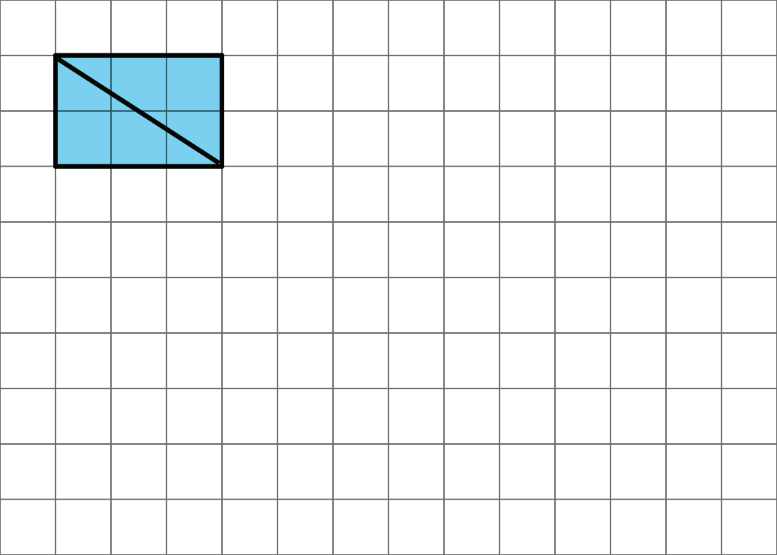
  - Decompose the rectangle along the diagonal, and recompose the two pieces to make a different shape.
  - How does the area of this new shape compare to the area of the original rectangle? Explain how you know.
- Priya decomposed a square into 16 smaller, equal-size squares and then cut out 4 of the small squares and attached them around the outside of original square to make a new figure.
- How does the area of her new figure compare with that of the original square?
- 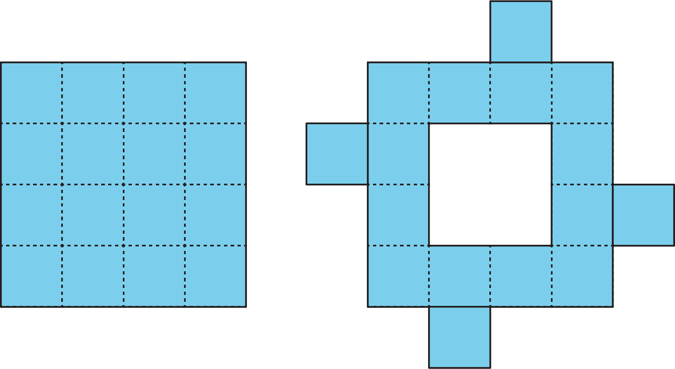
  - The area of the new figure is greater.
  - The two figures have the same area.
  - The area of the original square is greater.
  - We don’t know because neither the side length nor the area of the original square is known.
- The area of the square is 1 square unit. Two small triangles can be put together to make a square or to make a medium triangle.
- 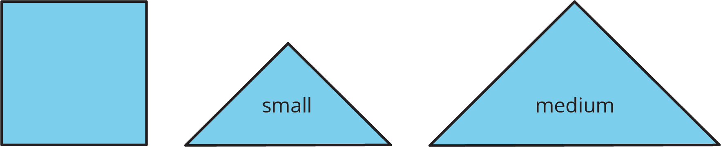
- Which figure also has an area of $1\frac{1}{2}$ square units? Select all that apply.
- 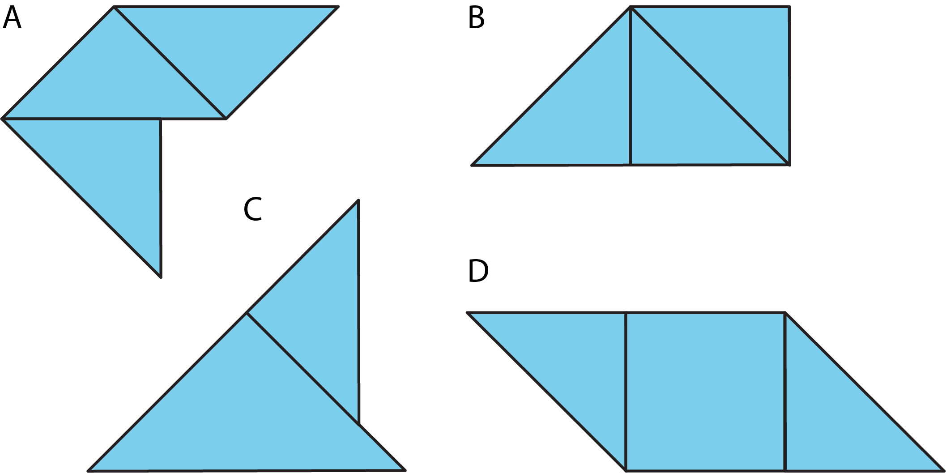
  - Figure A
  - Figure B
  - Figure C
  - Figure D
- The area of a rectangular playground is 78 square meters. If the length of the playground is 13 meters, what is its width?
- (From Unit 1, Lesson 1.)
- A student said, “We can’t find the area of the shaded region because the shape has many different measurements, instead of just a length and a width that we could multiply.”
- 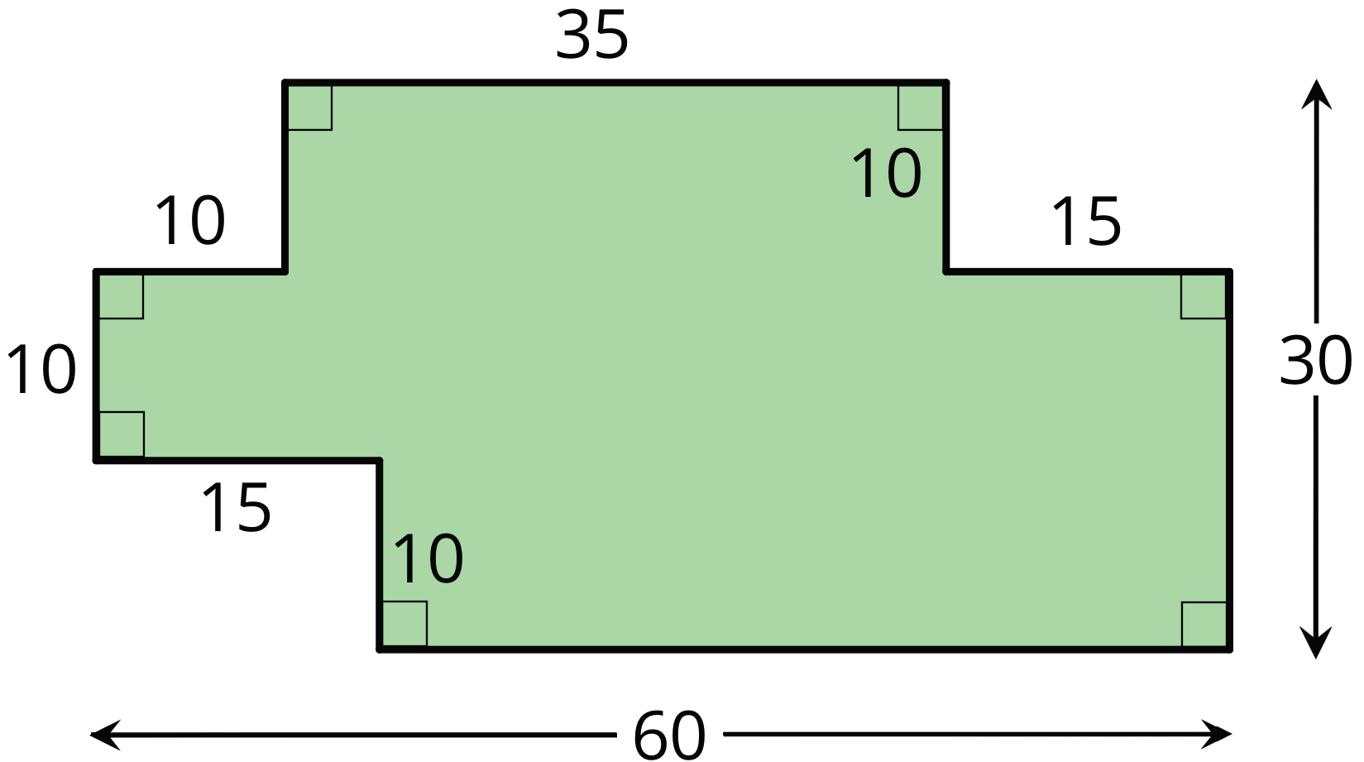
- Explain why the student’s statement about area is incorrect.
- (From Unit 1, Lesson 1.)
© CC BY Open Up Resources. Adaptations CC BY IM.

