Lesson 13: Describe Solid Shapes Around Us
- Let’s find solid shapes.

Warm-up: Notice and Wonder: At the Market
What do you notice?
What do you wonder?
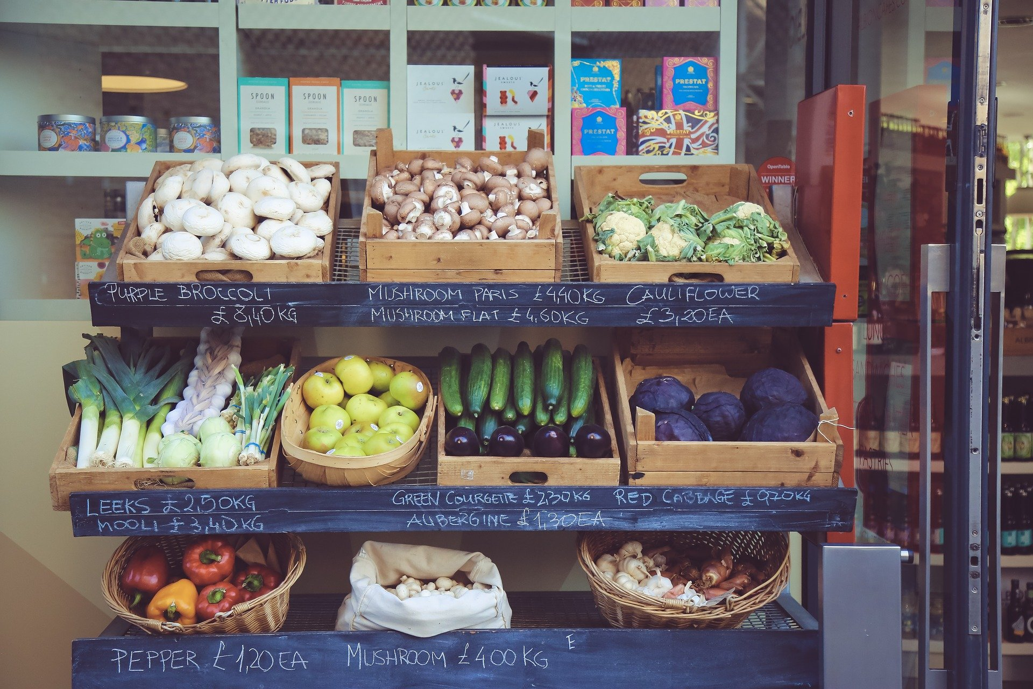

13.1: Solid Shape Walk

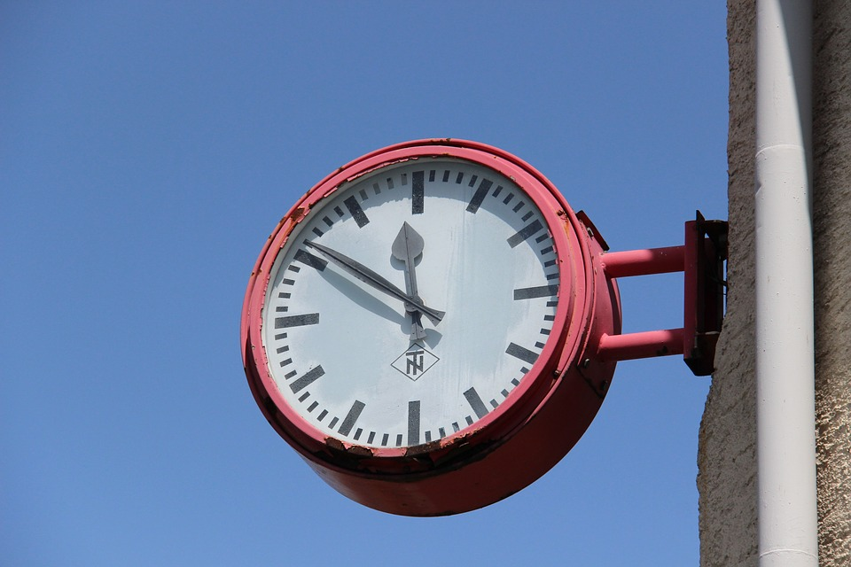
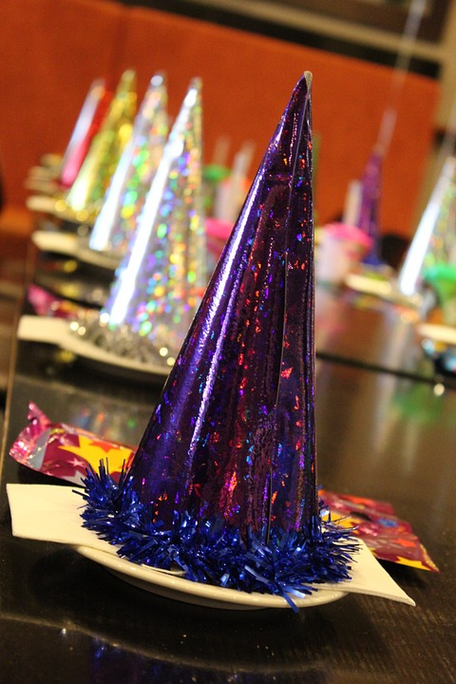

13.3: Centers: Choice Time
Choose a center.
Build Shapes
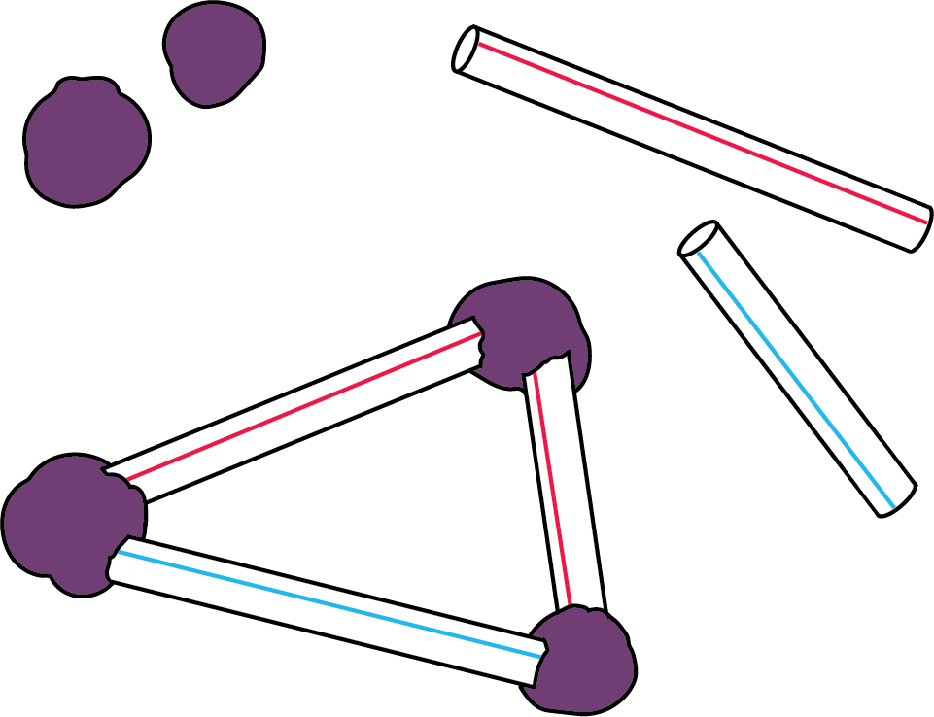
Geoblocks
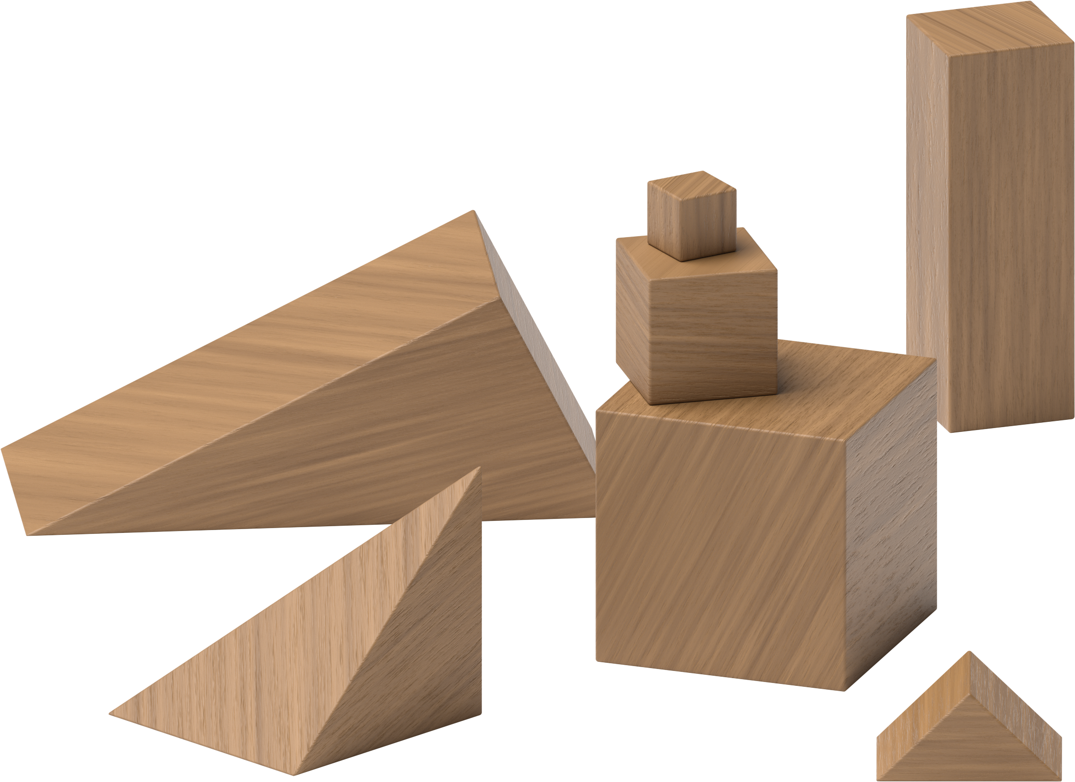
Counting Collections
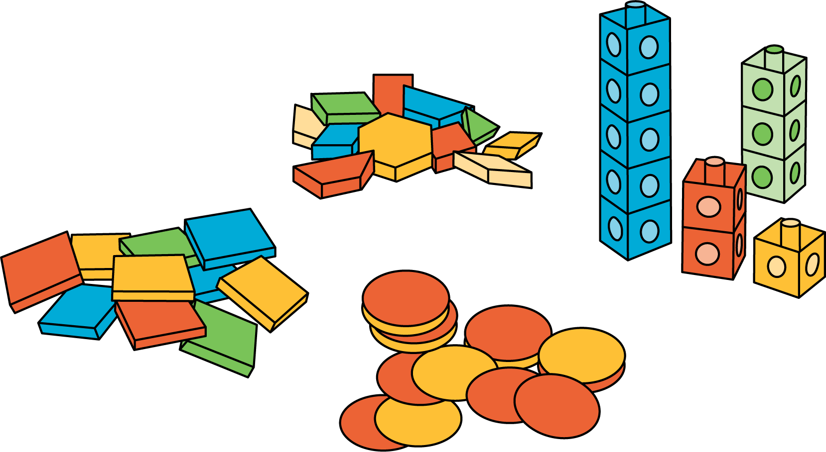
Match Mine
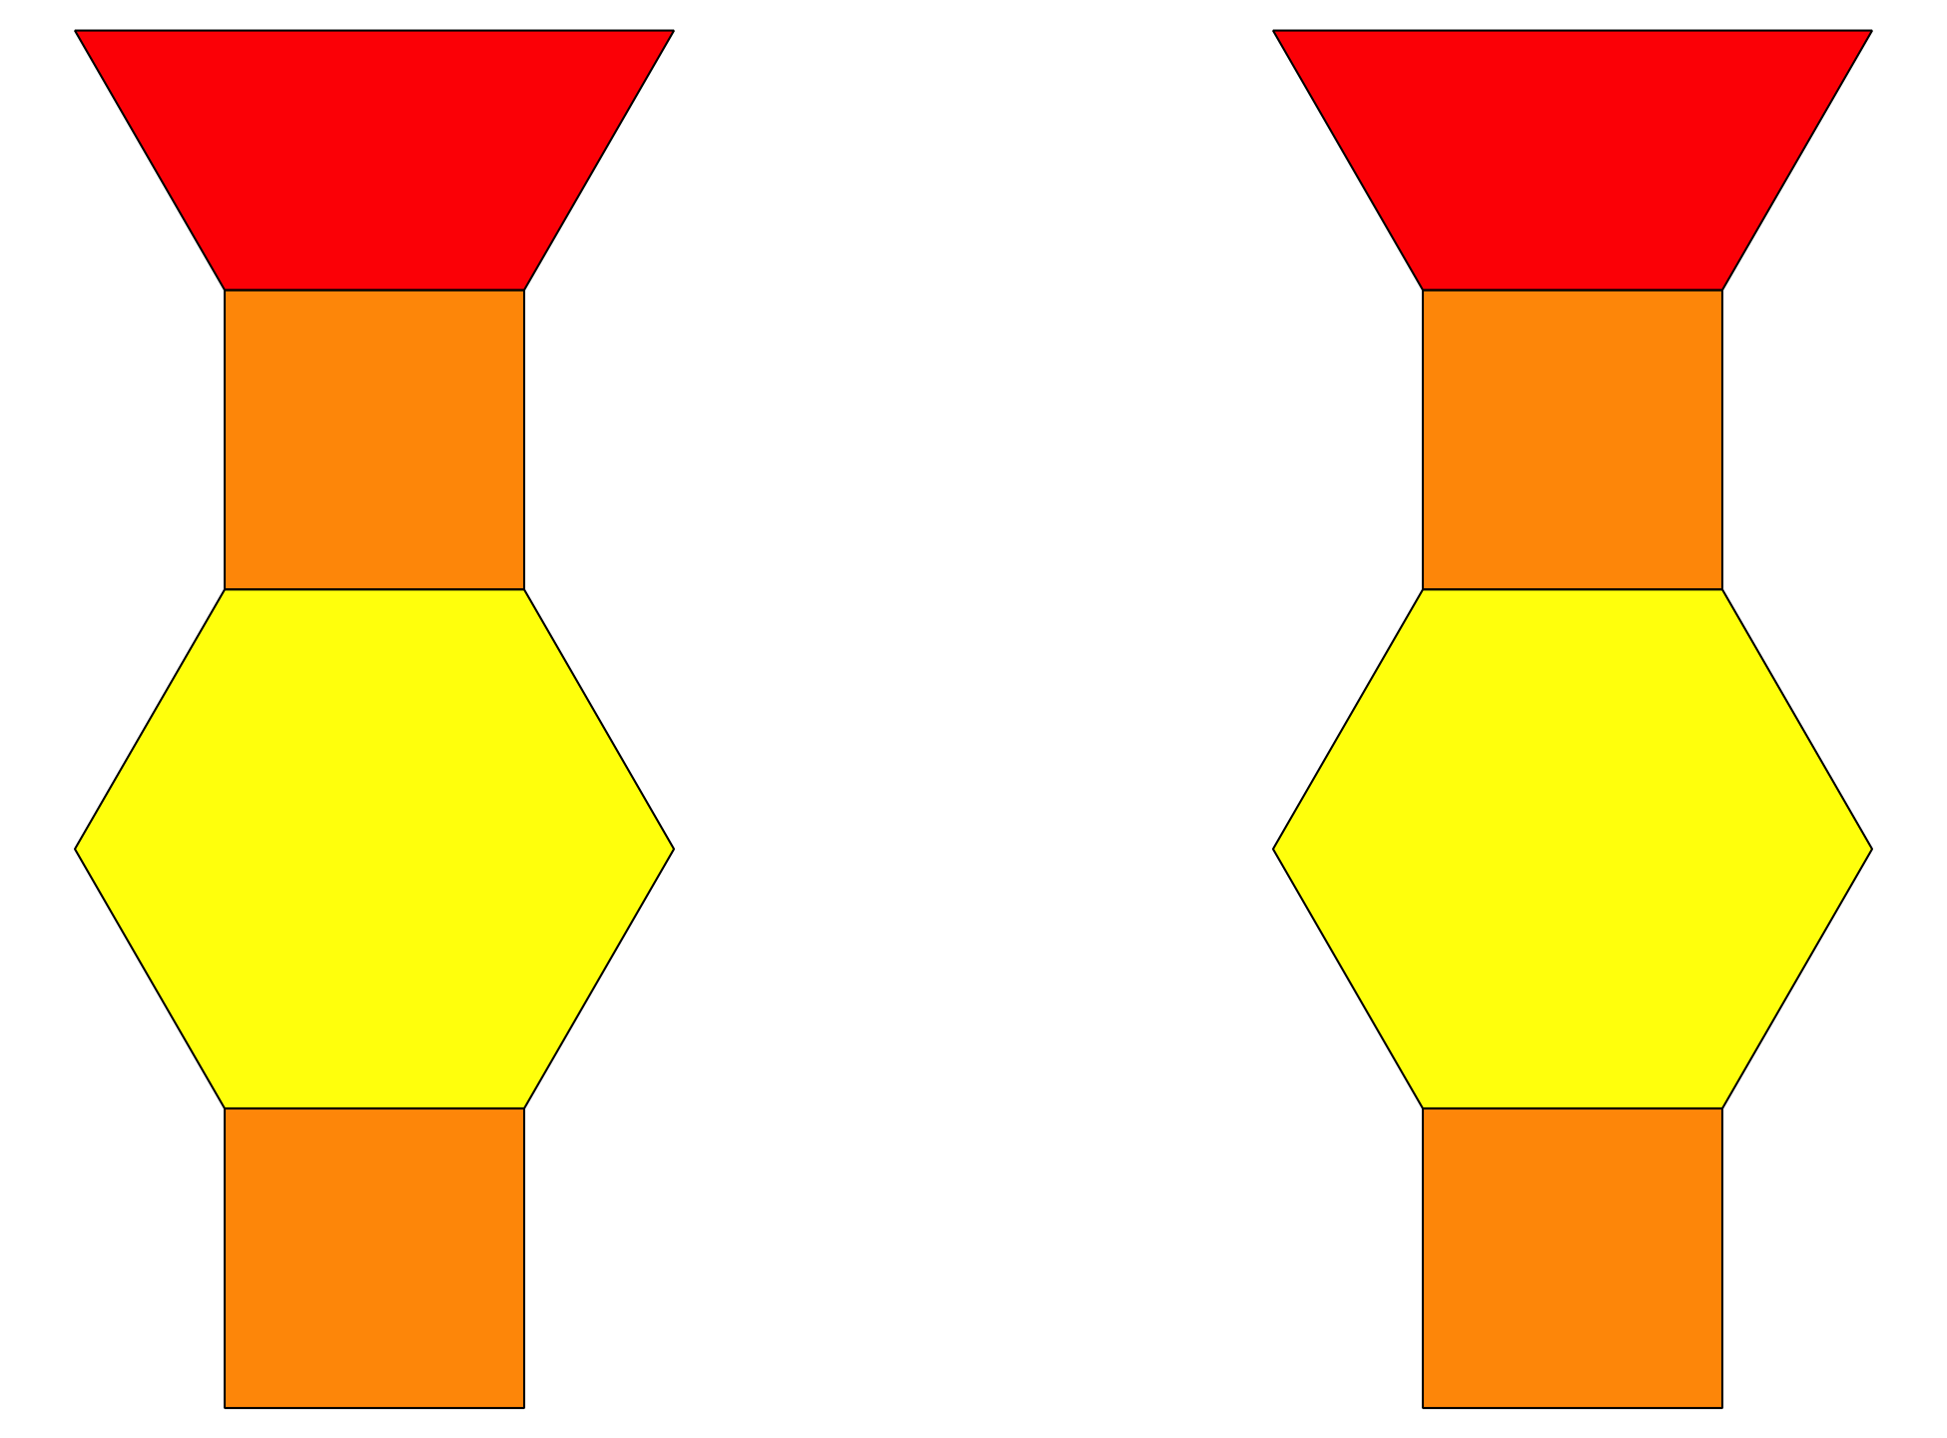
Shake and Spill
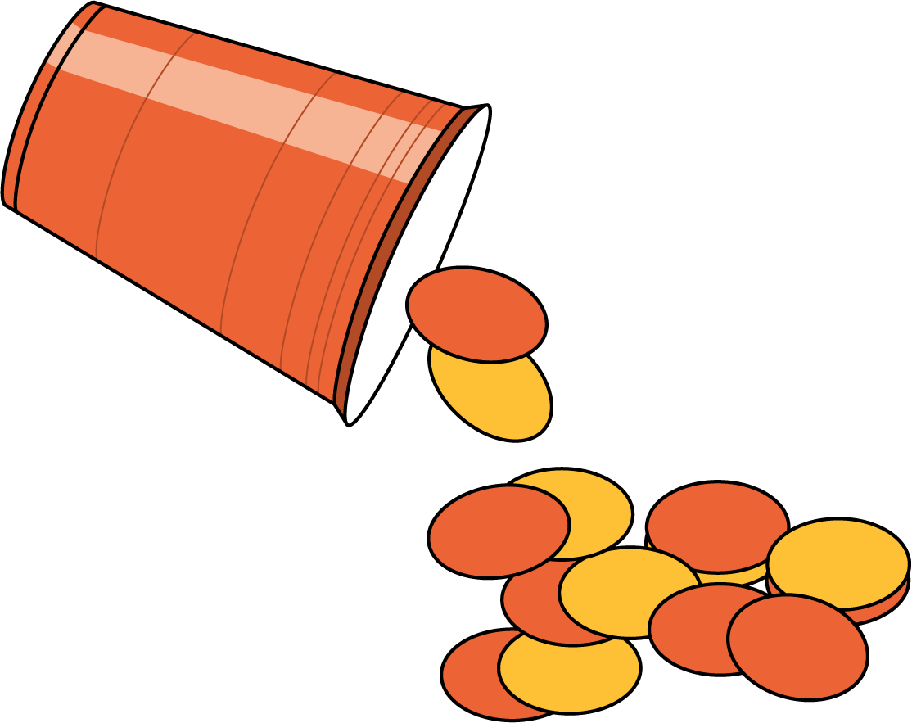
© CC BY 2021 Illustrative Mathematics®

