## Unit 1 Lesson 13: Standard Deviation in Real-World Contexts

### 1 Estimation: Marathon Runner (Warm up)

#### Student Task Statement

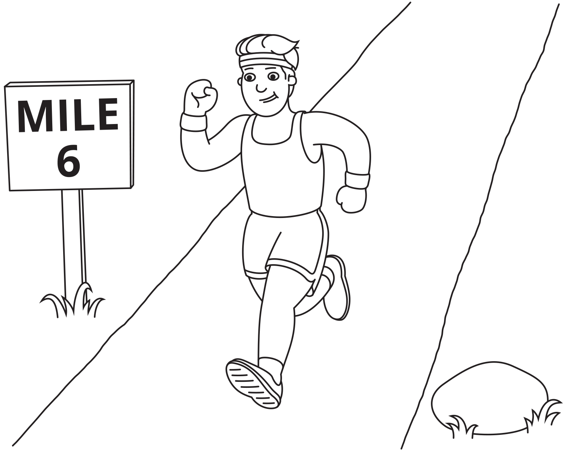

How long will it take the runner to finish the marathon?

1. Record an estimate that is:

| * too low | * about right | * too high |
| --- | --- | --- |
|  |  |  |

1. Explain your reasoning.

### 2 Calculate Standard Deviation

#### Student Task Statement



Movie A ratings on a 10 point scale:

9, 8, 10, 10, 7, 1, 8, 1, 2, 8

Movie B ratings on a 10 point scale:

9, 8, 8, 7, 9, 7, 7, 9, 7, 8

Restaurant A ratings on a 100 point scale:

88, 87, 89, 90, 87, 85, 88, 91, 86, 86, 88, 89

Restaurant B ratings on a 100 point scale:

90, 65, 89, 50, 94, 93, 95, 95, 75, 70, 88, 89

1. Calculate the mean and standard deviation for each data set.
2. Based on these statistics, which movie and restaurant would you choose? Explain your reasoning.

### 3 Which Route is the Best Route?

#### Student Task Statement

Priya timed the ride from home to school on two different routes.  
Here are the times in minutes:

Route A: 21.5, 23, 24, 25, 26.5

Route B: 12, 20, 24, 28, 36

1. Before calculating the standard deviation, predict which route has a greater standard deviation. Explain your reasoning.
2. Calculate the standard deviation and use it to decide which route you would recommend for Priya.



© CC BY 2019 by Illustrative Mathematics®