Unit 6 Lesson 8: Equations and Graphs

1 Focus on Distance (Warm up)

Student Task Statement
The image shows a parabola with focus $\left(\text{-}2,2\right)$ and directrix $y=0$ (the $x$-axis). Points $A$, $B$, and $C$ are on the parabola.
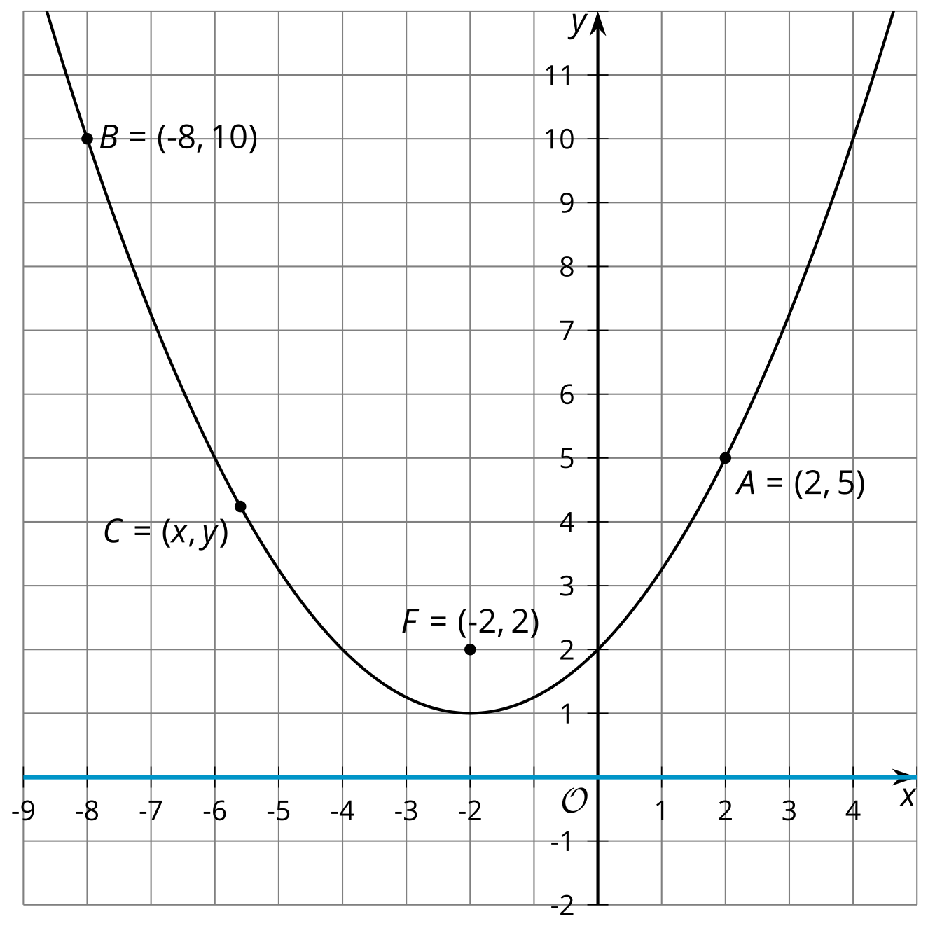
Without using the Pythagorean Theorem, find the distance from each plotted point to the parabola’s focus. Explain your reasoning.

Activity Synthesis
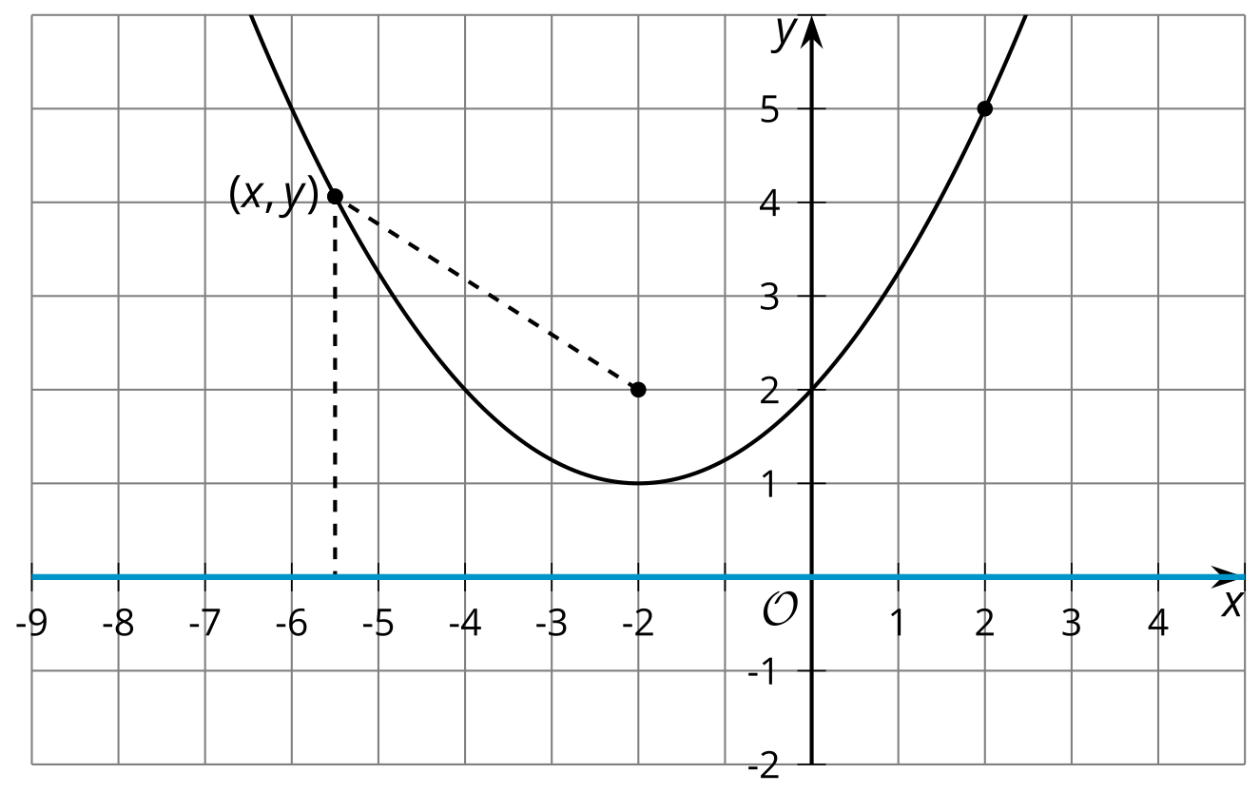

2 Building an Equation for a Parabola

Student Task Statement
The image shows a parabola with focus $\left(3,2\right)$ and directrix $y=0$ (the $x$-axis).
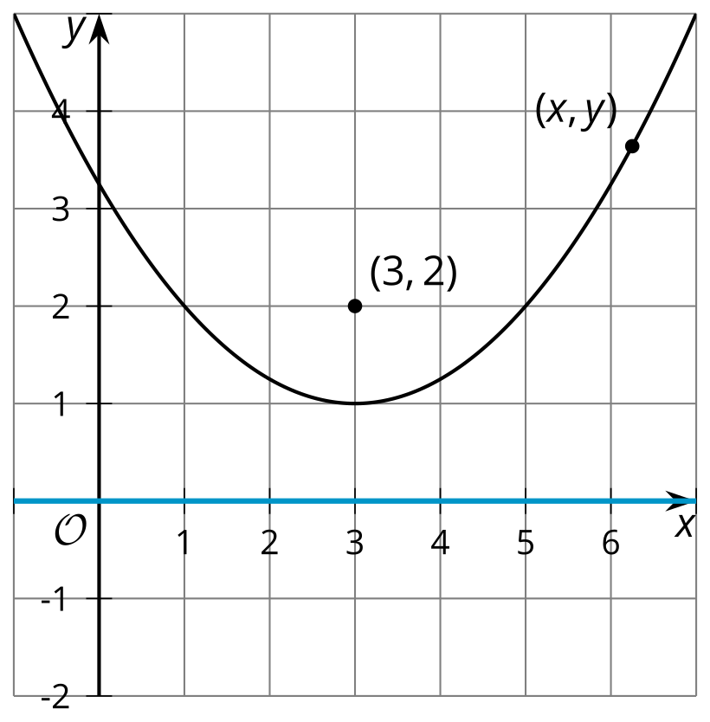
- Write an equation that would allow you to test whether a particular point $\left(x,y\right)$ is on the parabola.
- The equation you wrote defines the parabola, but it’s not in a very easy-to-read form. Rewrite the equation to be in vertex form: $y=a{\left(x−h\right)}^{2}+k$, where $\left(h,k\right)$ is the vertex.

3 Card Sort: Parabolas

Student Task Statement
Your teacher will give you a set of cards with graphs and equations of parabolas. Match each graph with the equation that represents it.

Images for Activity Synthesis
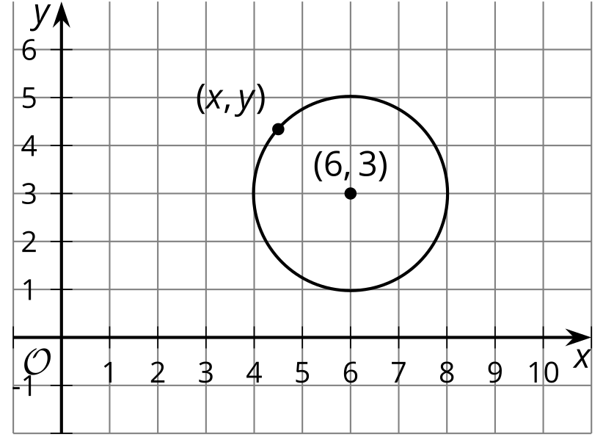
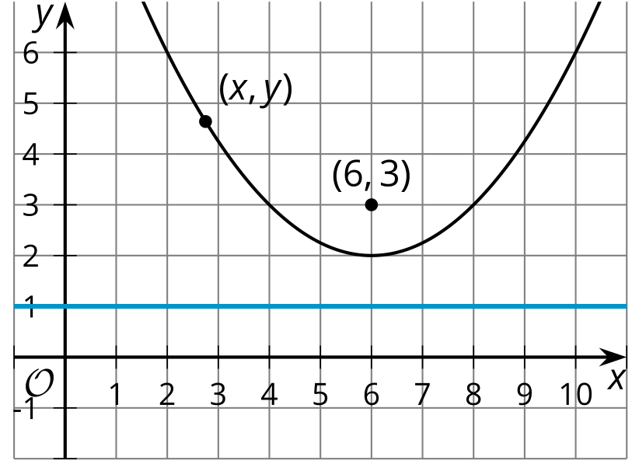
© CC BY 2019 by Illustrative Mathematics®

