Unit 5 Lesson 8: Center Day 2

WU Number Talk: Add Within 100 (Warm up)

Student Task Statement
Find the value of each expression mentally.
- $68+2$
- $3+68$
- $5+45$
- $45+7$

1 Introduce Target Numbers, Add Tens or Ones

Student Task Statement

2 Centers: Choice Time

Student Task Statement
Choose a center.
Target Numbers
Number Puzzles
Five in a Row
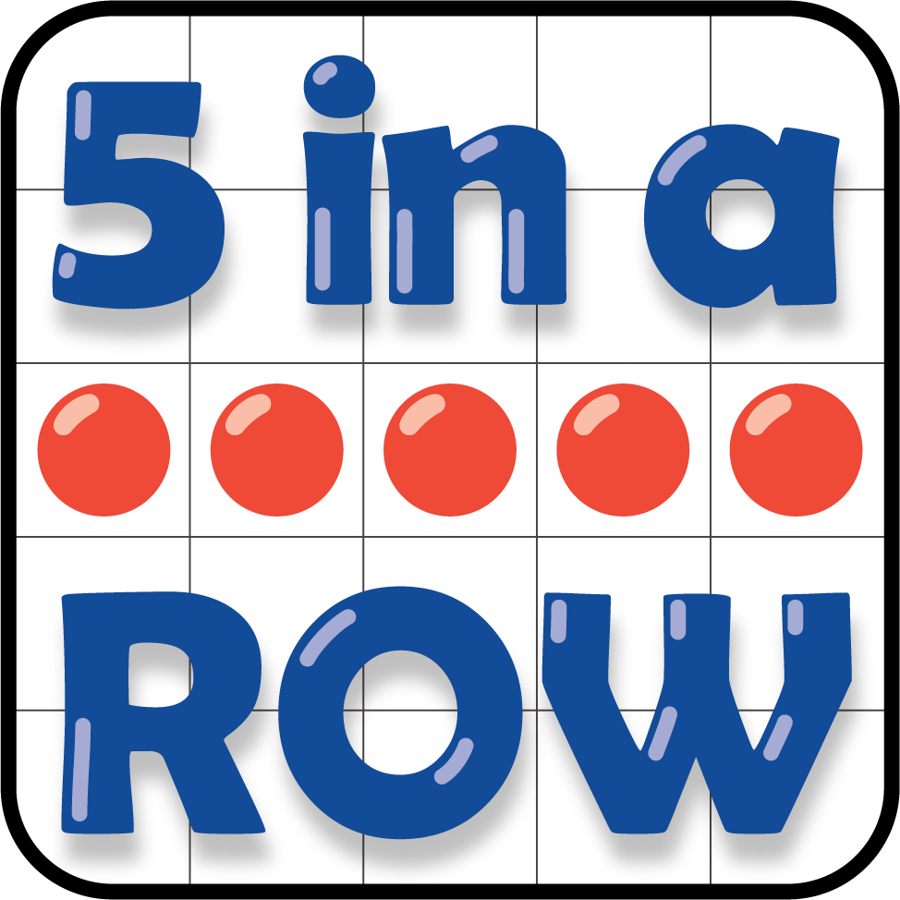

3 Addition Stories (Optional)

Student Task Statement
- Priya watched a football game.
The home team scored 35 points in the first half.
In the second half they scored 6 more points.
How many points did they score all together?
Show your thinking using drawings, numbers, or words.
- At the football game, 9 fans cheered for the visiting team.
There were 45 fans who cheered for the home team.
How many fans were at the game all together?
Show your thinking using drawings, numbers, or words.
© CC BY 2021 Illustrative Mathematics®

