Unit 1 Lesson 6: Center Day 1

WU Number Talk: Teen Numbers, Two-digit Numbers (Warm up)

Student Task Statement
Find the value of each expression mentally.
- $14+22$
- $19+22$
- $15+25$
- $17+25$

1 Revisit Number Puzzles, Within 20

Student Task Statement

2 Centers: Choice Time

Student Task Statement
Choose a center.
What's Behind My Back?
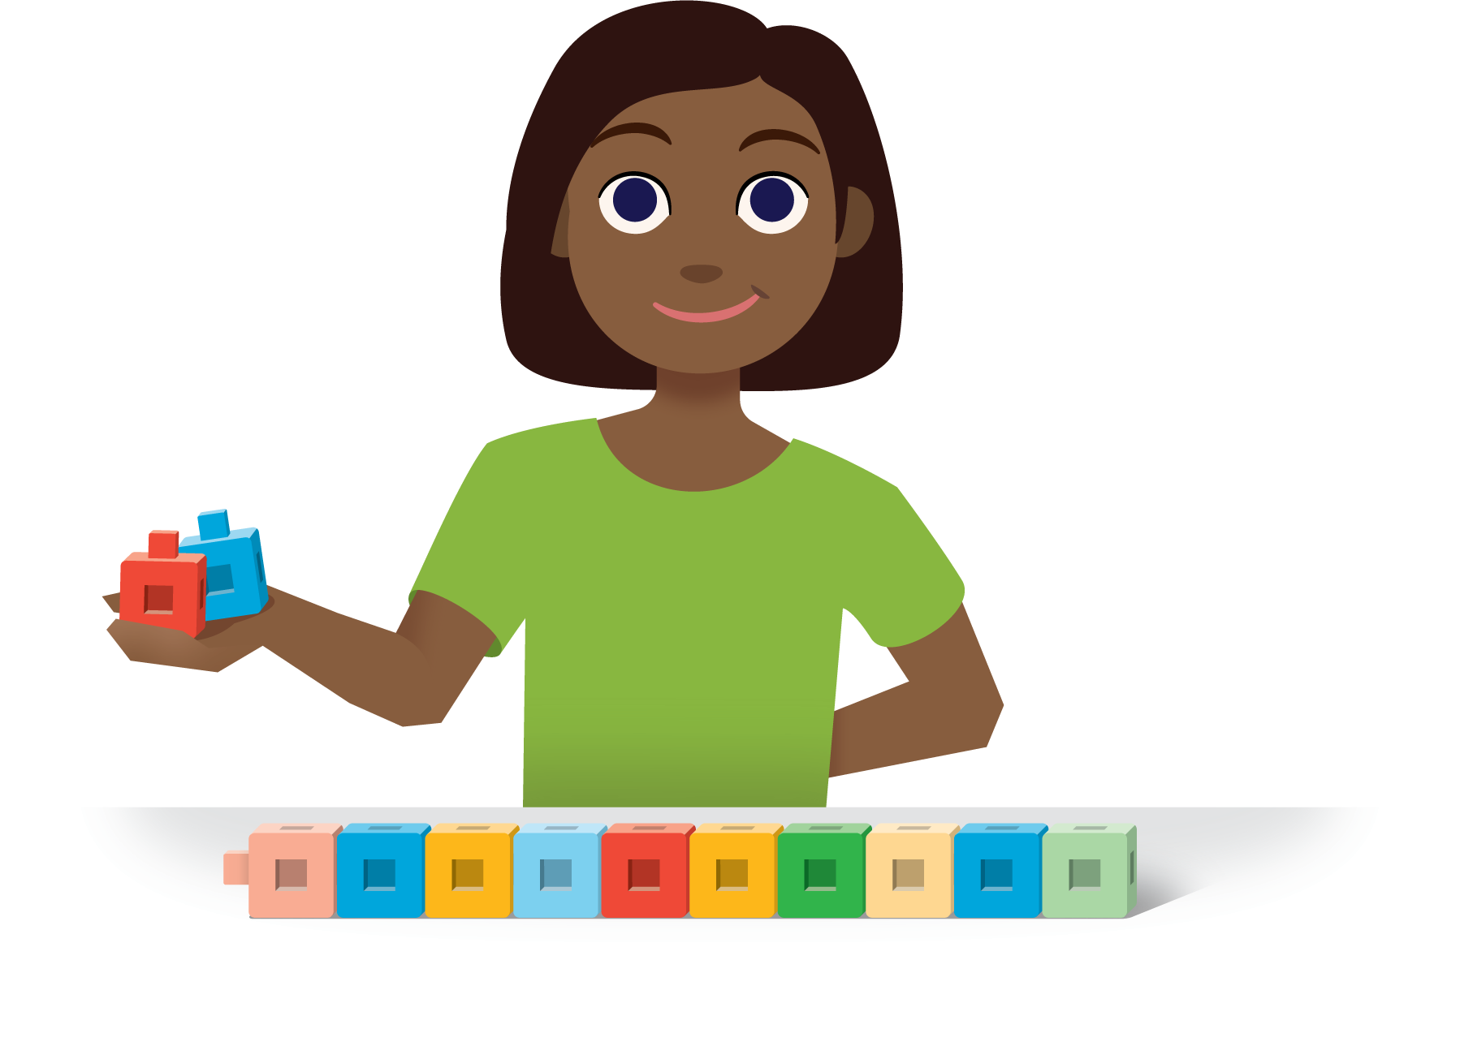
How Close?
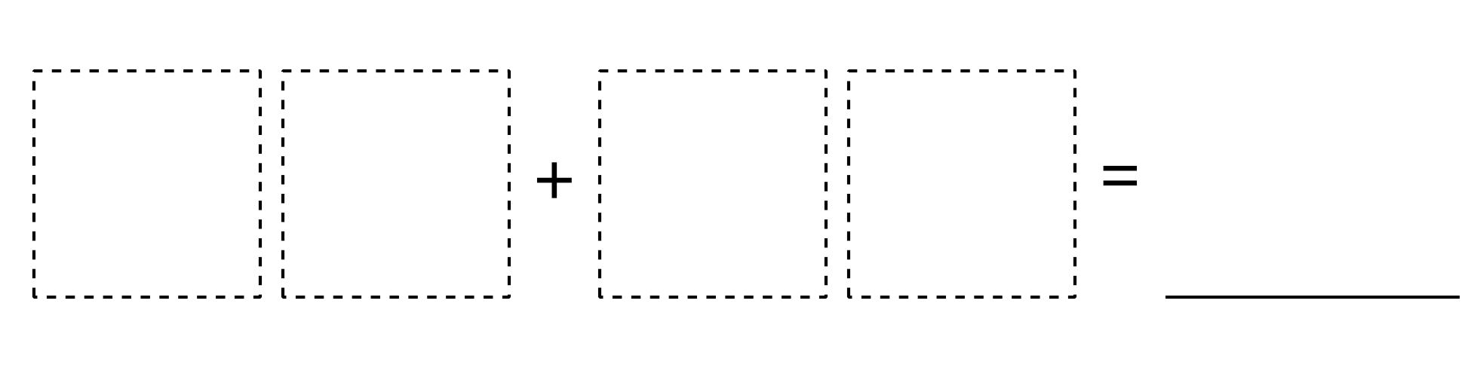
Number Puzzles
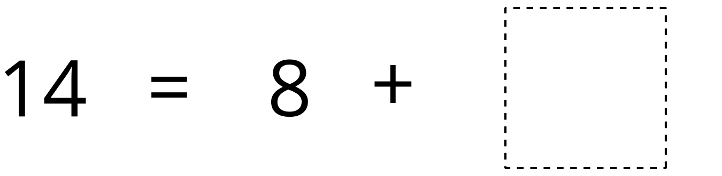
© CC BY 2021 Illustrative Mathematics®

