Lesson 21: Pattern Block Puzzles
- Let’s make pattern block puzzles.

Warm-up: Notice and Wonder: Pattern Block Bees
What do you notice? What do you wonder?
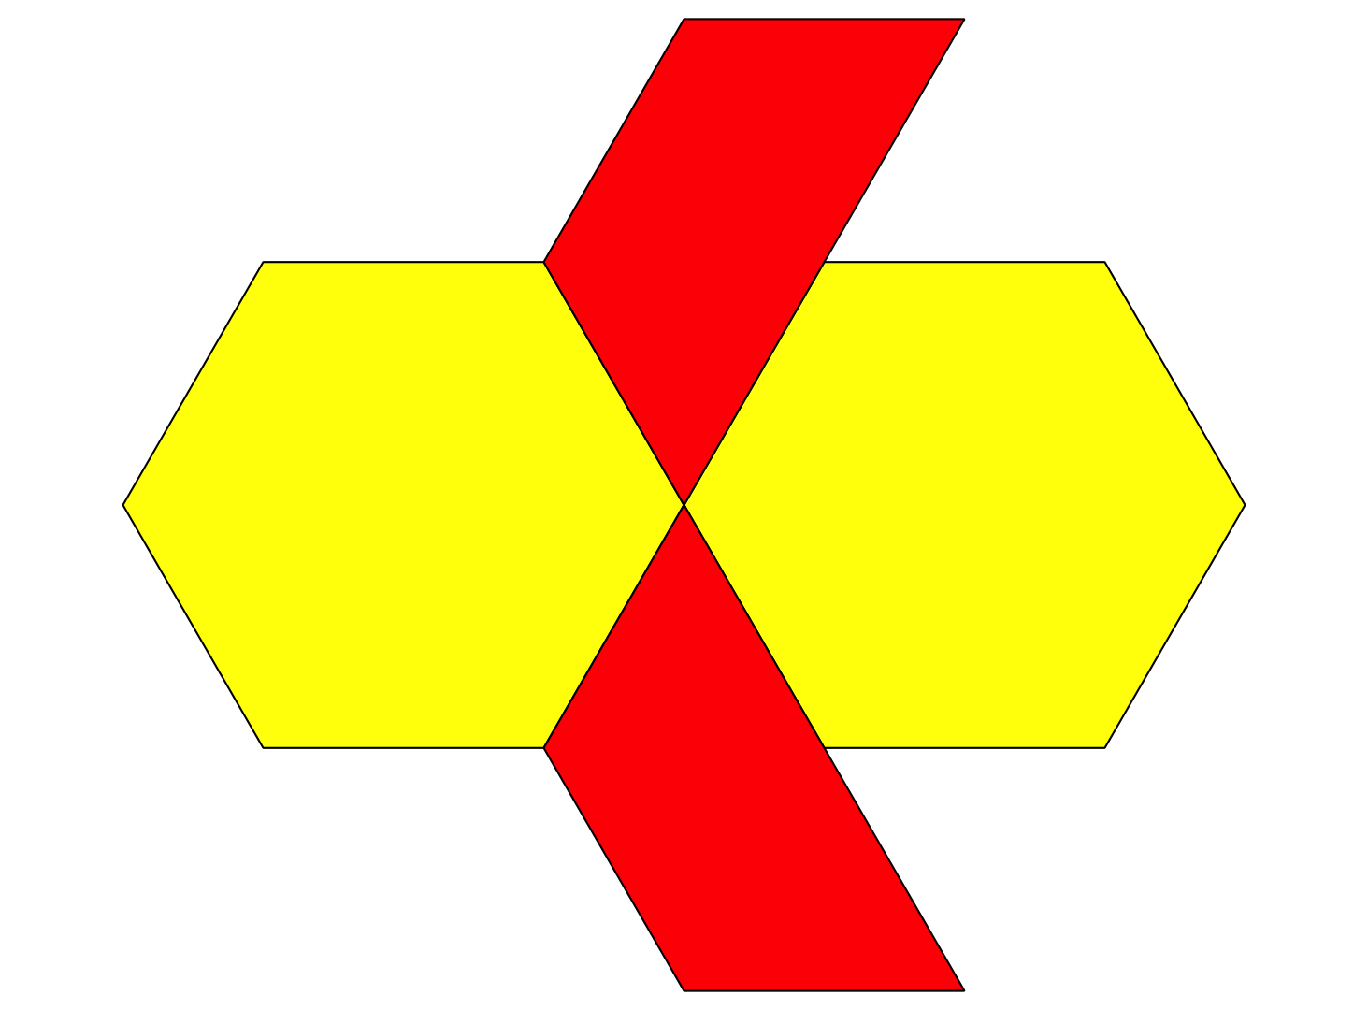
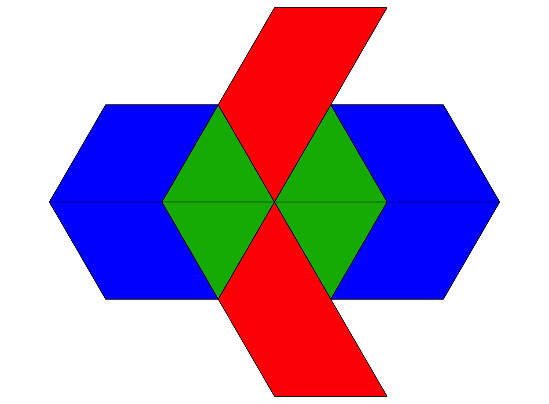

21.1: Pattern Block Puzzles
- Make a puzzle using 4 pattern blocks. Use at least 1 hexagon.
- Trace each pattern block on the blank puzzle paper.
- Trade the puzzle paper with another person in your group.
- Use the pattern blocks to show two different ways to make your partner’s puzzle. Sketch the two ways.
- Puzzle 1
- Puzzle 2
- Share one thing you notice about the puzzles.

21.2: The Pattern Block Store
shape | cost
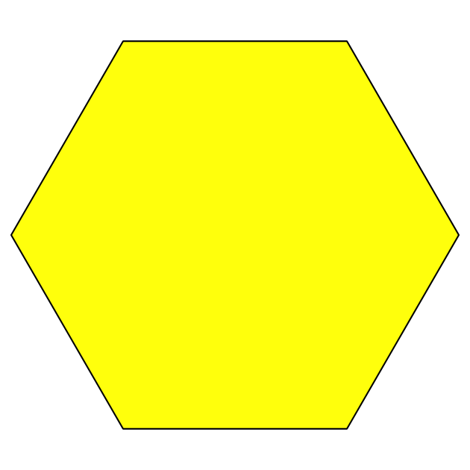
 | 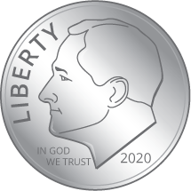
 | 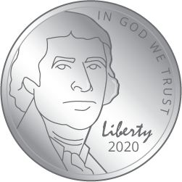
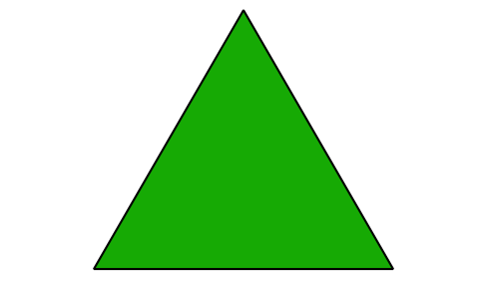
How much would the two puzzles you sketched cost at the Pattern Block Store? Show or explain your reasoning.
- Puzzle 1:
- Puzzle 2:
© CC BY 2021 Illustrative Mathematics®

