Unit 8 Lesson 13: Center Day 2

WU True or False: Two or False (Warm up)

Student Task Statement
Decide if each statement is true or false. Be prepared to explain your reasoning.
- $2+2+2+2=4+4$
- $2+2+2=3+3$
- $2+2+2+2+2+2=5+5$

1 Centers: Choice Time

Student Task Statement
Choose a center.
Write Numbers
Target Numbers
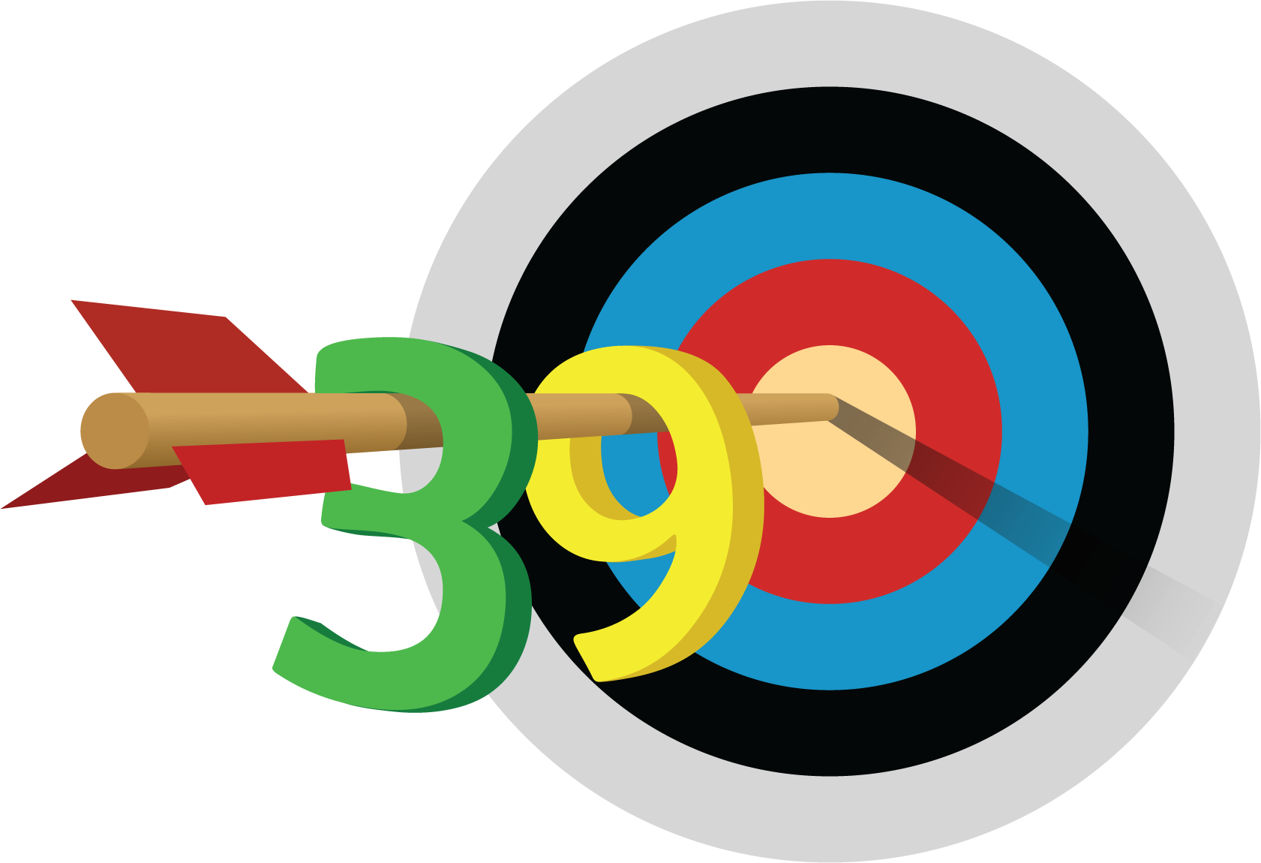
Five in a Row
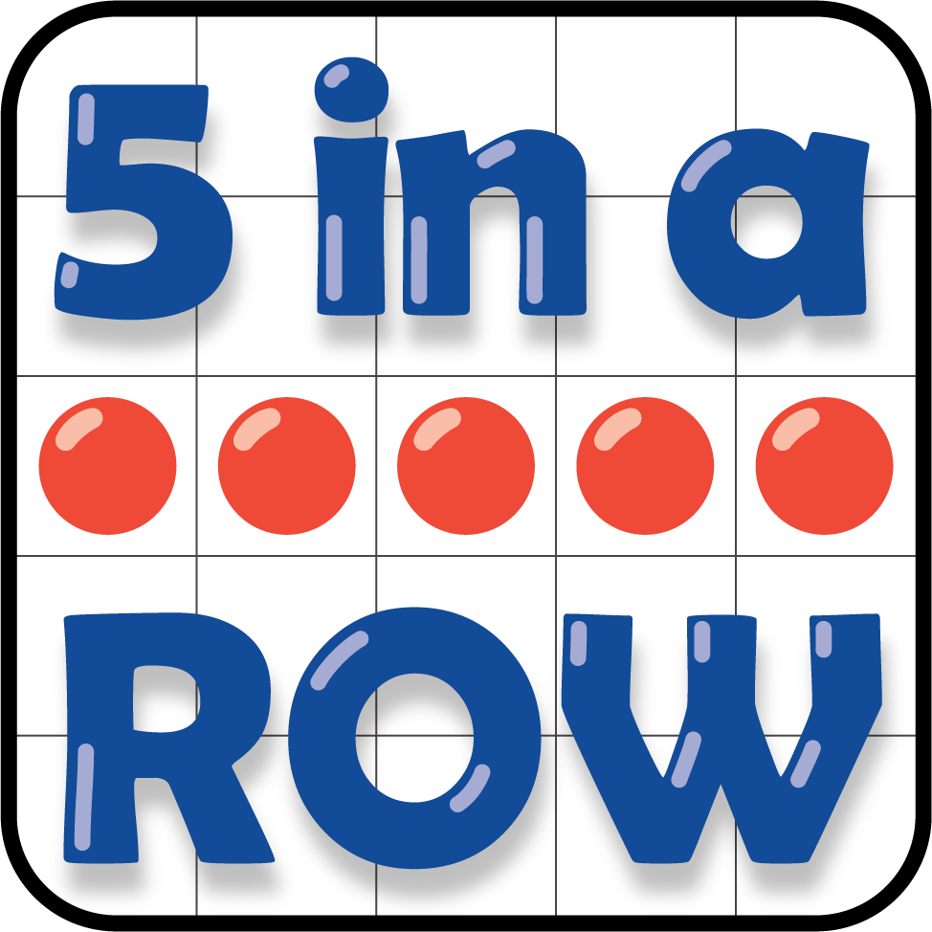
How Close
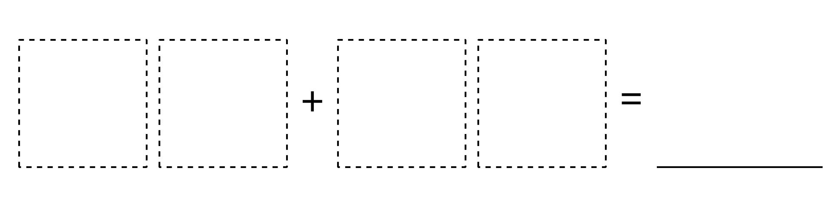
© CC BY 2021 Illustrative Mathematics®

