Lesson 15: Write Times
- Let’s write times in hours and half hours.

Warm-up: True or False: Close To 30
Decide if each statement is true or false.
Be prepared to explain your reasoning.
- $30=30$
- $10+15=15+10$
- $10+10+10=3$

15.1: Count the Minutes
Start at 12.
Count the minutes around the clock until you get to half the clock.
Circle where you stop.
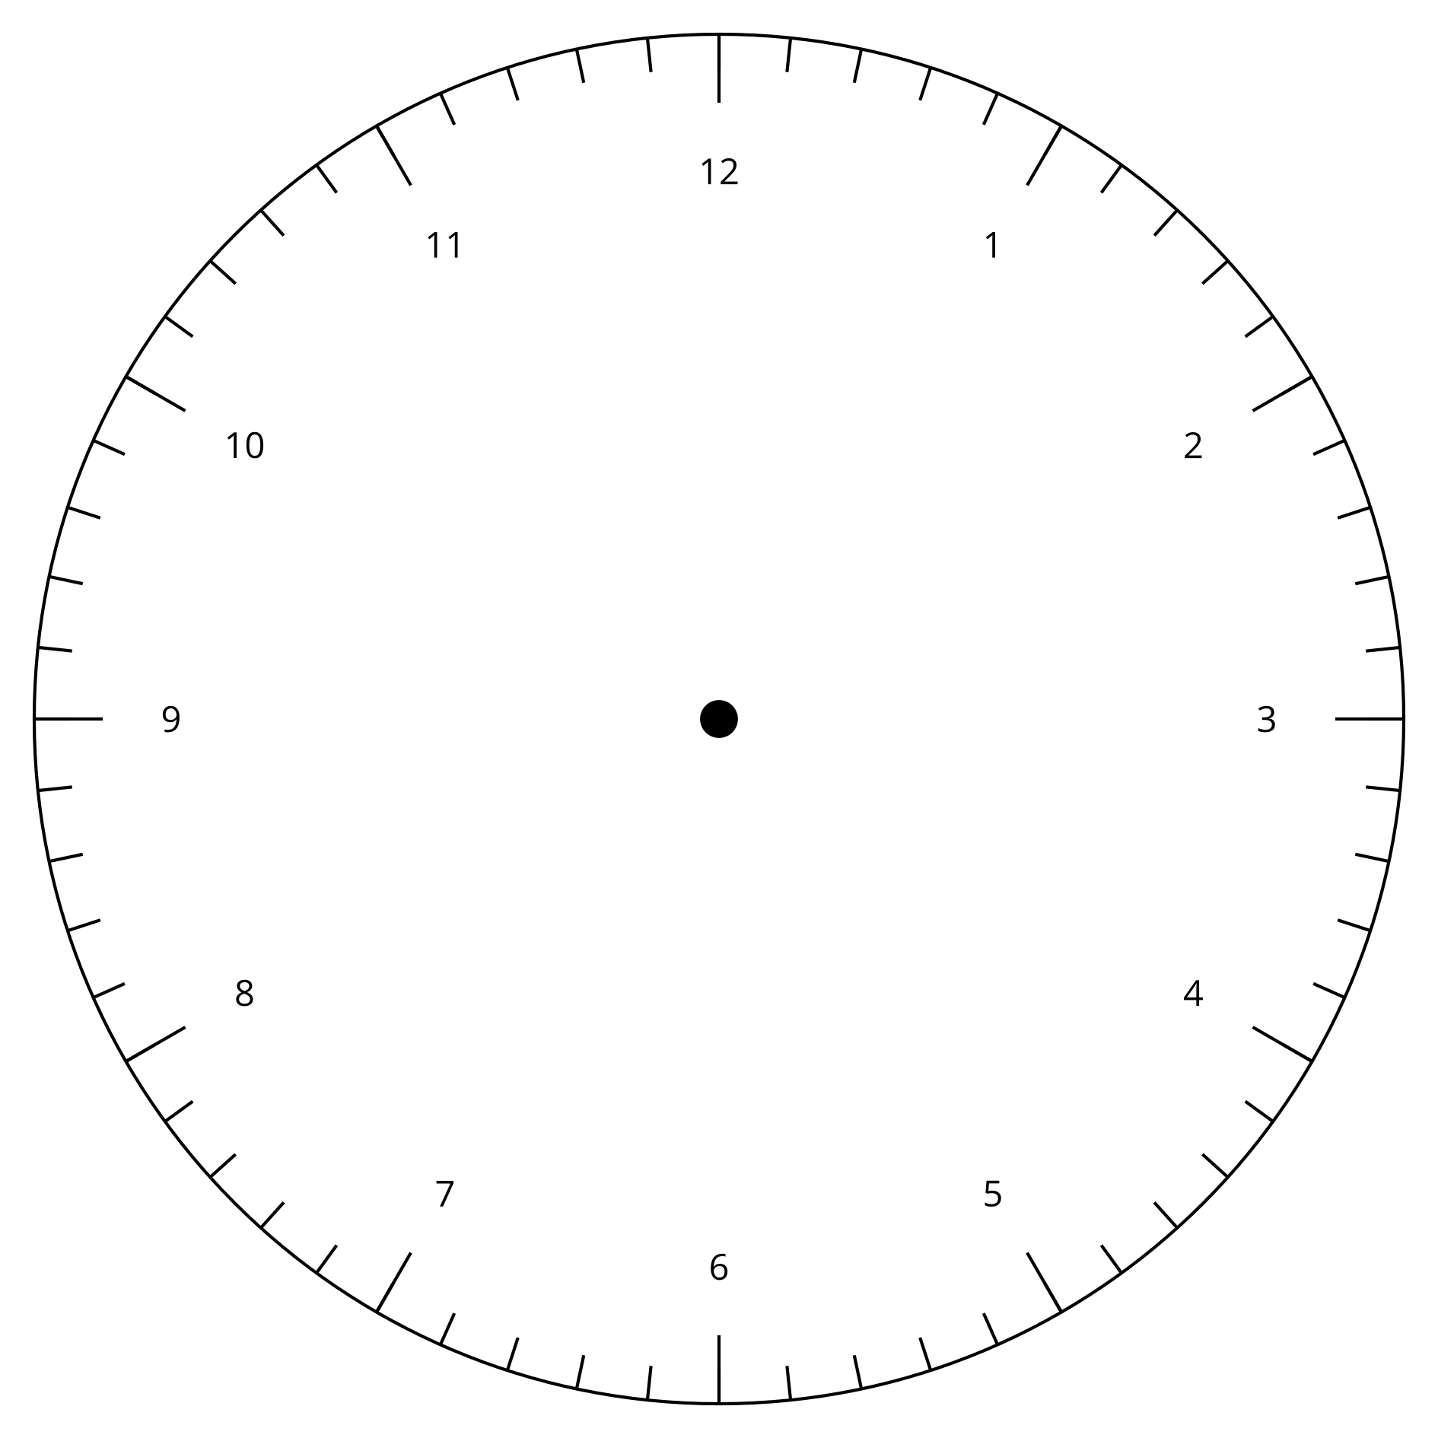
Synthesis:
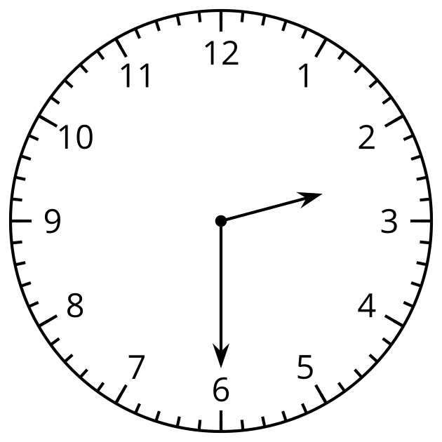
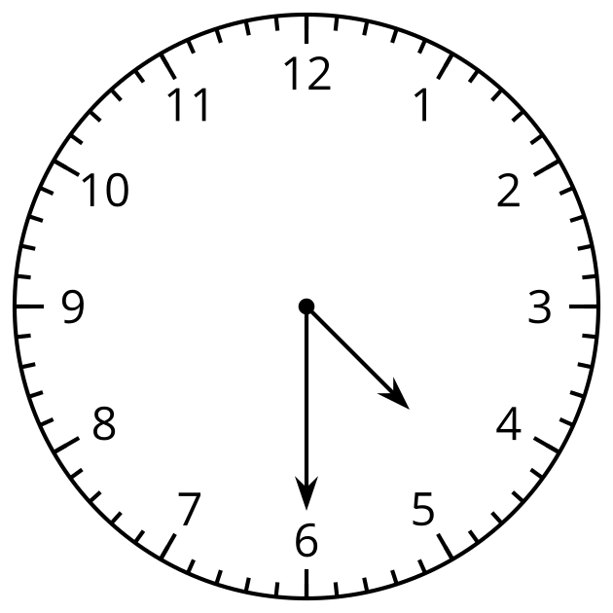

15.2: All the Time in the World
- For each clock, write the time.

  - 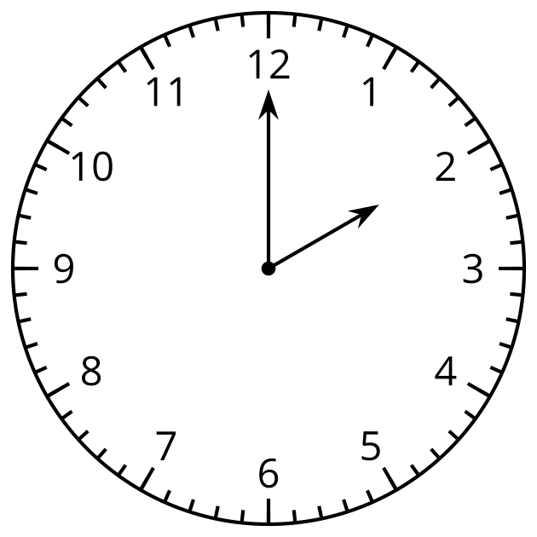

  - 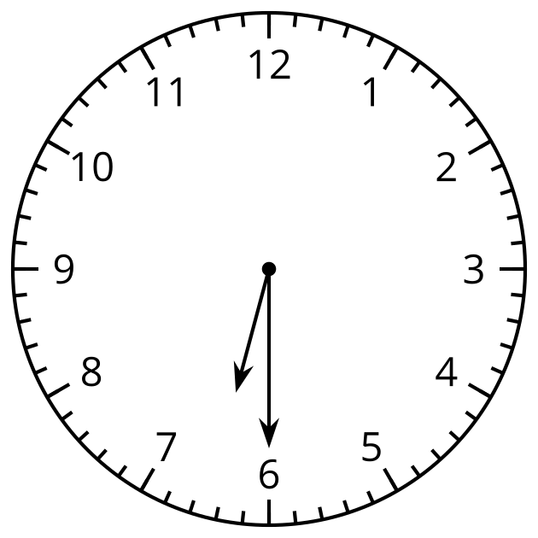

  - 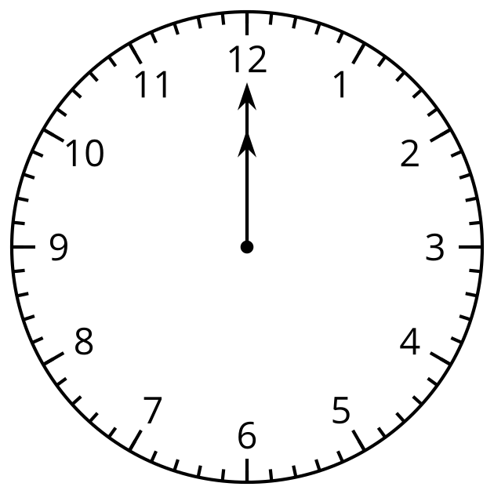

  - 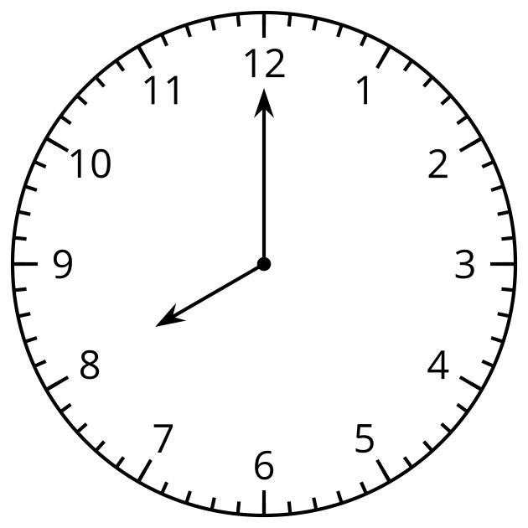
- For each clock, draw the minute hand and write the time.

  - 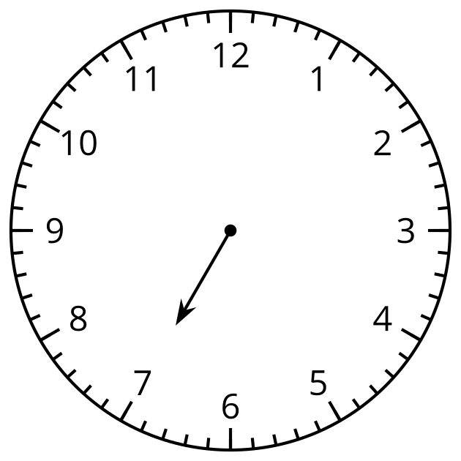

  - 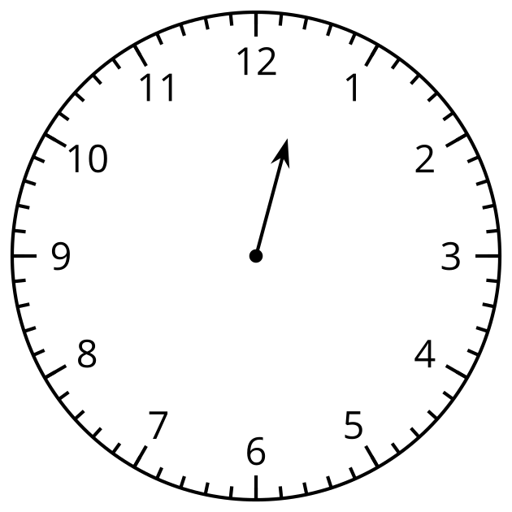

  - 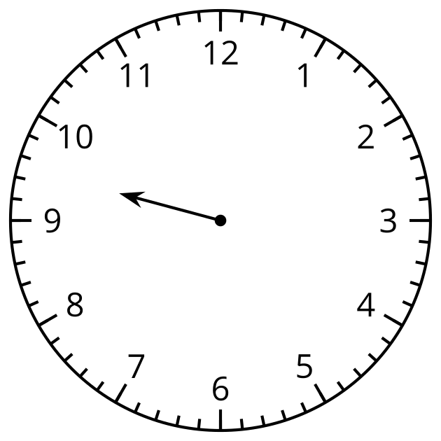

  - 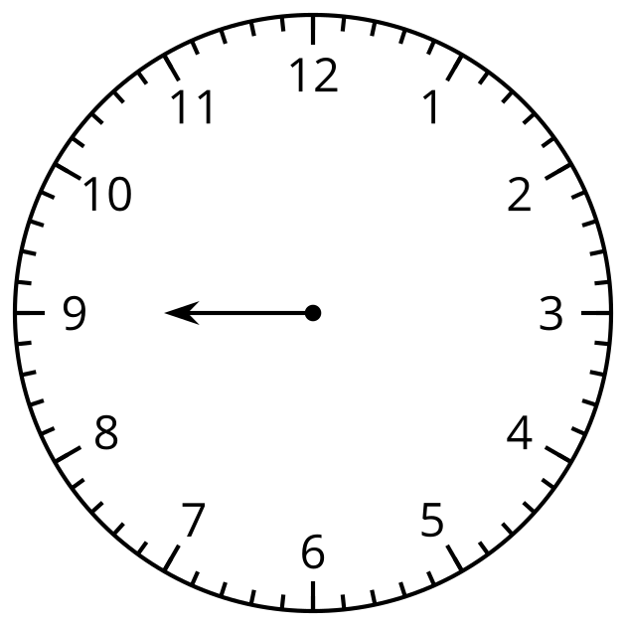

  - 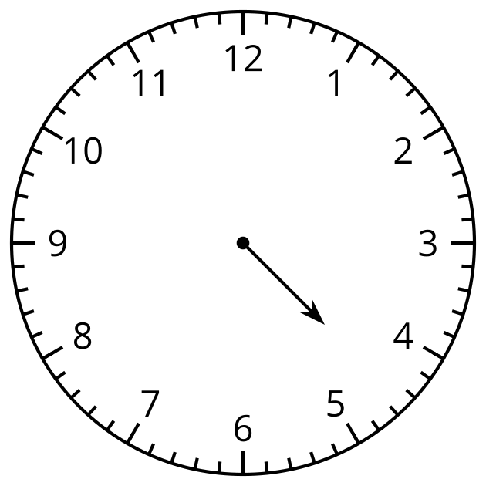
- This clock only has a minute hand.
What time could it be?
Draw an hour hand and write the time.
- 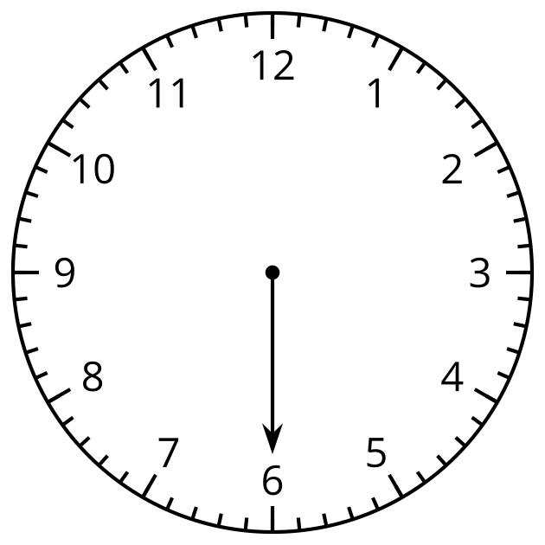

- If you have time: What other times can you show on the clock?
© CC BY 2021 Illustrative Mathematics®

