Unit 2 Lesson 5: Fractions on Number Lines

WU Number Talk: A Number Times Twelve (Warm up)

Student Task Statement
Find the value of each expression mentally.
- $2×12$
- $4×12$
- $8×12$
- $16×12$

1 All Lined Up

Student Task Statement
- These number lines have different labels for the tick mark on the far right.
- 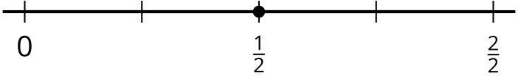
  - Explain to your partner why the tick mark on the far right can be labeled with fractions with different numbers.
  - Label each point with a number it represents (other than $\frac{1}{2}$).
  - Explain to your partner why the fractions you wrote are equivalent.
- Label the point on each number line with a number it represents. Be prepared to explain your reasoning.
- a.
- b.
- c.

2 How Far to Run?

Student Task Statement
- Han and Kiran plan to go for a run after school. They are deciding how far to run.
  - Han says, “Let’s run $\frac{3}{4}$ of a mile. That’s how far I run to my soccer practice.”
  - Kiran says, “I can only run $\frac{9}{12}$ of a mile.”
- Which distance should they run? Explain your reasoning. Use one or more number lines to show your reasoning.
- Tyler wants to join Han and Kiran on their run. He says, “How about we run $\frac{7}{8}$ of a mile?”
- Is the distance Tyler suggested the same as what his friends wanted to run? Explain or show your reasoning.​​​​

Images for Activity Synthesis
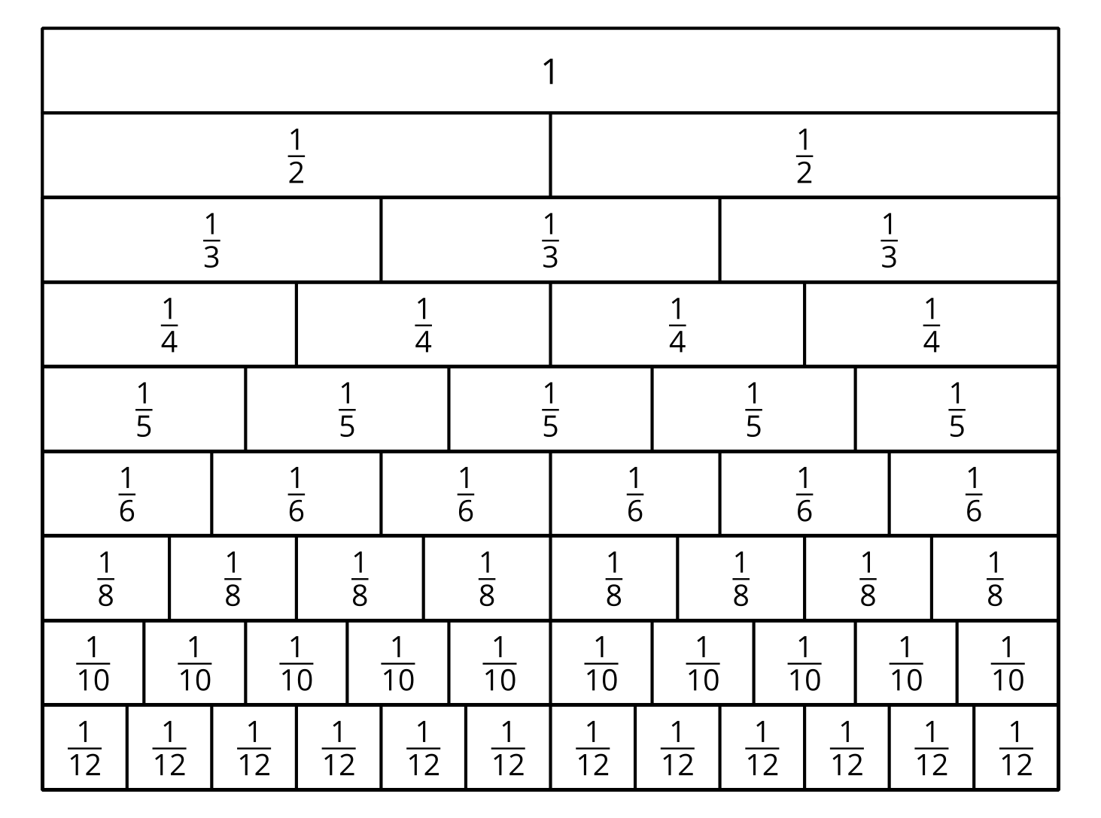
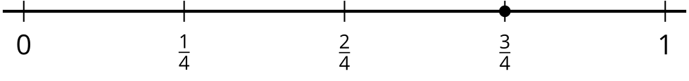
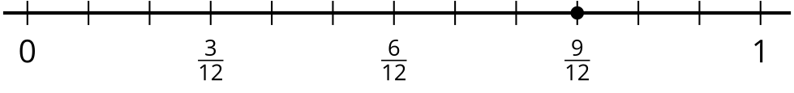
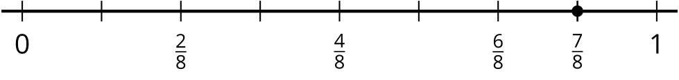
© CC BY 2021 Illustrative Mathematics®

