Unit 7 Lesson 6: Building Polygons (Part 1)

1 True or False: Signed Numbers (Warm up)

Student Task Statement
Decide whether each equation is true or false. Be prepared to explain your reasoning.
$4⋅\left(\text{-}6\right)=\left(\text{-}6\right)+\left(\text{-}6\right)+\left(\text{-}6\right)+\left(\text{-}6\right)$
$\text{-}8⋅4=\left(\text{-}8⋅3\right)+4$
$6⋅\left(\text{-}7\right)=7⋅\left(\text{-}7\right)+7$
$\text{-}10−6=\text{-}10−\left(\text{-}6\right)$

2 What Can You Build?

Student Task Statement
Your teacher will give you some strips of different lengths and fasteners you can use to attach the corners.
- Use the pieces to build several polygons, including at least one triangle and one quadrilateral.
- After you finish building several polygons, select one triangle and one quadrilateral that you have made.
  - Measure all the angles in the two shapes you selected.
  - Using these measurements along with the side lengths as marked, draw your triangle and quadrilateral as accurately as possible.

3 Building Diego’s and Jada’s Shapes

Student Task Statement
- Diego built a quadrilateral using side lengths of 4 in, 5 in, 6 in, and 9 in.
  - Build such a shape.
  - Is your shape an identical copy of Diego’s shape? Explain your reasoning.
- Jada built a triangle using side lengths of 4 in, 5 in, and 8 in.
  - Build such a shape.
  - Is your shape an identical copy of Jada’s shape? Explain your reasoning.

Activity Synthesis
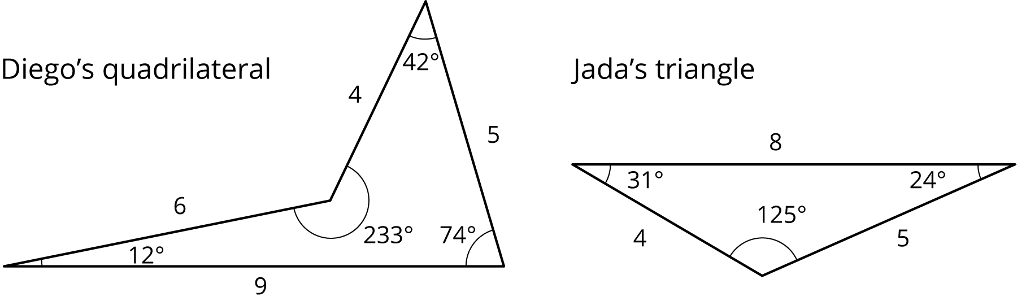

4 Building Han’s Shape (Optional)

Student Task Statement
Han built a polygon using side lengths of 3 in, 4 in, and 9 in.
- Build such a shape.
- What do you notice?
© CC BY Open Up Resources. Adaptations CC BY IM.

