Lesson 3 Practice Problems
- Find the area of each shaded region. Show your reasoning.
- 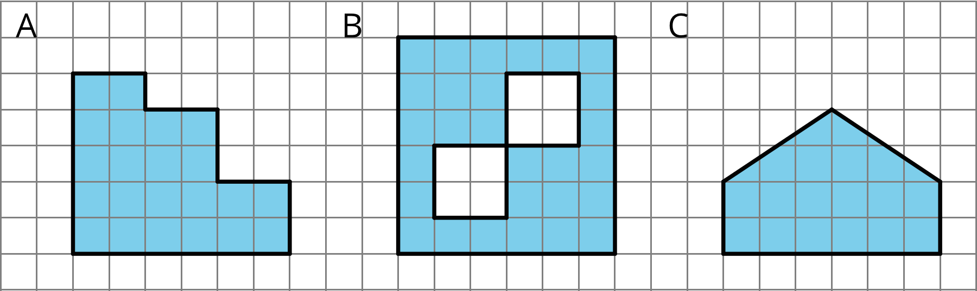

- Find the area of each shaded region. Show or explain your reasoning.
- 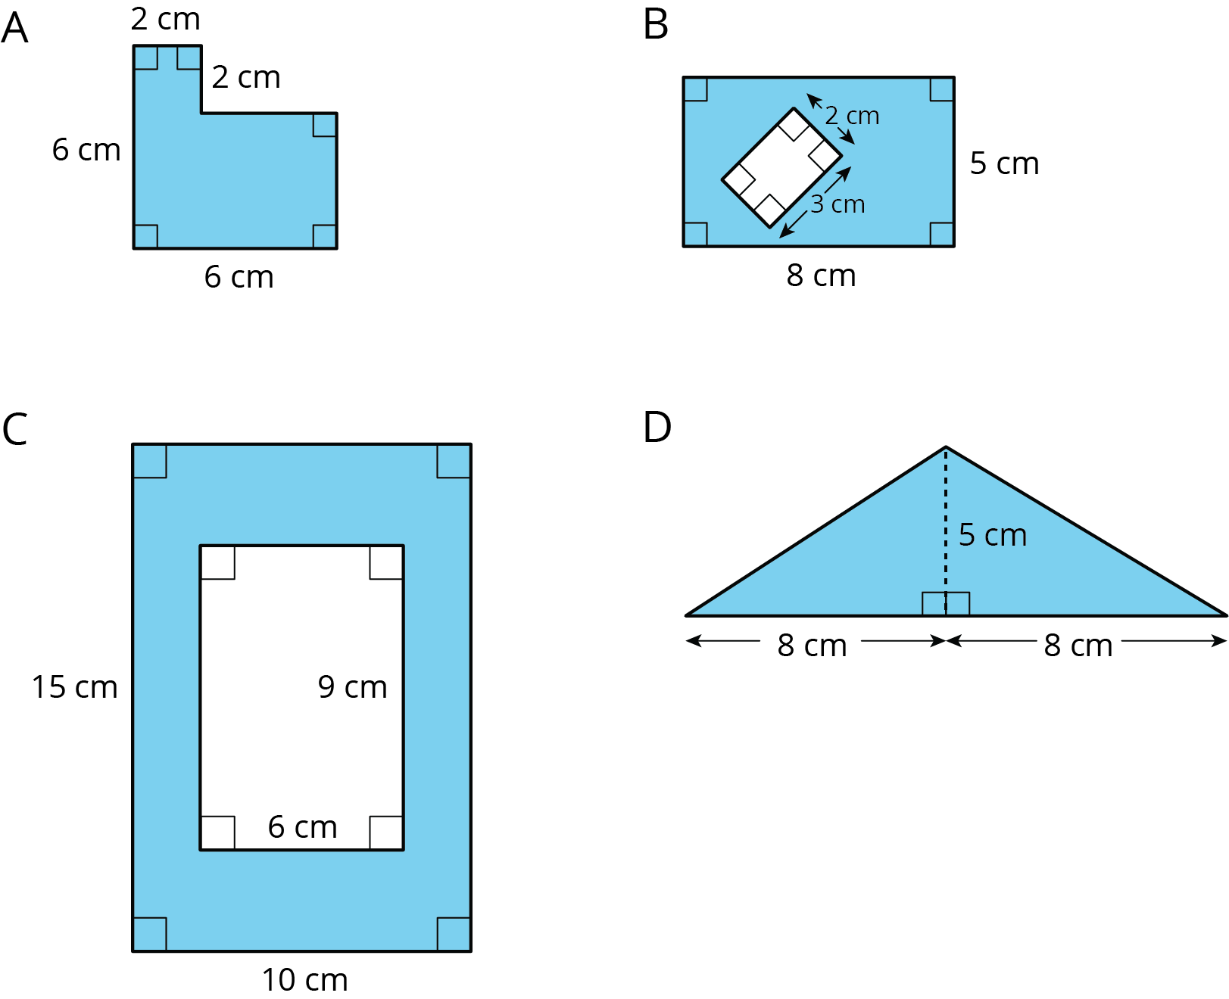
- Two plots of land have very different shapes. Noah said that both plots of land have the same area.
- 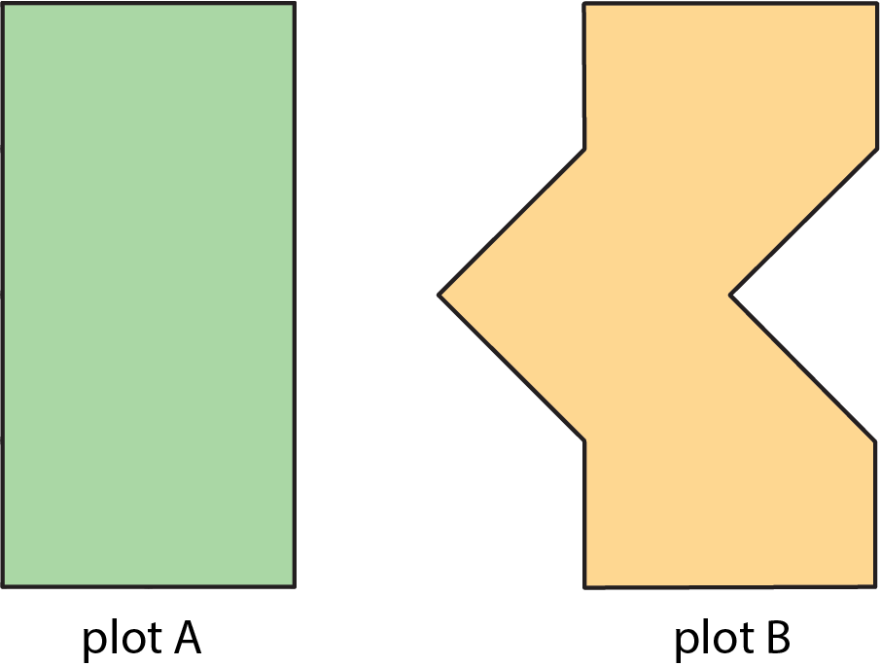
- Do you agree with Noah? Explain your reasoning.
- A homeowner is deciding on the size of tiles to use to fully tile a rectangular wall in her bathroom that is 80 inches by 40 inches. The tiles are squares and come in three side lengths: 8 inches, 4 inches, and 2 inches. State if you agree with each statement about the tiles. Explain your reasoning.
  - Regardless of the size she chooses, she will need the same number of tiles.
  - Regardless of the size she chooses, the area of the wall that is being tiled is the same.
  - She will need two 2-inch tiles to cover the same area as one 4-inch tile.
  - She will need four 4-inch tiles to cover the same area as one 8-inch tile.
  - If she chooses the 8-inch tiles, she will need a quarter as many tiles as she would with 2-inch tiles.
- (From Unit 1, Lesson 2.)
© CC BY Open Up Resources. Adaptations CC BY IM.

