Lesson 14: Compose with Solid Shapes
- Let’s build with solid shapes.

Warm-up: Number Talk: Subtract 1 and 2
Find the value of each expression.
- $3−1$
- $3−2$
- $4−2$
- $5−1$

14.3: Introduce Match Mine, Solid Shapes
Choose a center.
Build Shapes
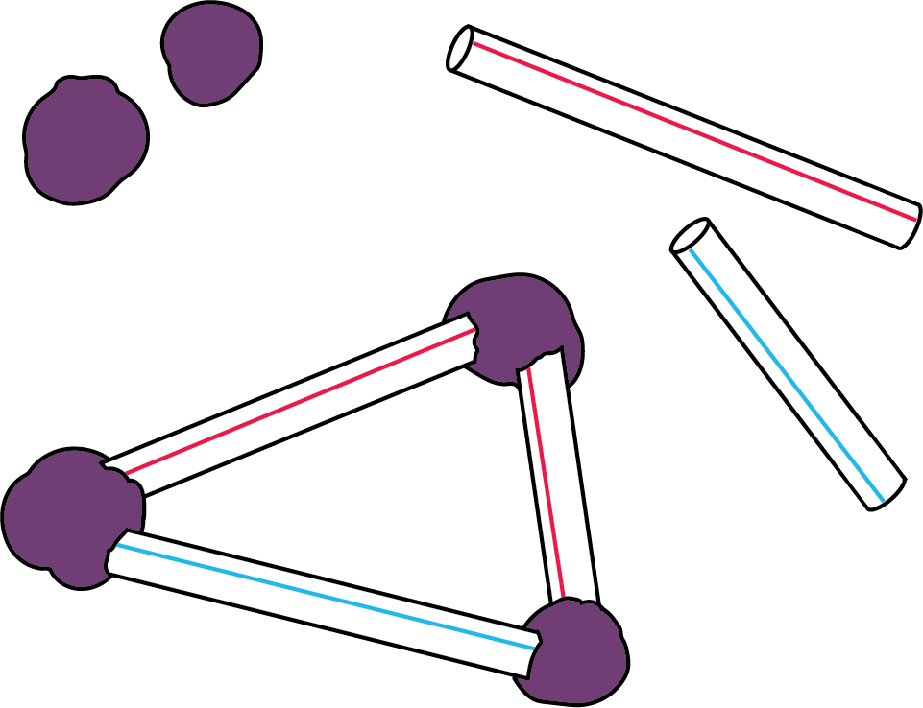
Geoblocks
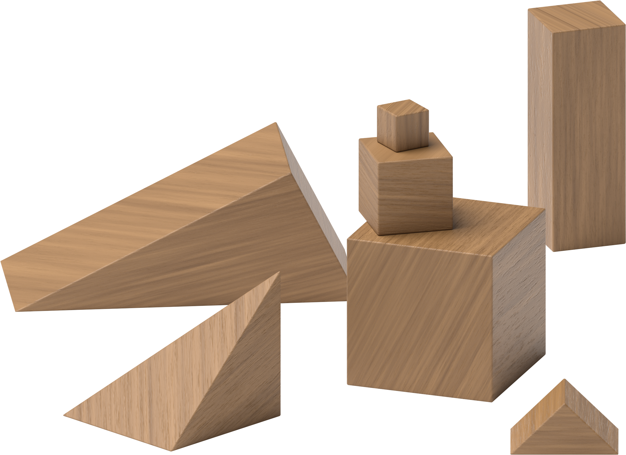
Counting Collections
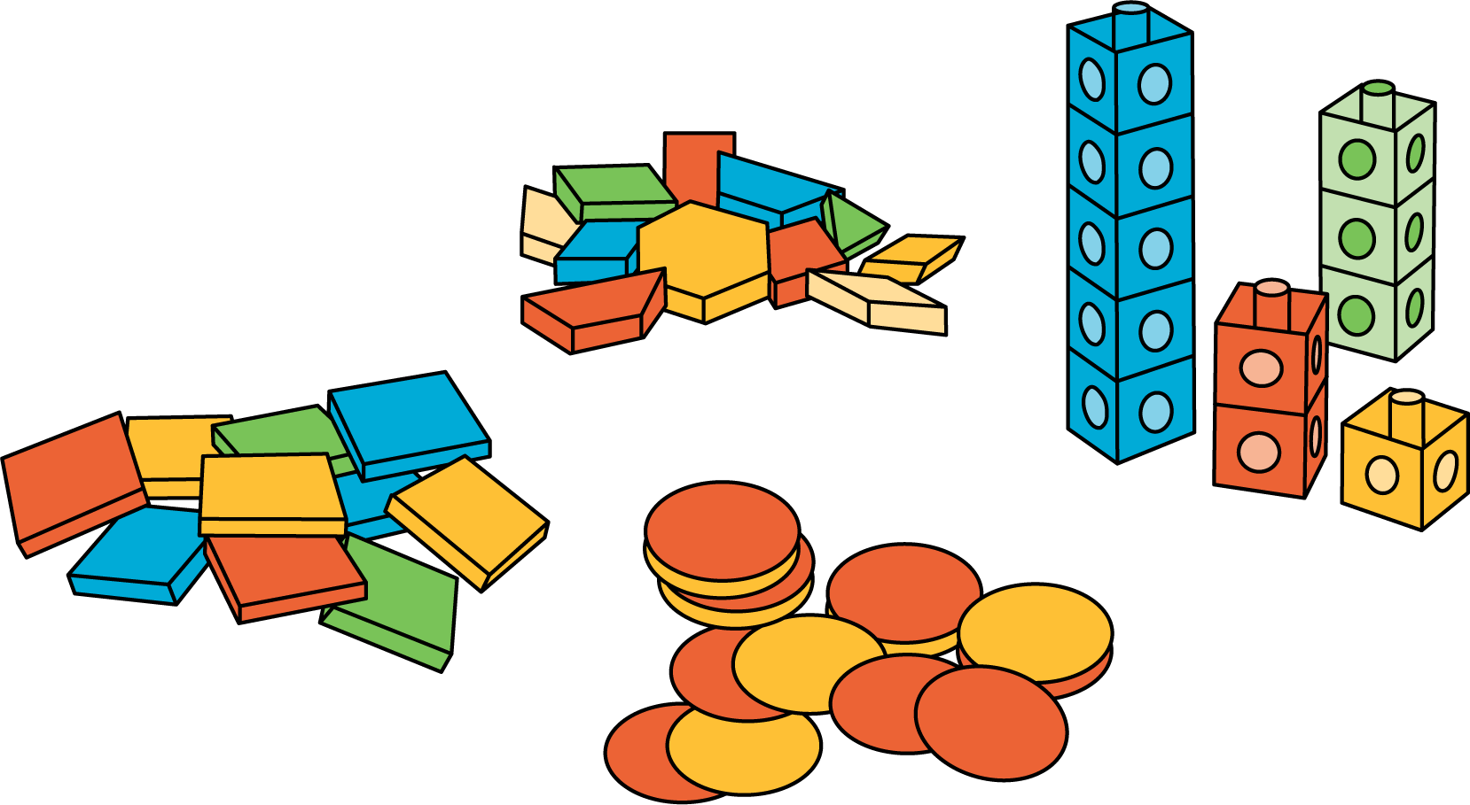
Match Mine
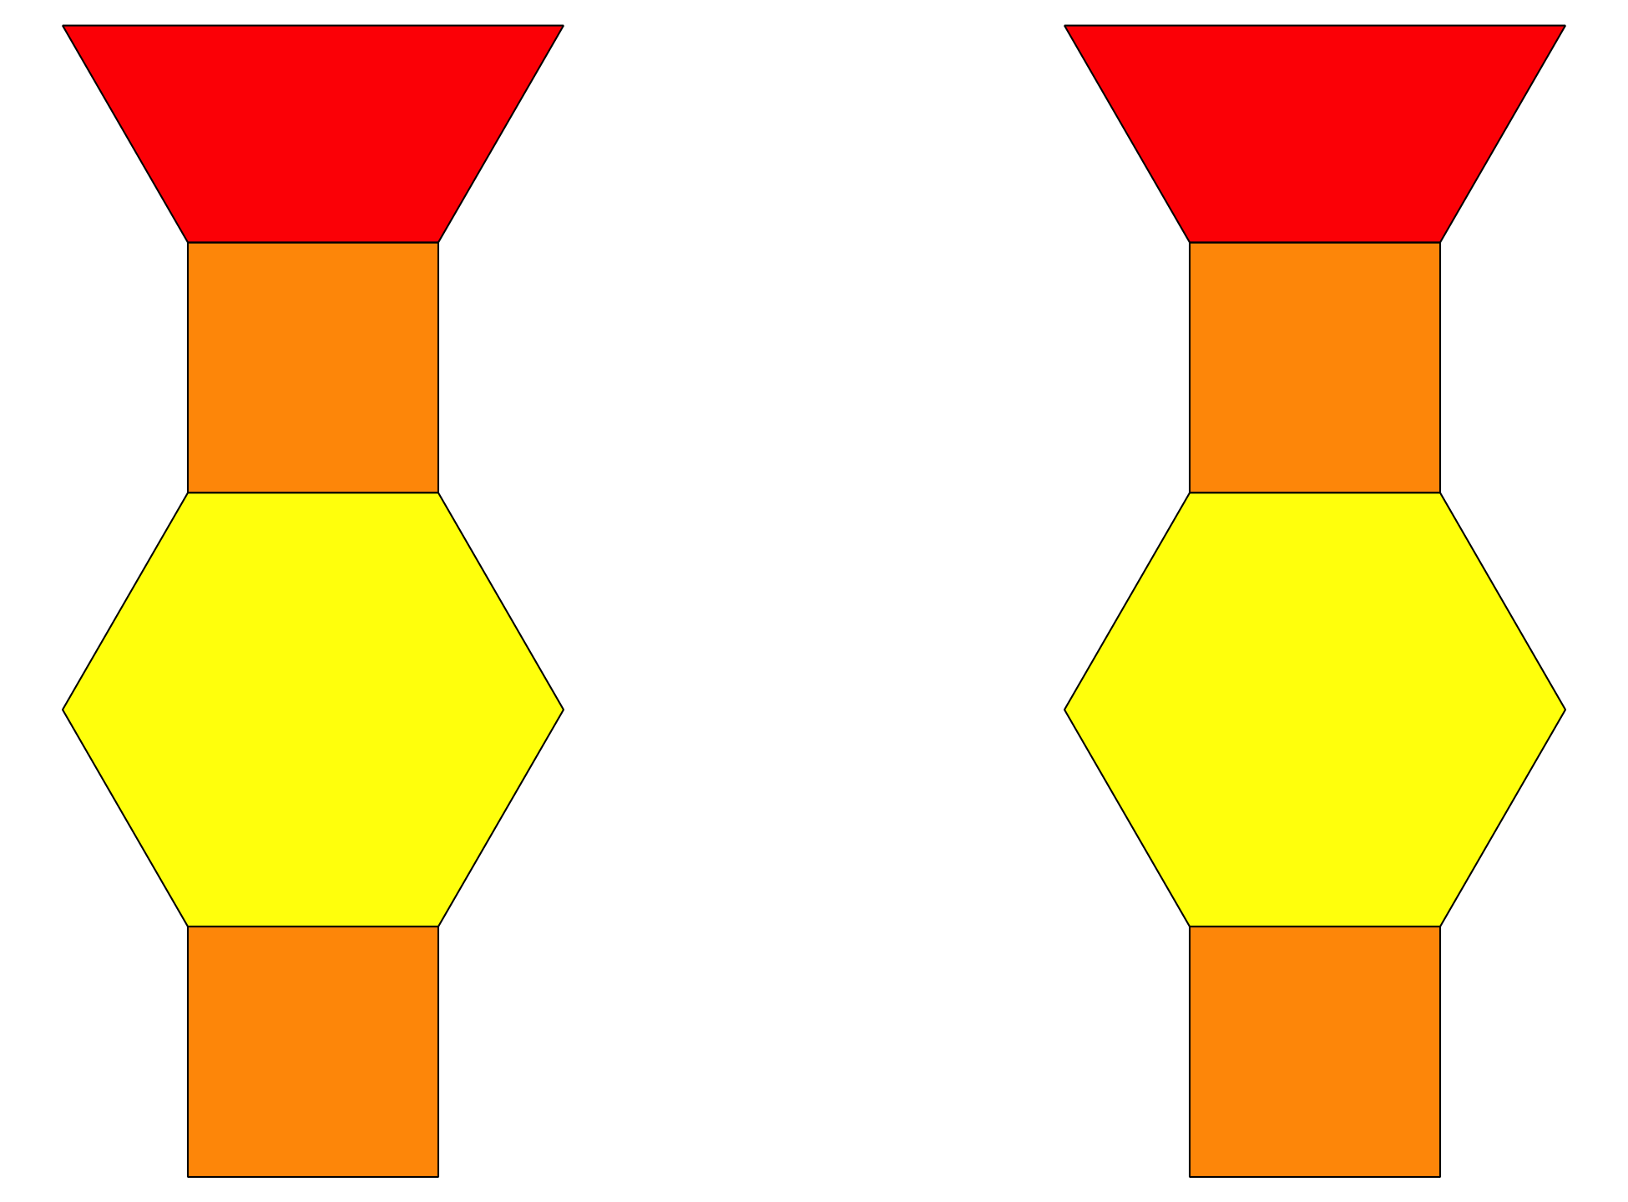
Shake and Spill
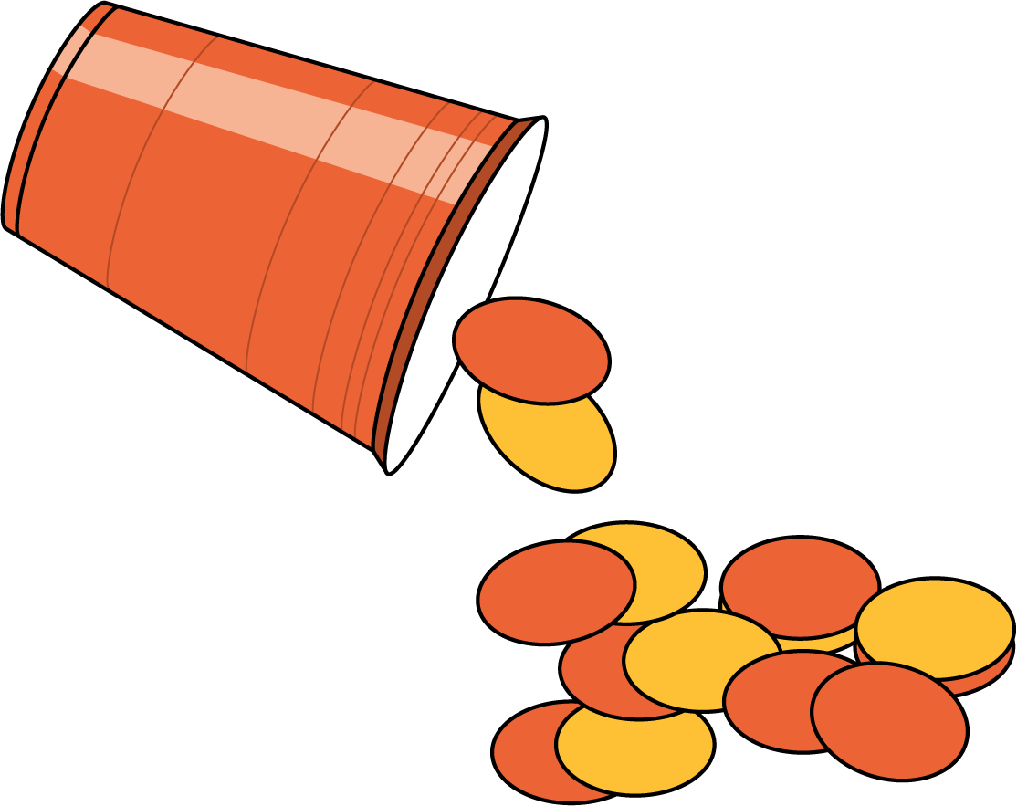
© CC BY 2021 Illustrative Mathematics®

