Unit 1 Lesson 7: Collect and Represent Data

WU Notice and Wonder: Let’s Get There (Warm up)

Student Task Statement
What do you notice? What do you wonder?
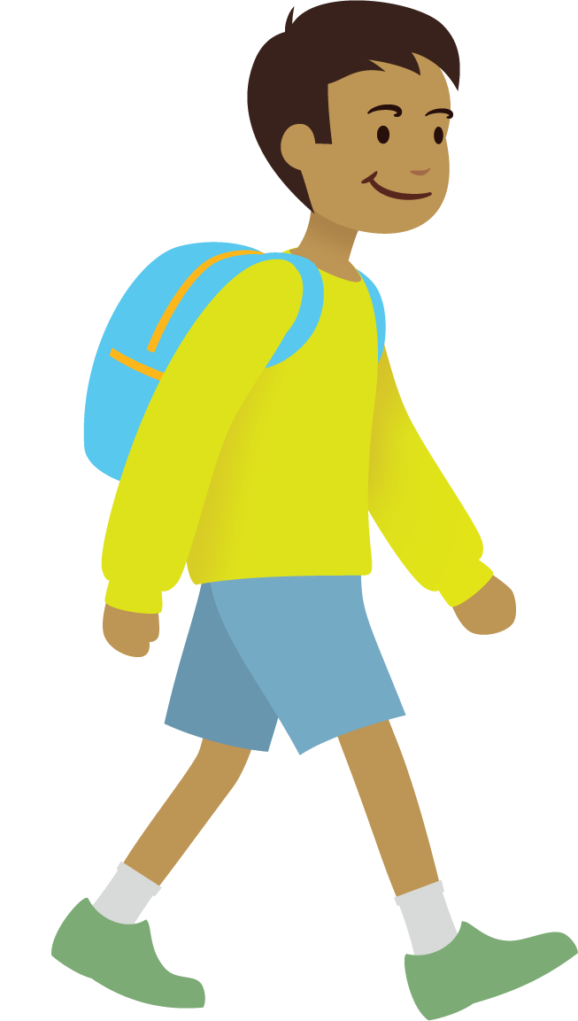
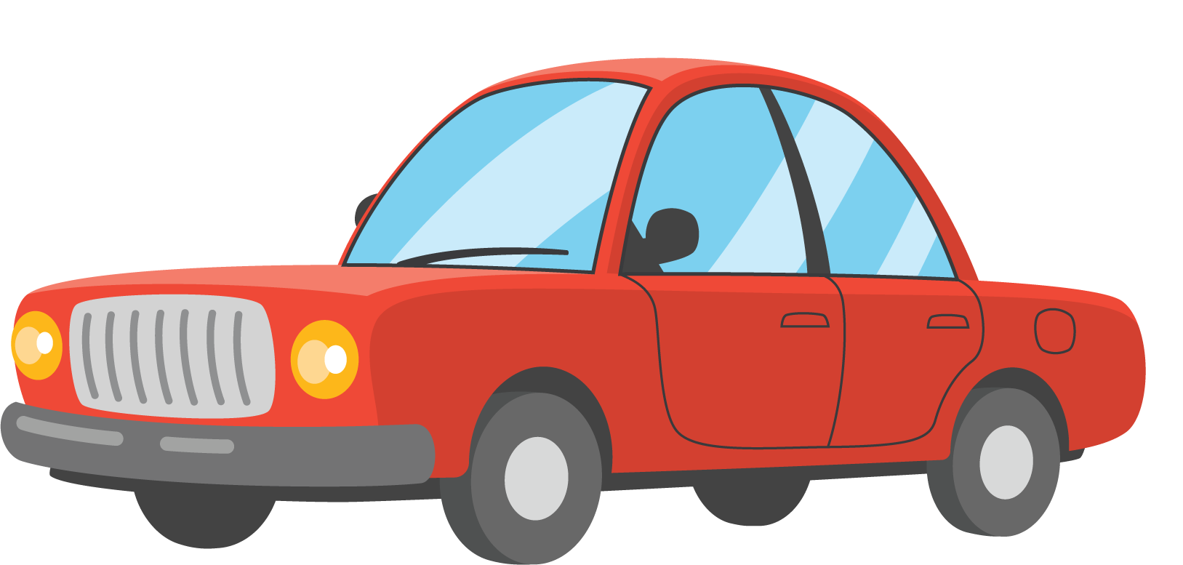
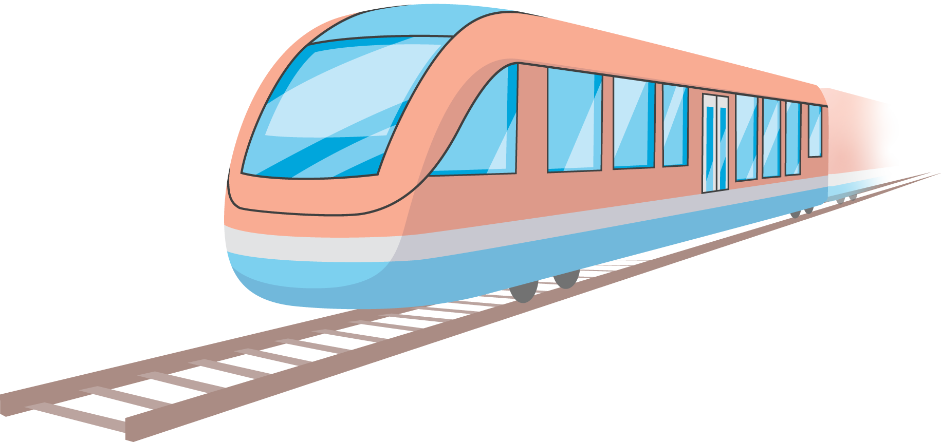

1 How Do We Get to School?

Student Task Statement
Choose the picture that shows how you got to school today.
Write your name on the picture.

2 Visual Representations of Data

Student Task Statement
Organize and represent the data about how our class gets to school.
© CC BY 2021 Illustrative Mathematics®

