Lesson 16: Hard Times
- Let’s show time in hours and half-hours.

Warm-up: Number Talk: Tens and Ones
Find the value of each expression mentally.
- $8+32$
- $8+33$
- $8+38$
- $8+48$

16.2: What’s the Time, Again?

- 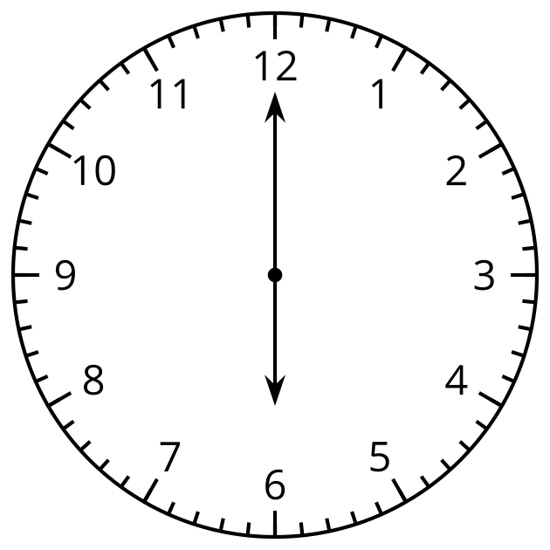
- Diego says this clock shows 6:00.
- Priya says the clock shows 12:30.
- Who do you agree with? Why?

Synthesis:
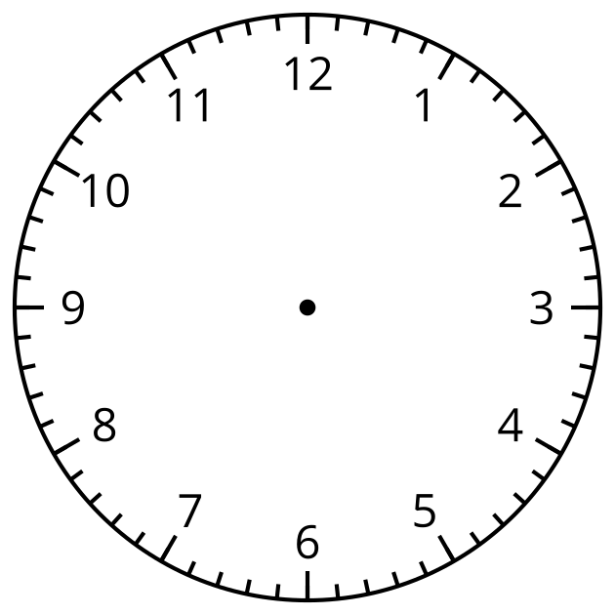
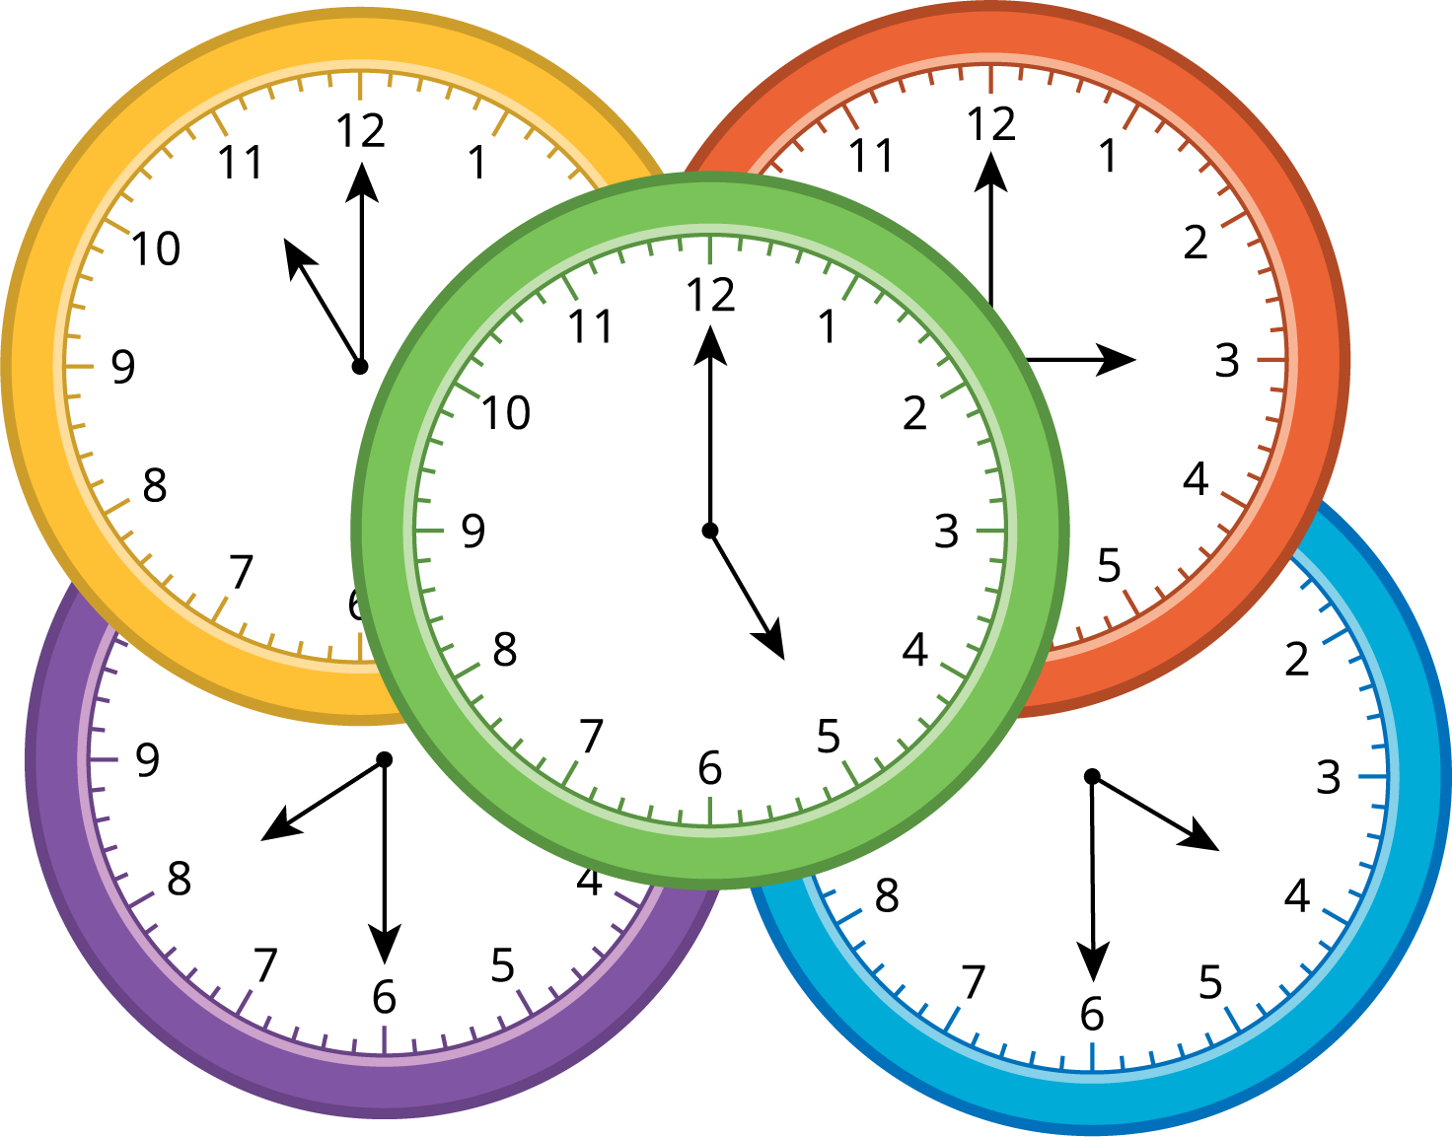

16.3: Sunday Schedule
Fill in the blanks to show your ideal Sunday schedule.
Time
Activity
Clock
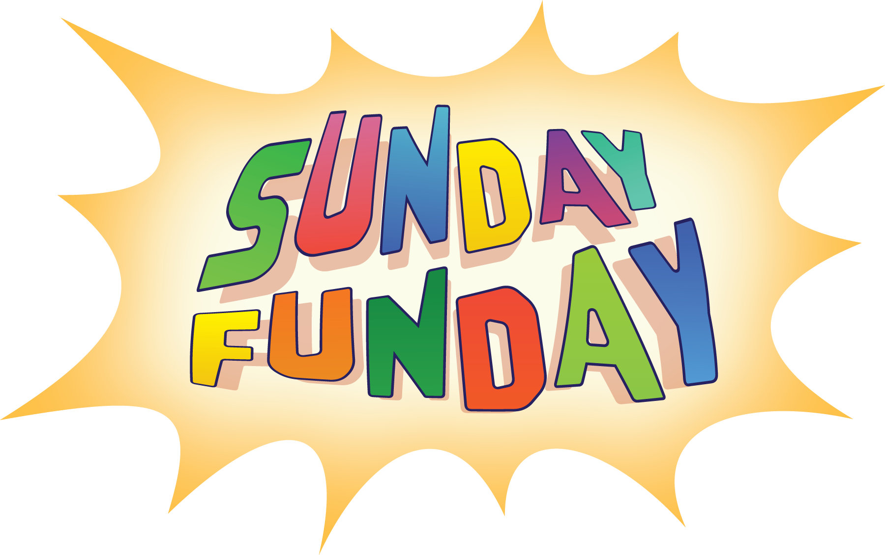

Section Summary
Section Summary
We learned how to tell time to the hour and half hour.
We learned when the minute hand points to the 12, the hour hand points to a number. We say “___ o’clock.”
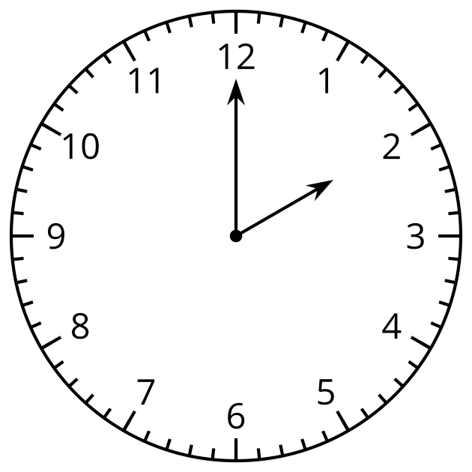
It is 2 o’clock.
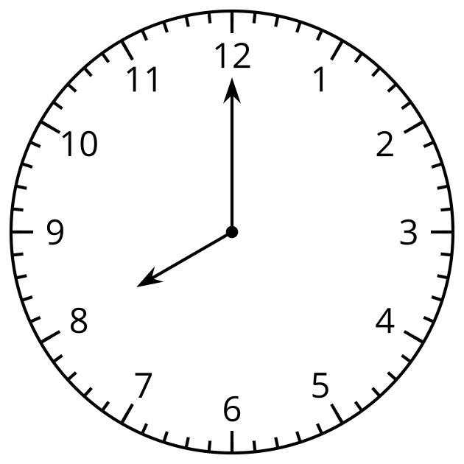
It is 8 o’clock.
We learned when the minute hand has gone half way around the clock and points to the 6, the hour hand points halfway between 2 numbers. We say “half past ___.”
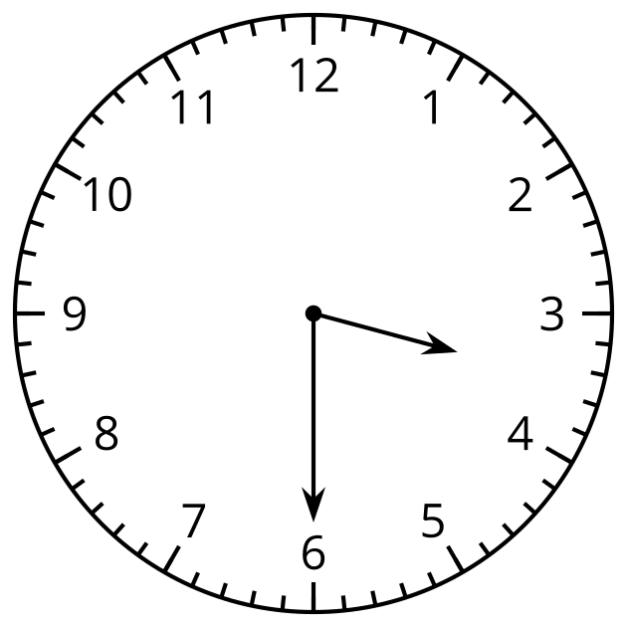
It is half past 3.
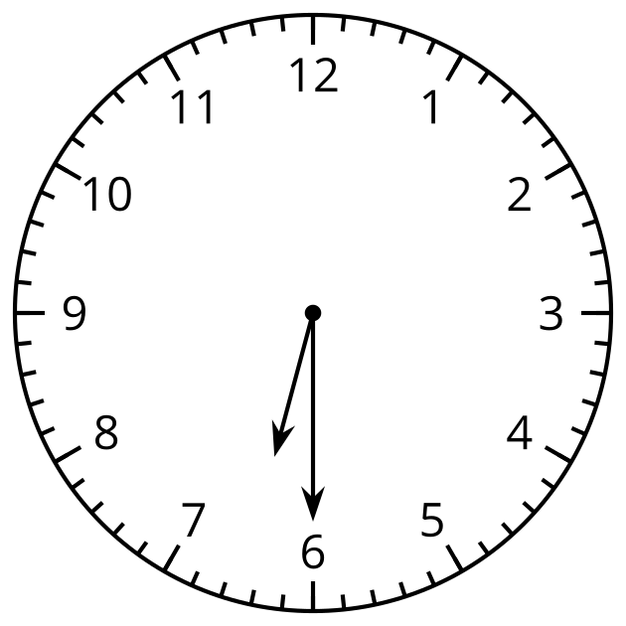
It is half past 6.
We learned how to write time.
It is 2:00.
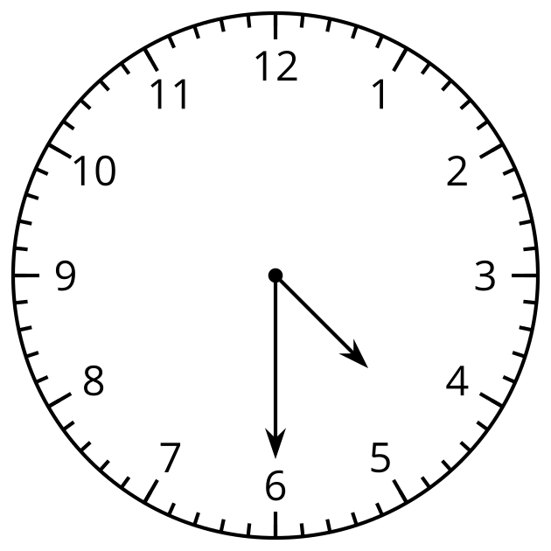
It is 4:30.
© CC BY 2021 Illustrative Mathematics®

