Unit 2 Lesson 6: Relate Fractions to Benchmarks

WU Notice and Wonder: A Point on a Number Line (Warm up)

Student Task Statement
What do you notice? What do you wonder?

1 Greater Than or Less Than 1?

Student Task Statement
For each diagram:
a. Name a fraction the point represents.
b. Is that fraction greater than or less than 1?
c. How far is it from 1?

- ​​​​​​
  - 00000
  - 00000
  - 00000

- ​​​​​​
  - 00000
  - 00000
  - 00000

- ​​​​​​
  - 00000
  - 00000
  - 00000

- ​​​​​​
  - 00000
  - 00000
  - 00000

2 Card Sort: Where Do They Belong? (Optional)

Student Task Statement
Sort the cards from your teacher into three groups: less than $\frac{1}{2}$, equal to $\frac{1}{2}$, and greater than $\frac{1}{2}$. Be prepared to explain how you know.
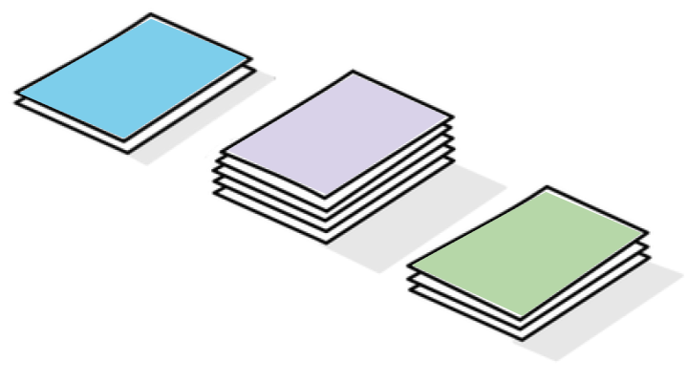
Record your sorting results here after you have discussed them with another group.
less than $\frac{1}{2}$ | equal to $\frac{1}{2}$ | greater than $\frac{1}{2}$
Complete the following sentences after class discussion:
- A fraction is less than $\frac{1}{2}$ when . . .
- A fraction is greater than $\frac{1}{2}$ when . . .
- A fraction is between $\frac{1}{2}$ and 1 when . . .

3 Greater Than or Less Than $\frac{1}{2}$?

Student Task Statement
For each diagram:
a. Name a fraction the point represents.
b. Is that fraction greater than or less than $\frac{1}{2}$?
c. How far is it from $\frac{1}{2}$?

  - 00000
  - 00000
  - 00000

  - 00000
  - 00000
  - 00000

  - 00000
  - 00000
  - 00000

  - 00000
  - 00000
  - 00000

Images for Activity Synthesis
© CC BY 2021 Illustrative Mathematics®

