Lesson 2: Ways to Look at Triangles
- Let’s sort and analyze triangles.

Warm-up: Number Talk: Sums and Products
Find the value of each expression mentally.
- $12+12+75$
- $12\frac{1}{2}+12\frac{1}{2}+75$
- $\left(2×12\frac{1}{2}\right)+\left(4×12\frac{1}{2}\right)$
- $7×12\frac{1}{2}$

2.1: Triangle Hunt
- From the set of triangle cards, find all the triangles that have each attribute. Record their letter names here.
- 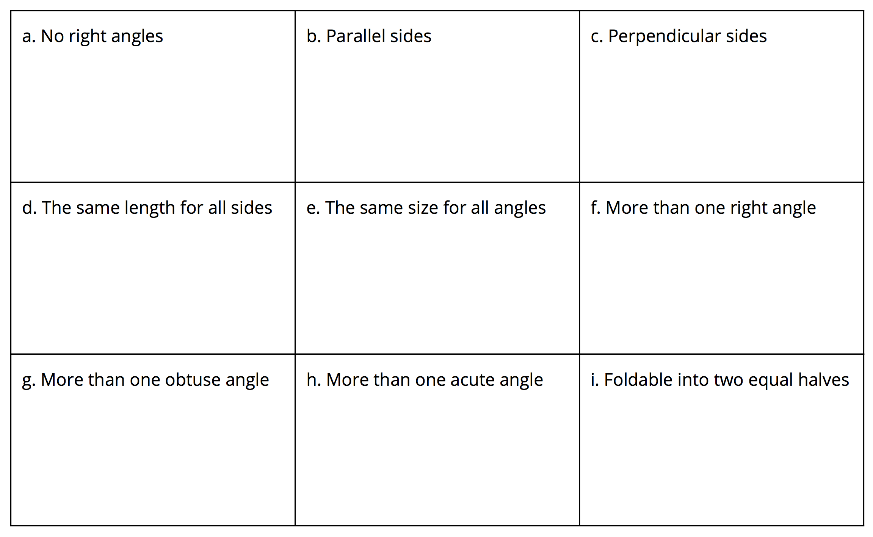
- Choose one sentence to complete based on your work.
  - I noticed that some triangles . . .
  - I noticed that all triangles . . .
  - I noticed that no triangles . . .

2.2: The Right Kind of Triangle
- Identify all shapes that are right triangles. For each right triangle, mark the right angle with a small square.
- 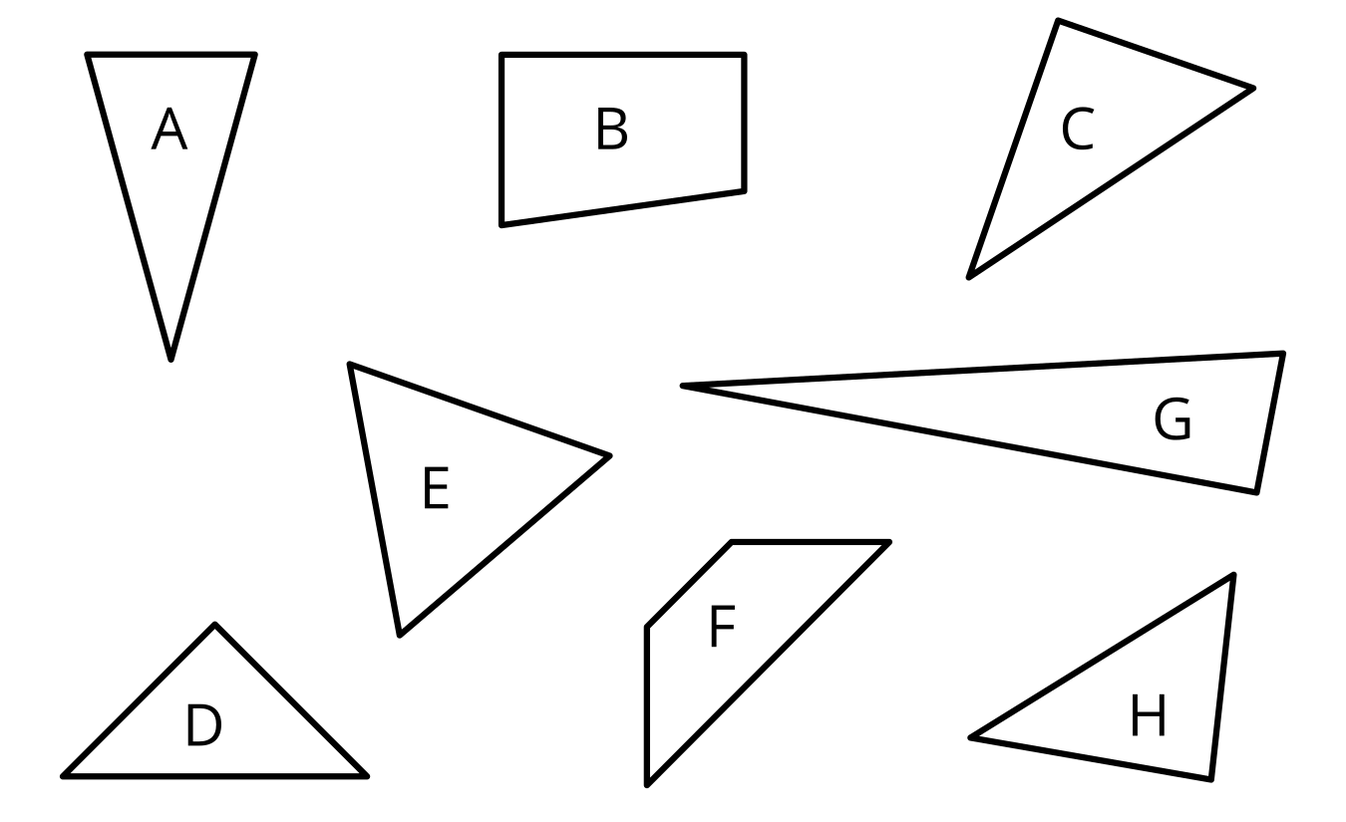
- Explain why the other shapes are not right triangles.
© CC BY 2021 Illustrative Mathematics®

