Unit 3 Lesson 2 Cumulative Practice Problems
- Select all stories that the tape diagram can represent.
- 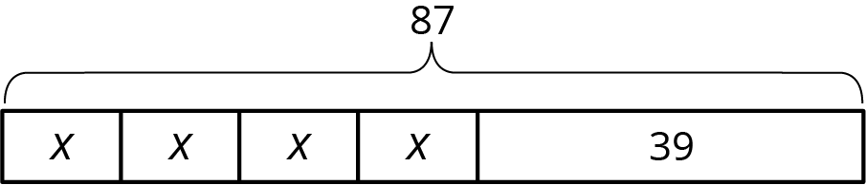
  - There are 87 children and 39 adults at a show. The seating in the theater is split into 4 equal sections.
  - There are 87 first graders in after-care. After 39 students are picked up, the teacher put the remaining students into 4 groups for an activity.
  - Lin buys a pack of 87 pencils. She gives 39 to her teacher and shared the remaining pencils between herself and 3 friends.
  - Andre buys 4 packs of paper clips with 39 paper clips in each. Then he gives 87 paper clips to his teacher.
  - Diego’s family spends $87 on 4 tickets to the fair and a $39 dinner.
- Andre wants to save $40 to buy a gift for his dad. Andre’s neighbor will pay him weekly to mow the lawn, but Andre always gives a $2 donation to the food bank in weeks when he earns money. Andre calculates that it will take him 5 weeks to earn the money for his dad’s gift. He draws a tape diagram to represent the situation.
- 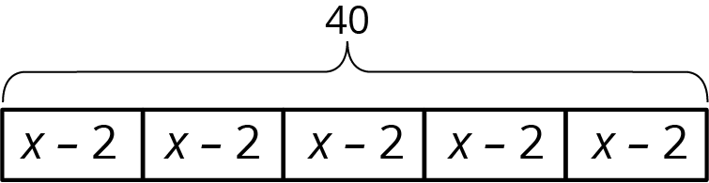
  - Explain how the parts of the tape diagram represent the story.
  - How much does Andre’s neighbor pay him each week to mow the lawn?
- Which of these scales is equivalent to the scale 1 cm to 5 km? Select all that apply.
  - 3 cm to 15 km
  - 1 mm to 150 km
  - 5 cm to 1 km
  - 5 mm to 2.5 km
  - 1 mm to 500 m
- (From Unit 2, Lesson 7.)
- Kiran and Mai are standing at one corner of a rectangular field of grass looking at the diagonally opposite corner. Kiran says that if the the field were twice as long and twice as wide, then it would be twice the distance to the far corner. Mai says that it would be more than twice as far, since the diagonal is even longer than the side lengths. Do you agree with either of them?
- (From Unit 2, Lesson 3.)
© CC BY Open Up Resources. Adaptations CC BY IM.

