Unit 1 Lesson 7: Rotation Patterns

1 Building a Quadrilateral (Warm up)

Student Task Statement
Here is a right isosceles triangle:
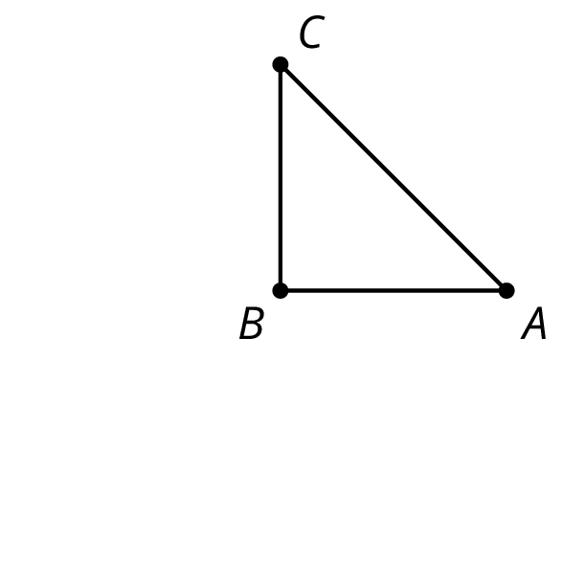

- Rotate triangle $ABC$ 90 degrees clockwise around $B$.
- Rotate triangle $ABC$ 180 degrees clockwise round $B$.
- Rotate triangle $ABC$ 270 degrees clockwise around $B$.
- What would it look like when you rotate the four triangles 90 degrees clockwise around $B$? 180 degrees? 270 degrees clockwise?

2 Rotating a Segment

Student Task Statement
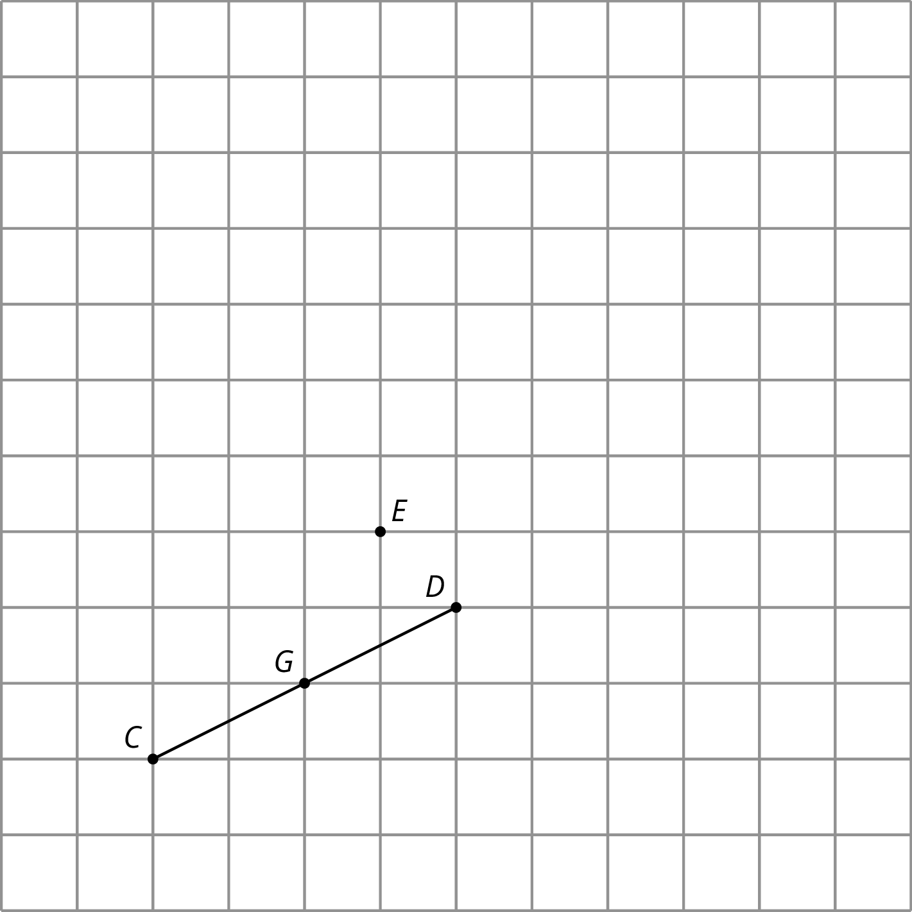
- Rotate segment $CD$ 180 degrees around point $D$. Draw its image and label the image of $C$ as $A.$
- Rotate segment $CD$ 180 degrees around point $E$. Draw its image and label the image of $C$ as $B$ and the image of $D$ as $F$.
- Rotate segment $CD$ 180 degrees around its midpoint, $G.$ What is the image of $C$?
- What happens when you rotate a segment 180 degrees around a point?

3 A Pattern of Four Triangles

Student Task Statement
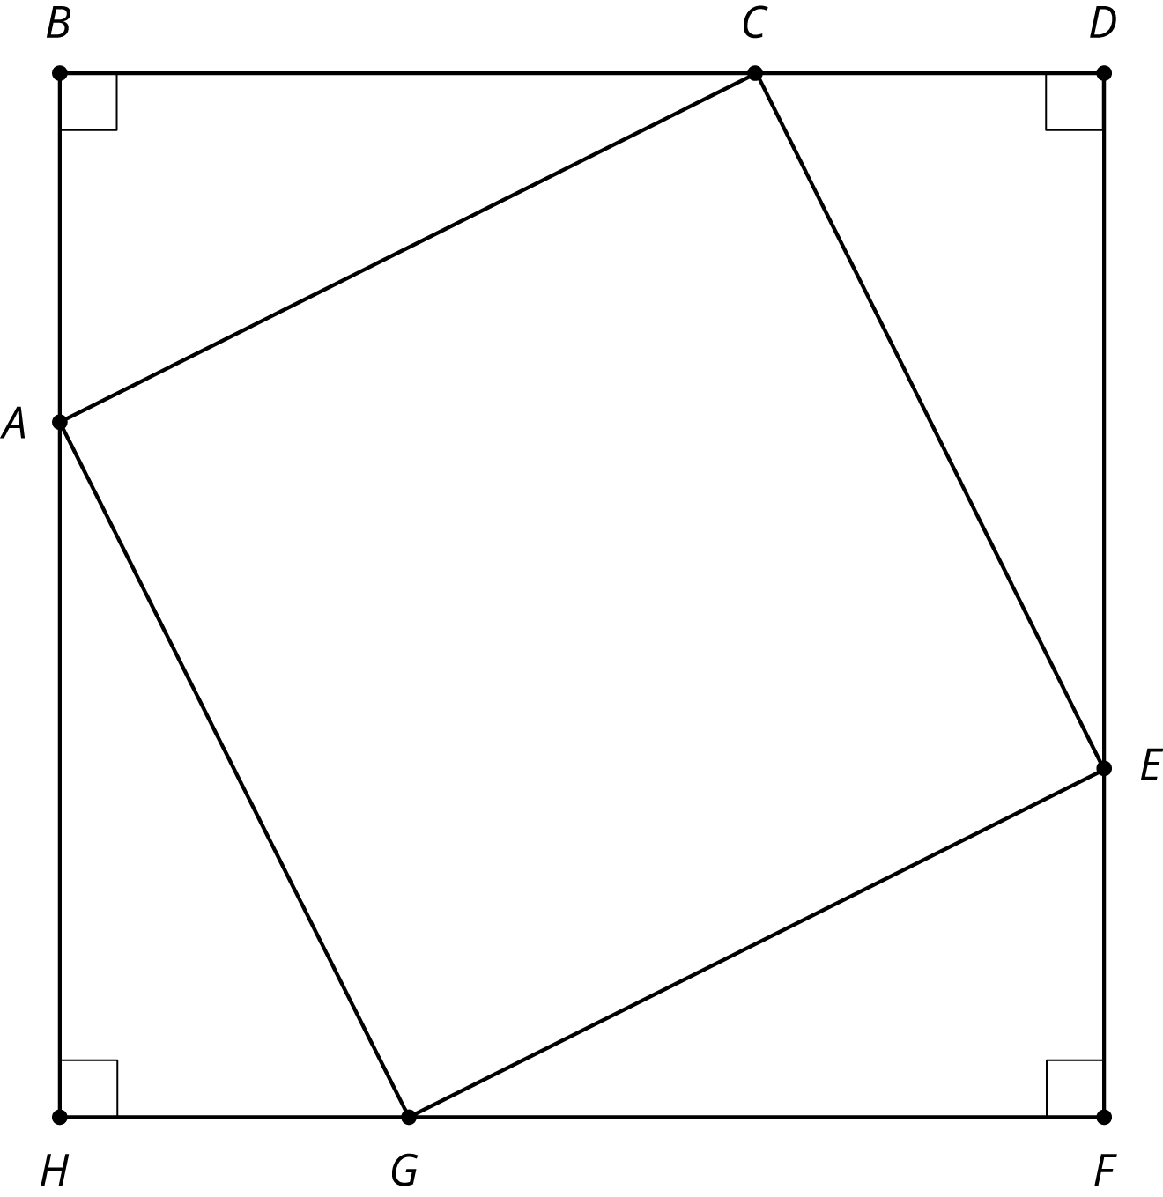
You can use rigid transformations of a figure to make patterns. Here is a diagram built with three different transformations of triangle $ABC$.
- Describe a rigid transformation that takes triangle $ABC$ to triangle $CDE$.
- Describe a rigid transformation that takes triangle $ABC$ to triangle $EFG$.
- Describe a rigid transformation that takes triangle $ABC$ to triangle $GHA$.
- Do segments $AC$, $CE$, $EG$, and $GA$ all have the same length? Explain your reasoning.
© CC BY Open Up Resources. Adaptations CC BY IM.

