Lesson 3: Questions and Stories About Shapes
- Let’s ask questions about shapes.

Warm-up: Notice and Wonder: Mai’s Shape
Mai used pattern blocks to make this shape.
What do you notice?
What do you wonder?
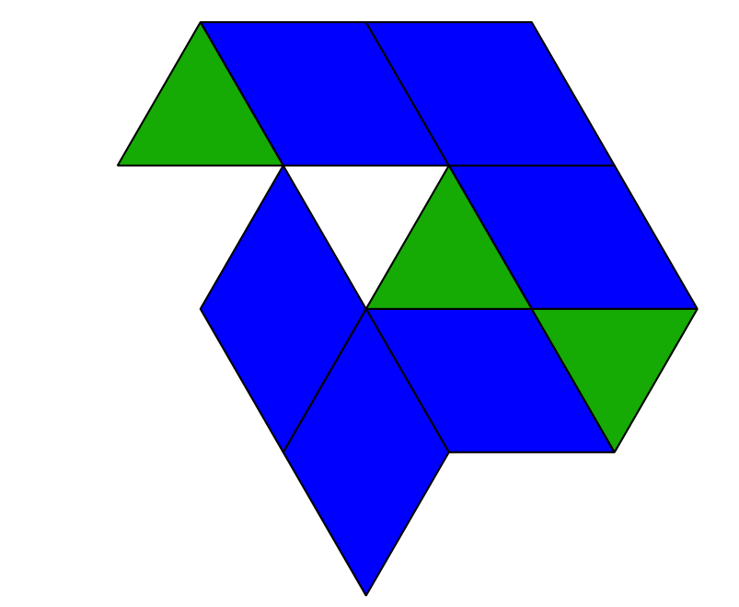

3.1: Ask Math Questions About Shapes

3.3: Introduce Pattern Blocks, Build and Draw
Choose a center.
Pattern Blocks
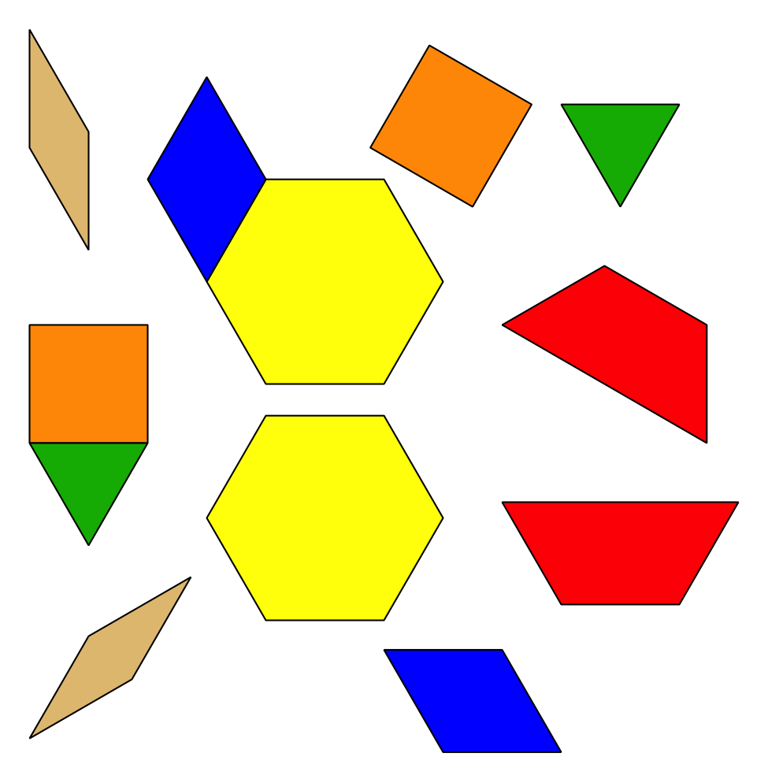
Geoblocks
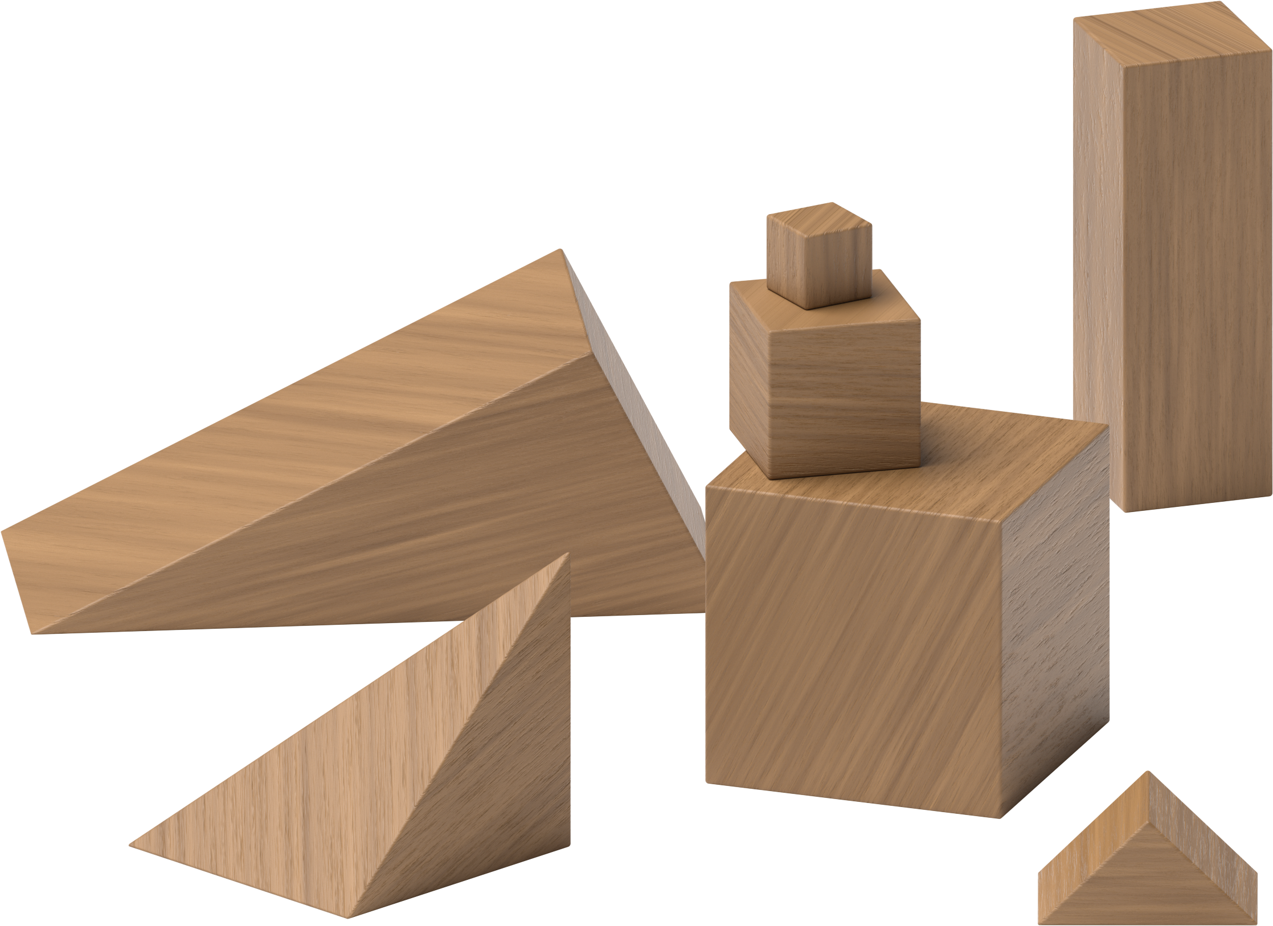
Grab and Count
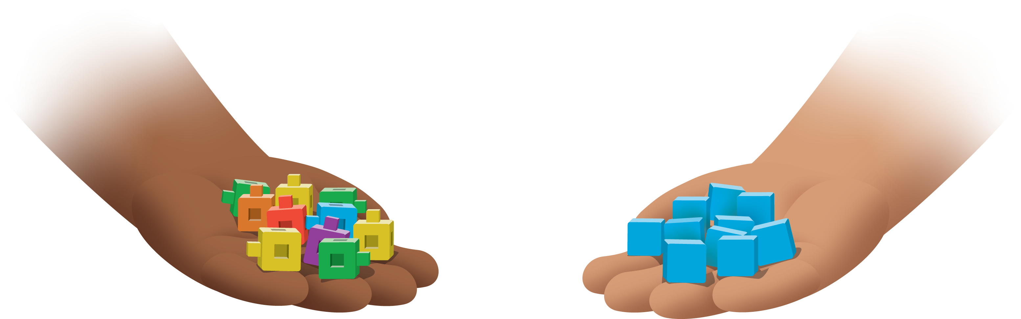
Find the Pair
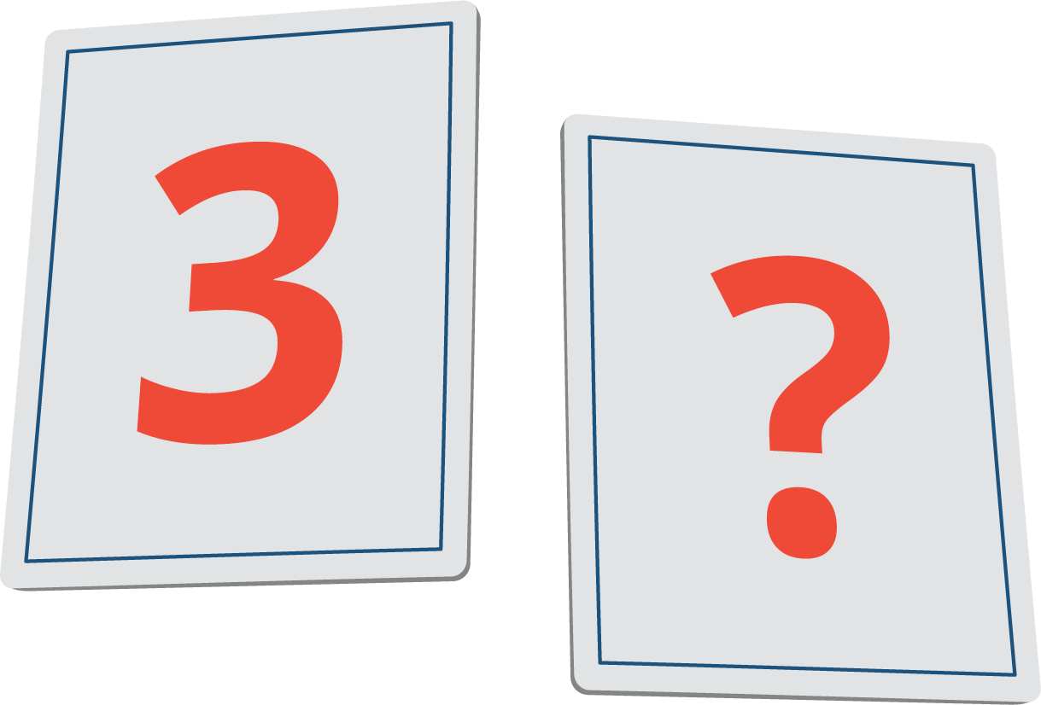
© CC BY 2021 Illustrative Mathematics®

