Lesson 11 Practice Problems
- This prism has a right triangle for a base. What is the volume of the prism?
- 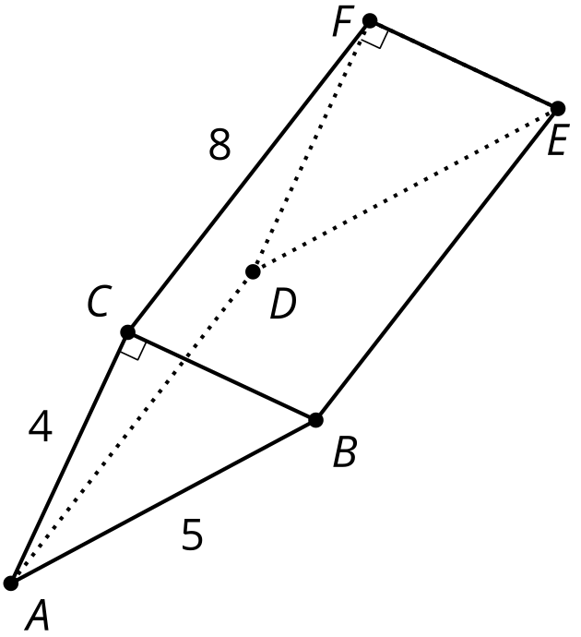
- An oblique cylinder with a base of radius 2 units is shown. The top of the cylinder can be obtained by translating the base by the directed line segment $AB$ which has length $6\sqrt{2}$ units. The segment $AB$ forms a ${45}^{∘}$ angle with the plane of the base. What is the volume of the cylinder?
- 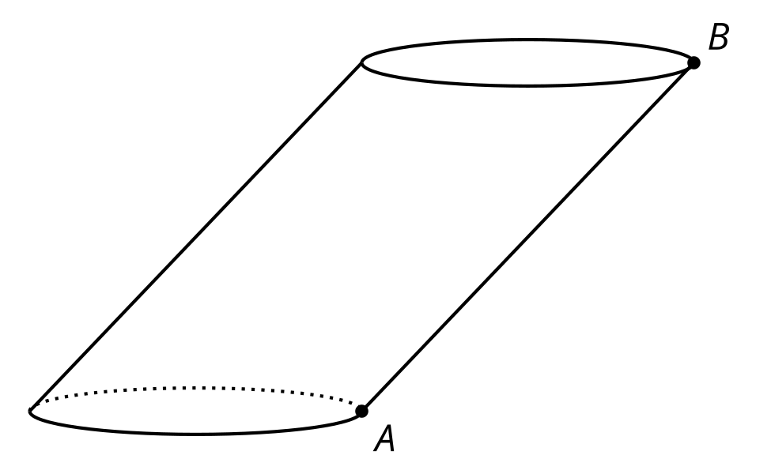
- A prism has a height of 5 inches and a volume of 80 cubic inches. Select all figures that could be the base for this prism.
  - a square with side length 4 inches
  - a 2 inch by 8 inch rectangle
  - a circle with radius 2 inches
  - a right triangle with legs 4 inches long
  - a heart-shaped base with an area of 16 square inches
- This water bottle has a base with area $B$ square inches and a height of $h$ inches. Tyler thinks the volume of the water bottle is $Bh$. Elena thinks the volume is less than $Bh$.
- Do you agree with either of them? Explain your reasoning.
- 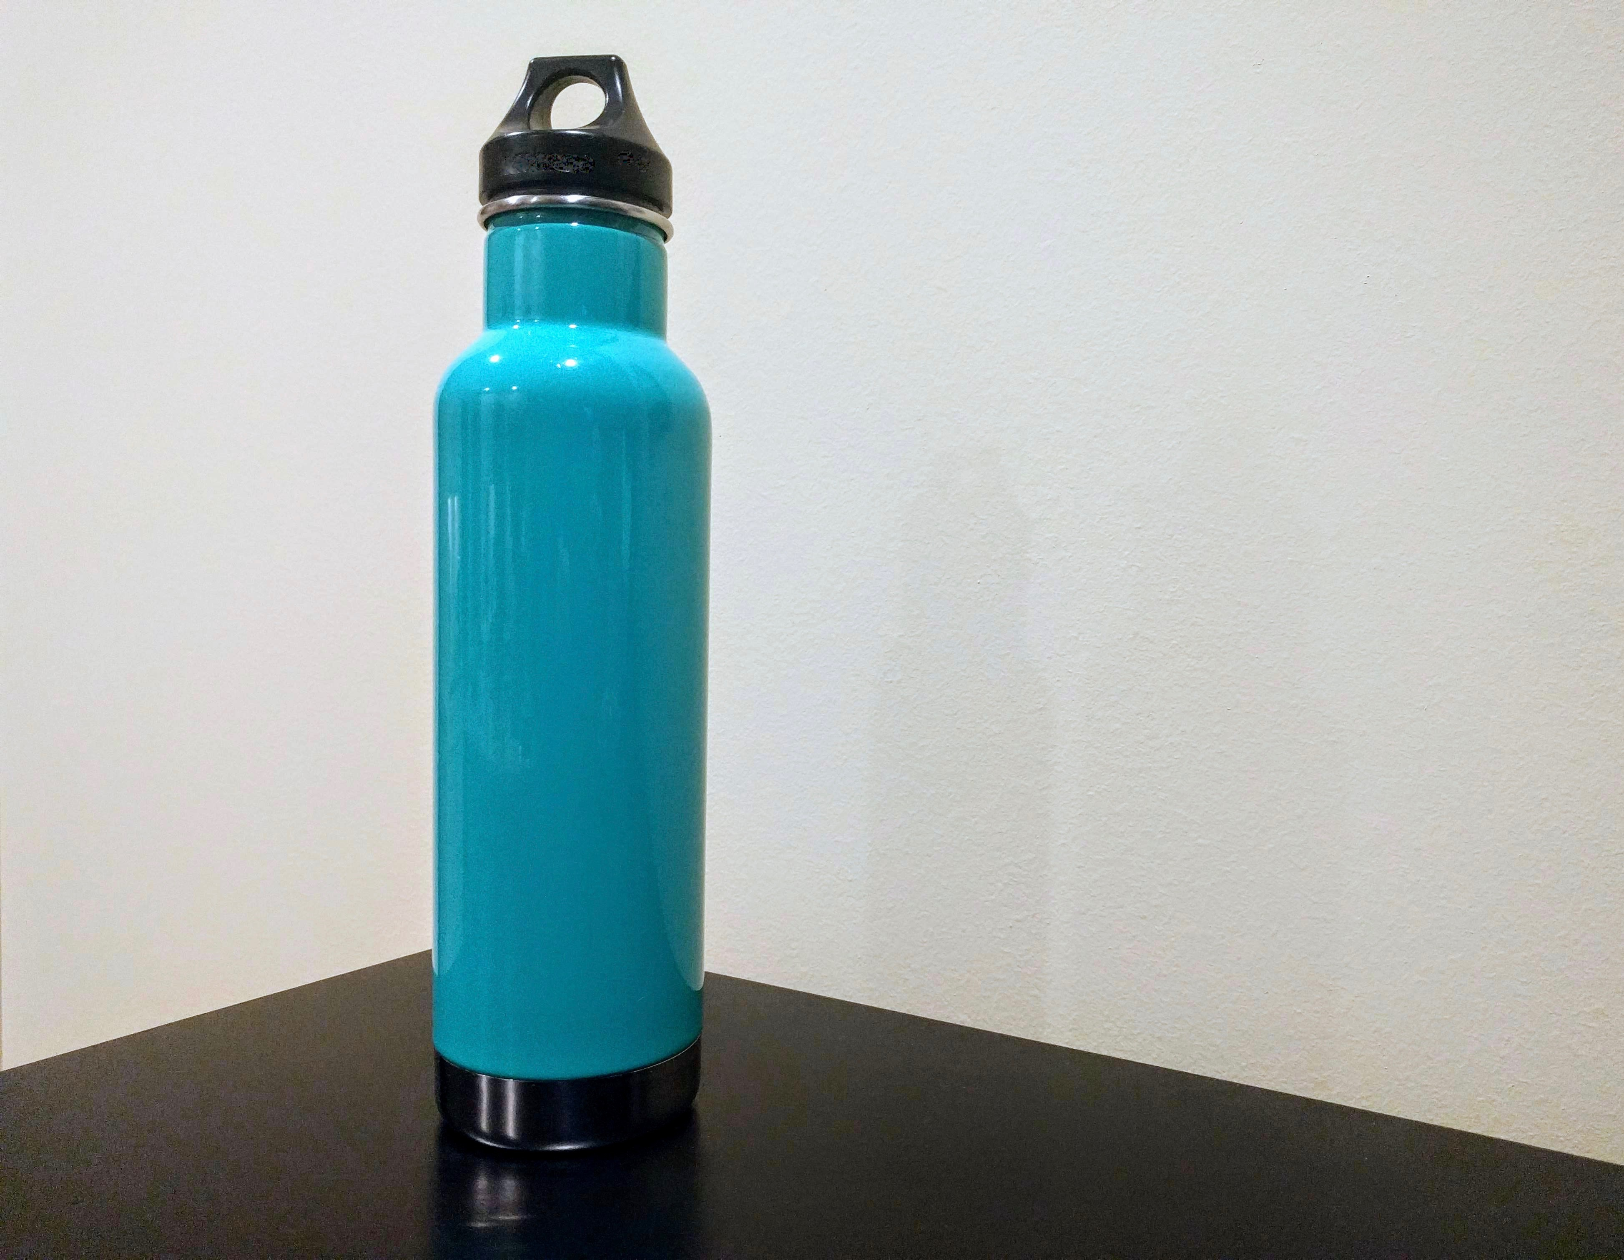
- (From Unit 5, Lesson 10.)
- This solid has curved sides. All cross sections parallel to the base are squares measuring 3 units on each side. The height from the base to the top is 10 units. What is the volume of this solid?
- 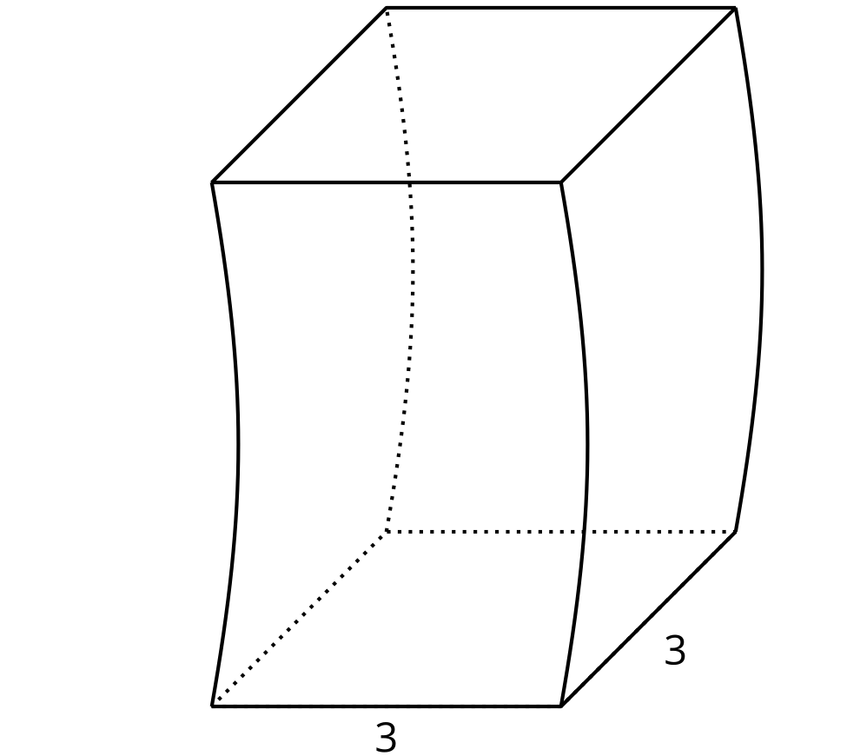
  - 30 cubic units
  - 60 cubic units
  - 90 cubic units
  - There is not enough information to determine the volume.
- (From Unit 5, Lesson 10.)
- Each small square represents 1 square centimeter.
  - Sketch and label the solid formed by rotating this two-dimensional figure around the horizontal axis shown.
  - 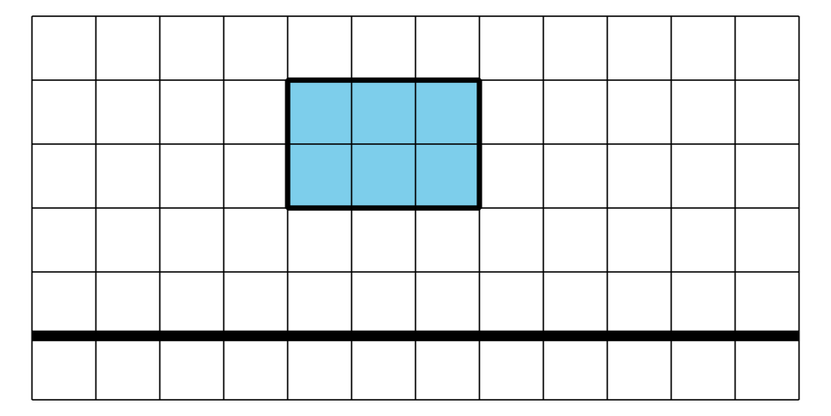
  - What is the volume of this solid?
- (From Unit 5, Lesson 9.)
- A solid has volume 6 cubic units and surface area 22 square units. The solid is dilated, and the image has surface area 198 square units. What is the volume of the image?
- (From Unit 5, Lesson 8.)
- The Pyramid of Khufu in Giza, Egypt was the world’s tallest free-standing structure for more than 3,500 years. Its original height was about 144 meters. Its base is approximately a square with a side length of 231 meters.
- The diagram shows a cross section created by dilating the base using the top of the pyramid as a center. The cross section has side length of 154 meters.
- 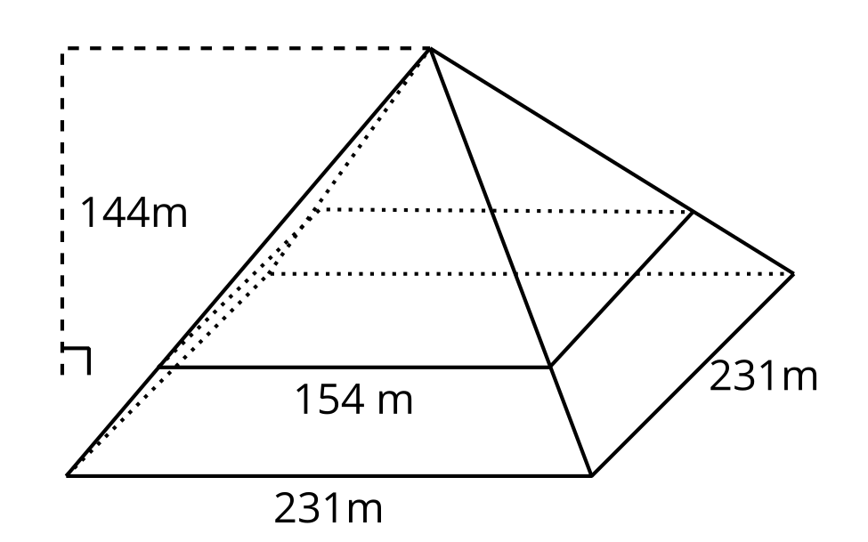
  - What scale factor was used to create the cross section?
  - What is the height of the cross section?
- (From Unit 5, Lesson 3.)
- Select all statements that must be true.
  - The angle bisector of an isosceles triangle is also the perpendicular bisector.
  - The angle bisector of any angle divides the angle into 2 congruent parts.
  - The median of a triangle is also the perpendicular bisector.
  - The median of an isosceles triangles is also the angle bisector.
  - The median of a triangle is also the angle bisector.
- (From Unit 2, Lesson 14.)
© CC BY 2019 by Illustrative Mathematics®

