Lesson 2: Reasoning about Contexts with Tape Diagrams
Let’s use tape diagrams to make sense of different kinds of stories.

2.1: Notice and Wonder: Remembering Tape Diagrams
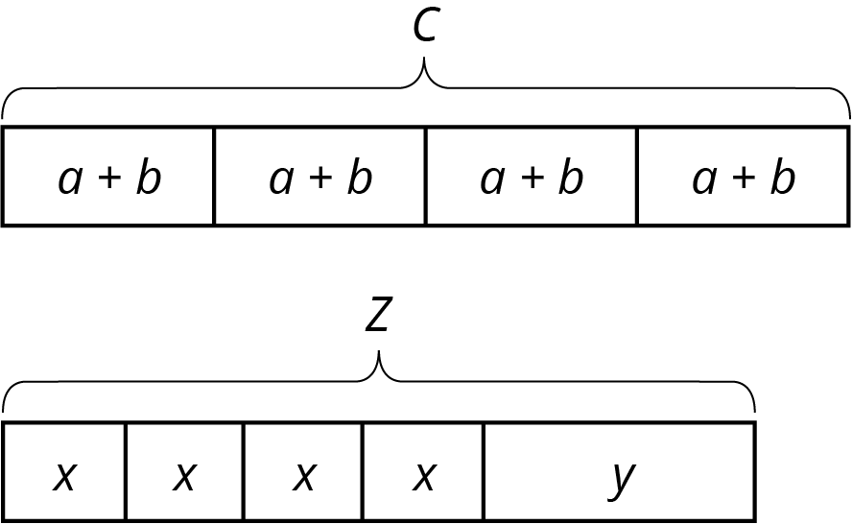
- What do you notice? What do you wonder?
- What are some possible values for $a$, $b$, and $c$ in the first diagram?
- For $x$, $y$, and $z$ in the second diagram? How did you decide on those values?

2.2: Every Picture Tells a Story
Here are three stories with a diagram that represents it. With your group, decide who will go first. That person explains why the diagram represents the story. Work together to find any unknown amounts in the story. Then, switch roles for the second diagram and switch again for the third.
- Mai made 50 flyers for five volunteers in her club to hang up around school. She gave 5 flyers to the first volunteer, 18 flyers to the second volunteer, and divided the remaining flyers equally among the three remaining volunteers.
- 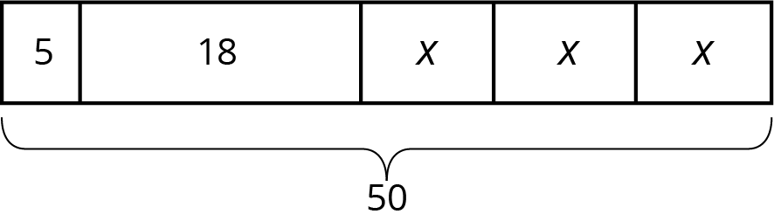

- To thank her five volunteers, Mai gave each of them the same number of stickers. Then she gave them each two more stickers. Altogether, she gave them a total of 30 stickers.
- 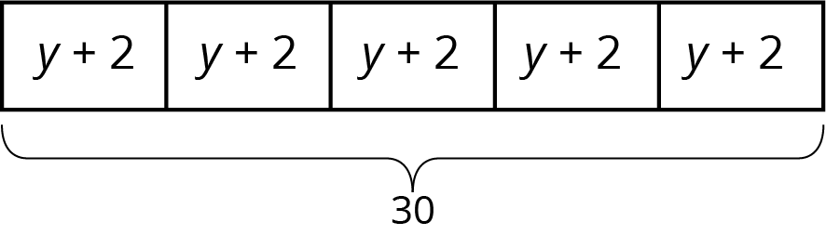

- Mai distributed another group of flyers equally among the five volunteers. Then she remembered that she needed some flyers to give to teachers, so she took 2 flyers from each volunteer. Then, the volunteers had a total of 40 flyers to hang up.
- 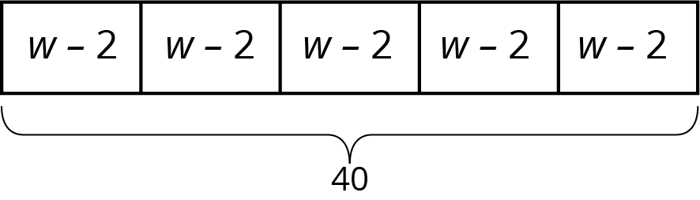

2.3: Every Story Needs a Picture
Here are three more stories. Draw a tape diagram to represent each story. Then describe how you would find any unknown amounts in the stories.
- Noah and his sister are making gift bags for a birthday party. Noah puts 3 pencil erasers in each bag. His sister puts $x$ stickers in each bag. After filling 4 bags, they have used a total of 44 items.
- Noah’s family also wants to blow up a total of 60 balloons for the party. Yesterday they blew up 24 balloons. Today they want to split the remaining balloons equally between four family members.
- Noah’s family bought some fruit bars to put in the gift bags. They bought one box each of four flavors: apple, strawberry, blueberry, and peach. The boxes all had the same number of bars. Noah wanted to taste the flavors and ate one bar from each box. There were 28 bars left for the gift bags.

Are you ready for more?
Design a tiling that uses a repeating pattern consisting of 2 kinds of shapes (e.g., 1 hexagon with 3 triangles forming a triangle). How many times did you repeat the pattern in your picture? How many individual shapes did you use?

Lesson 2 Summary
Tape diagrams are useful for representing how quantities are related and can help us answer questions about a situation.
Suppose a school receives 46 copies of a popular book. The library takes 26 copies and the remainder are split evenly among 4 teachers. How many books does each teacher receive? This situation involves 4 equal parts and one other part. We can represent the situation with a rectangle labeled 26 (books given to the library) along with 4 equal-sized parts (books split among 4 teachers). We label the total, 46, to show how many the rectangle represents in all. We use a letter to show the unknown amount, which represents the number of books each teacher receives. Using the same letter, $x$, means that the same number is represented four times.
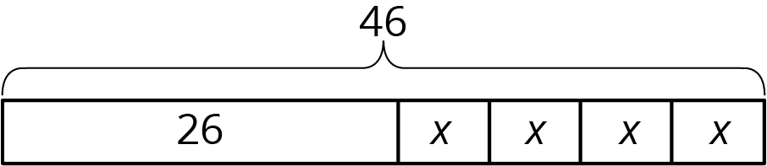
Some situations have parts that are all equal, but each part has been increased from an original amount:
A company manufactures a special type of sensor, and packs them in boxes of 4 for shipment. Then a new design increases the weight of each sensor by 9 grams. The new package of 4 sensors weighs 76 grams. How much did each sensor weigh originally?
We can describe this situation with a rectangle representing a total of 76 split into 4 equal parts. Each part shows that the new weight, $x+9$, is 9 more than the original weight, $x$.
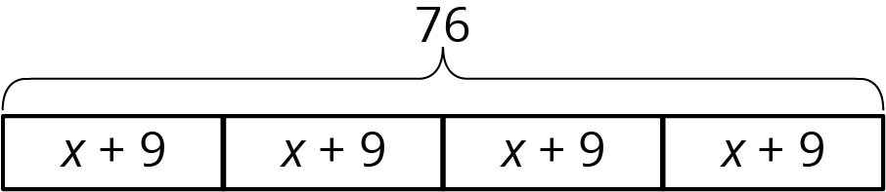
© CC BY Open Up Resources. Adaptations CC BY IM.

