Unit 8 Lesson 12: More about Sampling Variability

1 Average Reactions (Warm up)

Student Task Statement
The other day, you worked with the reaction times of twelfth graders to see if they were fast enough to help out at the track meet. Look back at the sample you collected.
- Calculate the mean reaction time for your sample.
- Did you and your partner get the same sample mean? Explain why or why not.

2 Reaction Population (Optional)

Images for Launch
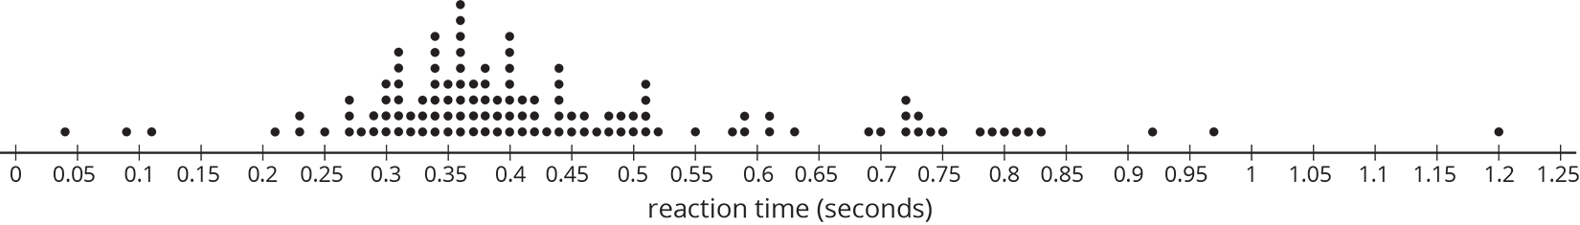

Student Task Statement
Your teacher will display a blank dot plot.
- Plot your sample mean from the previous activity on your teacher's dot plot.
- What do you notice about the distribution of the sample means from the class?
  - Where is the center?
  - Is there a lot of variability?
  - Is it approximately symmetric?
- The population mean is 0.442 seconds. How does this value compare to the sample means from the class?
- Pause here so your teacher can display a dot plot of the population of reaction times.
- What do you notice about the distribution of the population?
  - Where is the center?
  - Is there a lot of variability?
  - Is it approximately symmetric?
- Compare the two displayed dot plots.
- Based on the distribution of sample means from the class, do you think the mean of a random sample of 20 items is likely to be:
  - within 0.01 seconds of the actual population mean?
  - within 0.1 seconds of the actual population mean?
- Explain or show your reasoning.

Activity Synthesis
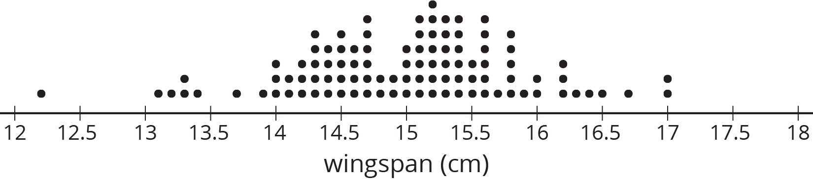
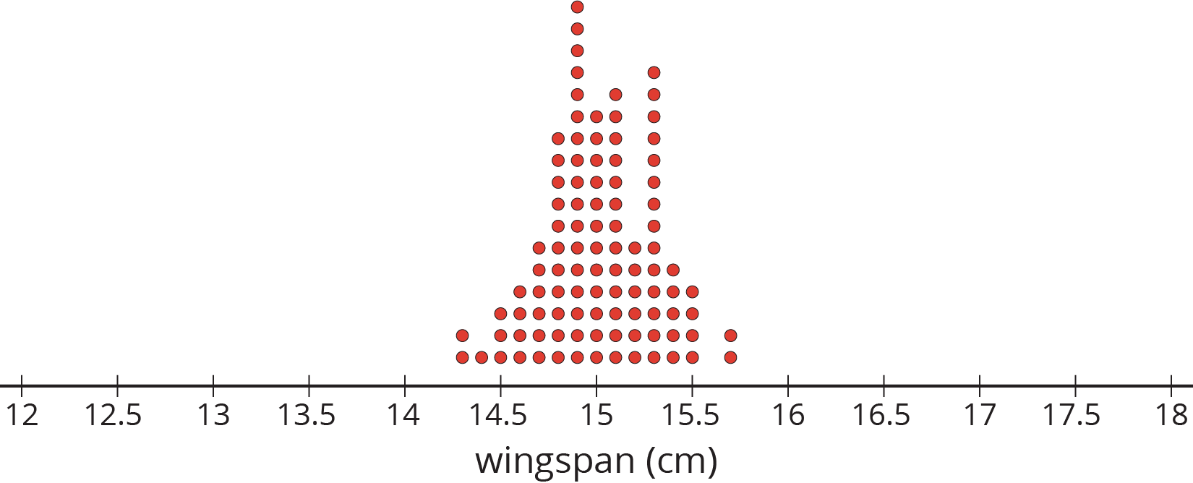
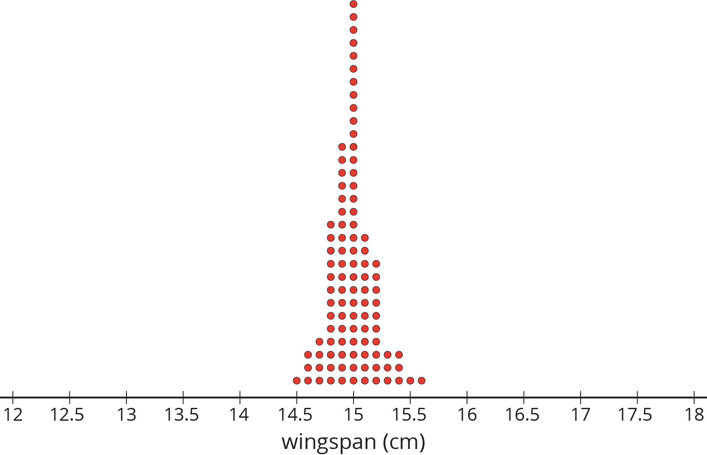

3 How Much Do You Trust the Answer? (Optional)

Student Task Statement
The other day you worked with 2 different samples of viewers from each of 3 different television shows. Each sample included 10 viewers. Here are the mean ages for 100 different samples of viewers from each show.
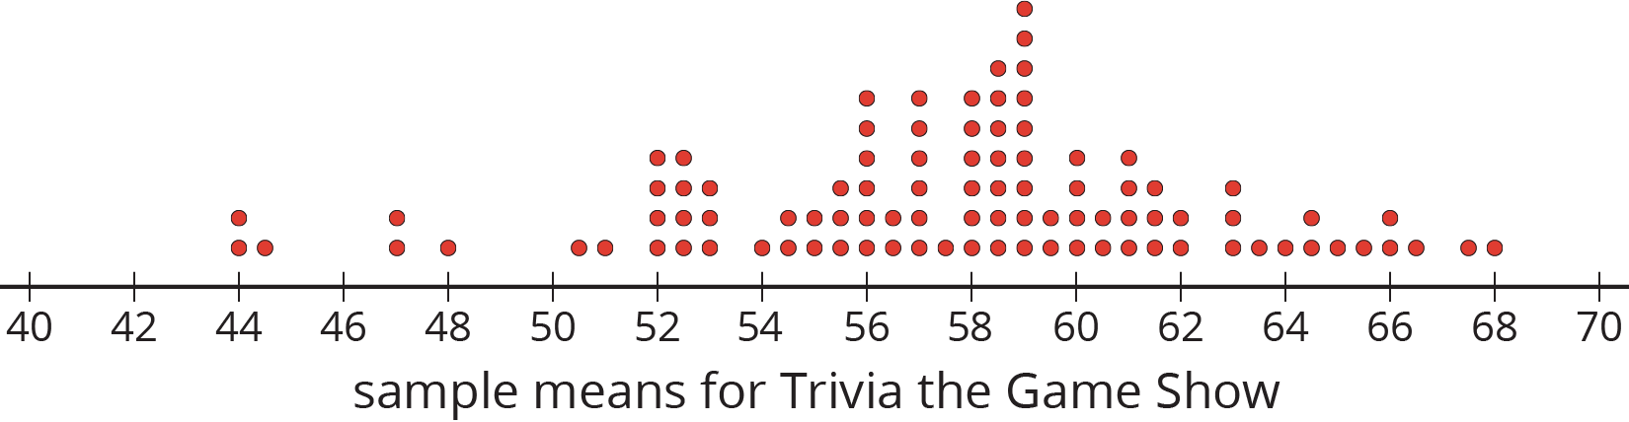
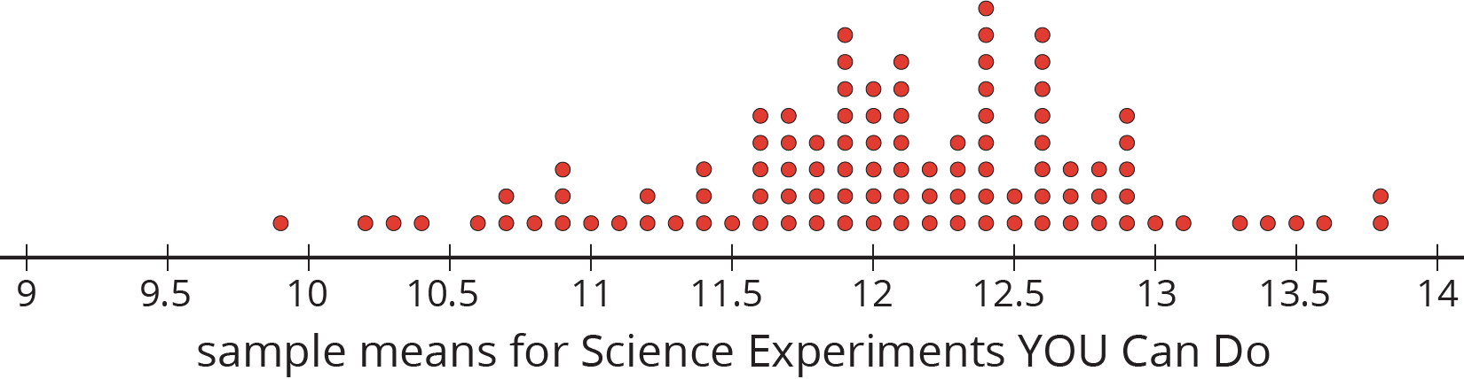
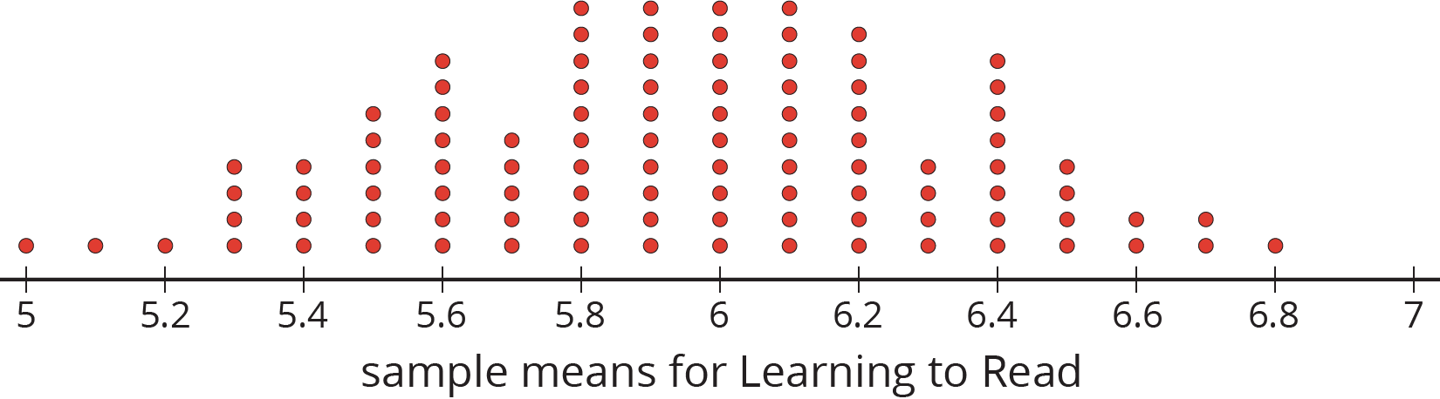
- For each show, use the dot plot to estimate the population mean.
  - Trivia the Game Show
  - Science Experiments YOU Can Do
  - Learning to Read
- For each show, are most of the sample means within 1 year of your estimated population mean?
- Suppose you take a new random sample of 10 viewers for each of the 3 shows. Which show do you expect to have the new sample mean closest to the population mean? Explain or show your reasoning.
© CC BY Open Up Resources. Adaptations CC BY IM.

