Unit 4 Lesson 15: Using Graphs and Logarithms to Solve Problems (Part 1)

1 Using a Graph to Estimate (Warm up)

Student Task Statement
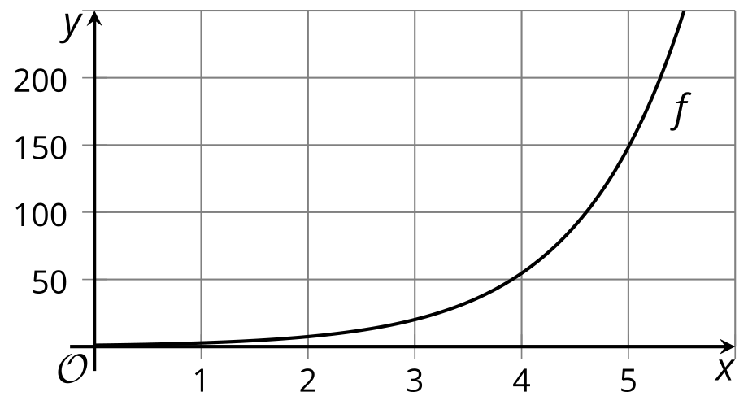
Here is a graph that represents an exponential function with base $e$, defined by $f\left(x\right)=e^{x}$.
- Explain how to use the graph to estimate logarithms such as $ln100$.
- Use the graph to estimate $ln100$.
- How can you use a calculator to check your estimate? What would you enter into the calculator?

2 Retire A Millionaire?

Student Task Statement
The expression $1⋅e^{\left(0.06t\right)}$ models the balance, in thousands of dollars, of an account $t$ years after the account was opened.
- What is the account balance:
  - when the account is opened?
  - after 1 year?
  - after 2 years?
- Diego says that the expression $ln5$ represents the time, in years, when the account will have 5 thousand dollars. Do you agree? Explain your reasoning.
- Suppose you opened this account at the beginning of this year. Assume that you deposit no additional money and withdraw nothing from the account. Will the account balance reach $1,000,000 and make you a millionaire by the time you reach retirement? Show your reasoning.

3 Cicada Population

Student Task Statement
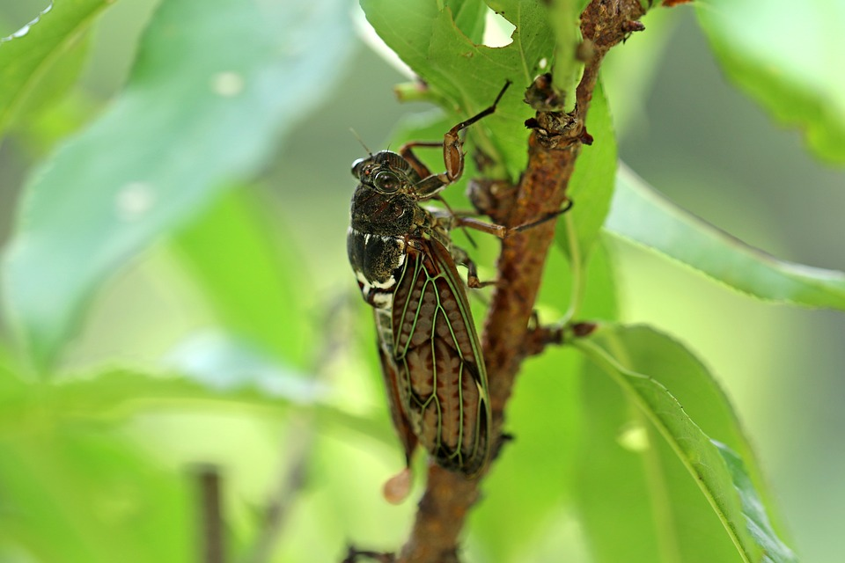
A population of cicadas is modeled by a function defined by $f\left(w\right)=250⋅e^{\left(0.5w\right)}$ where $w$ is the number of weeks since the population was first measured.
- Explain why solving the equation $500=250⋅e^{\left(0.5w\right)}$ gives the number of weeks it takes for the cicada population to double.
- How many weeks does it take the cicada population to double? Show your reasoning.
- Use graphing technology to graph $y=f\left(w\right)$ and $y=100,​000$ on the same axes. Explain why we can use the intersection of the two graphs to estimate when the cicada population will reach 100,000.
© CC BY 2019 by Illustrative Mathematics®

