Lesson 8: Are All Pieces Created Equal?
- Let’s make halves, thirds, and fourths in different ways.

Warm-up: Number Talk: 5 Ones
Find the value of each expression mentally.
- $25−15$
- $40−15$
- $65−25$
- $60−35$

8.1: Make Quarters and Halves
Lin wanted to partition this square into quarters. She started by splitting the square into halves.
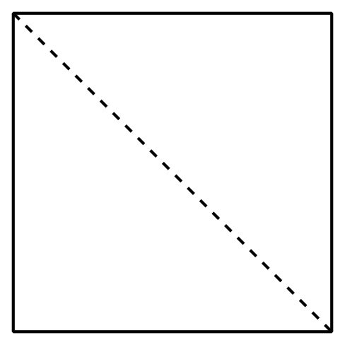
After she drew the first line, she tried 3 different ways to make fourths.
- Which of these shows fourths or quarters? Explain and share with your partner.
- A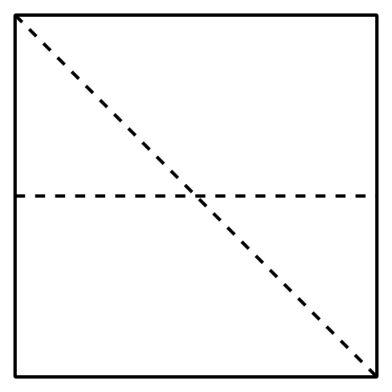
- B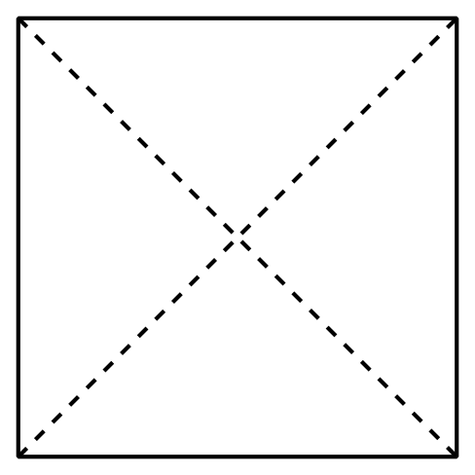
- C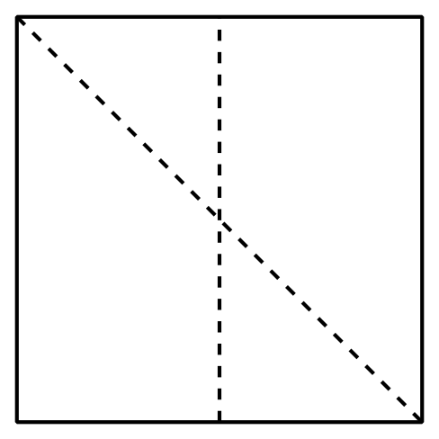
- Name the shaded piece.
- A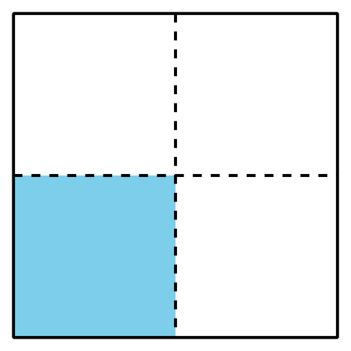
- Shape A has a ________________ shaded.
- B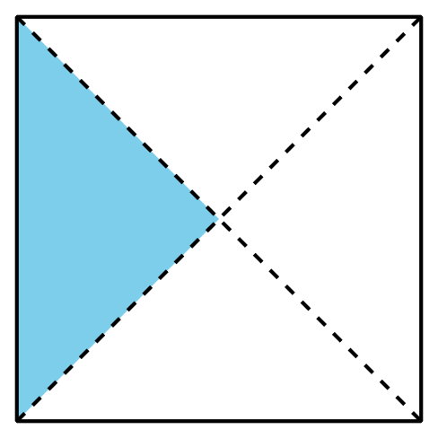
- Shape B has a ________________ shaded.
- Show 2 different ways to partition the rectangle into quarters or fourths. Shade in a fourth of each rectangle.
- Show 2 different ways to partition the square into halves.
Shade in a half of each square.

8.2: Make Equal Pieces
- Lin, Mai, and Andre were asked to shade in a third of a shape.
- Lin
- 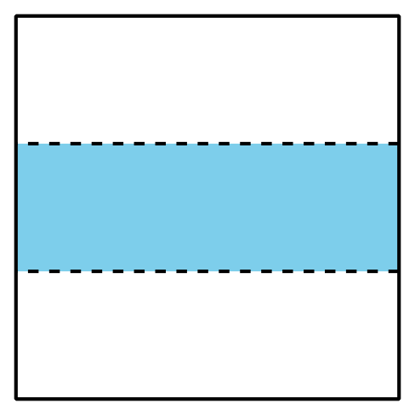
- Mai
- 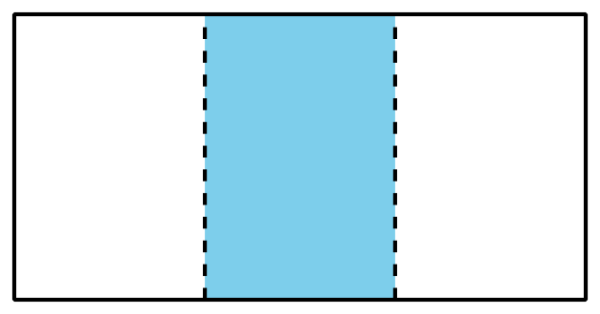
- Andre
- 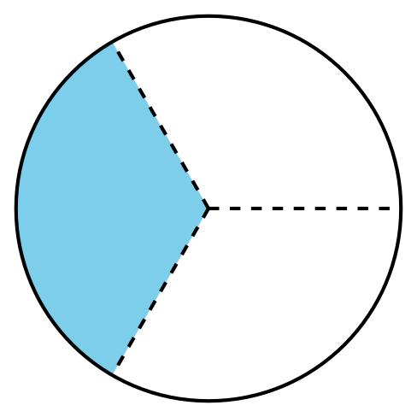
- Do all their shapes show a third shaded? Explain and share with a partner.
- Partition the rectangle into thirds and shade a third of the shape.
- Diego’s dad made 2 square pans of cornbread and sliced them up for the family.
- Diego’s Brother
- Diego’s
- 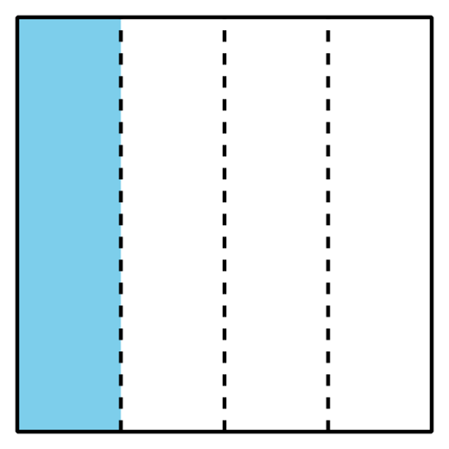
- Diego’s little brother was upset because he thought his piece of cornbread was smaller than Diego’s. What would you tell him?
© CC BY 2021 Illustrative Mathematics®

