Lesson 21: Center Day 4
- Let’s play games to practice adding and subtracting.

Warm-up: Number Talk: Missing Values
Find the missing value mentally.
- 4+1=5
- 5−1=4
- 6+2=8
- 8−2=6

21.2: Centers: Choice Time
Choose a center.
Capture Squares
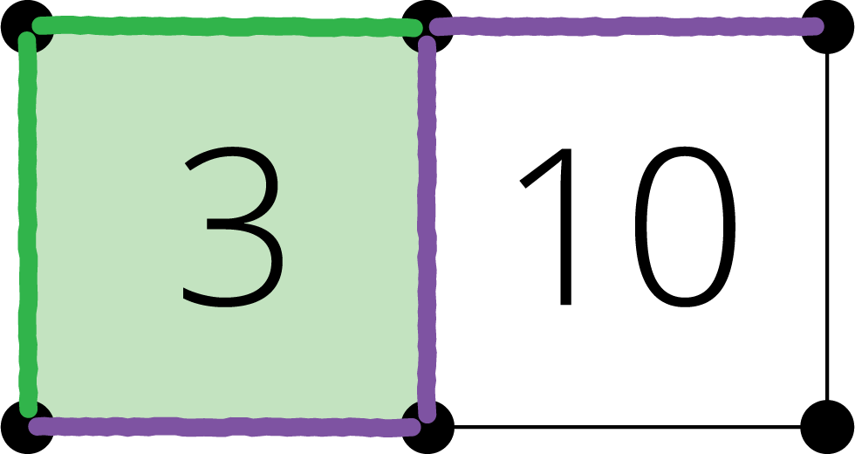
Math Stories
What's Behind My Back
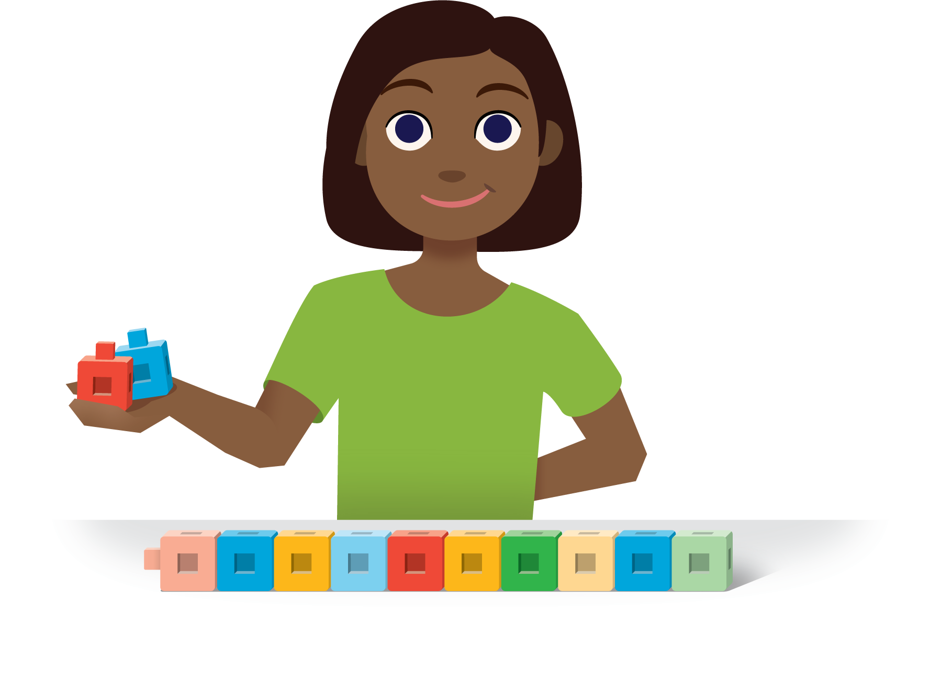
© CC BY 2021 Illustrative Mathematics®

