Lesson 2: Build Shapes from Other Shapes
- Let’s use solid shapes to build new shapes.

Warm-up: Notice and Wonder: A Shape Bridge
What do you notice?
What do you wonder?
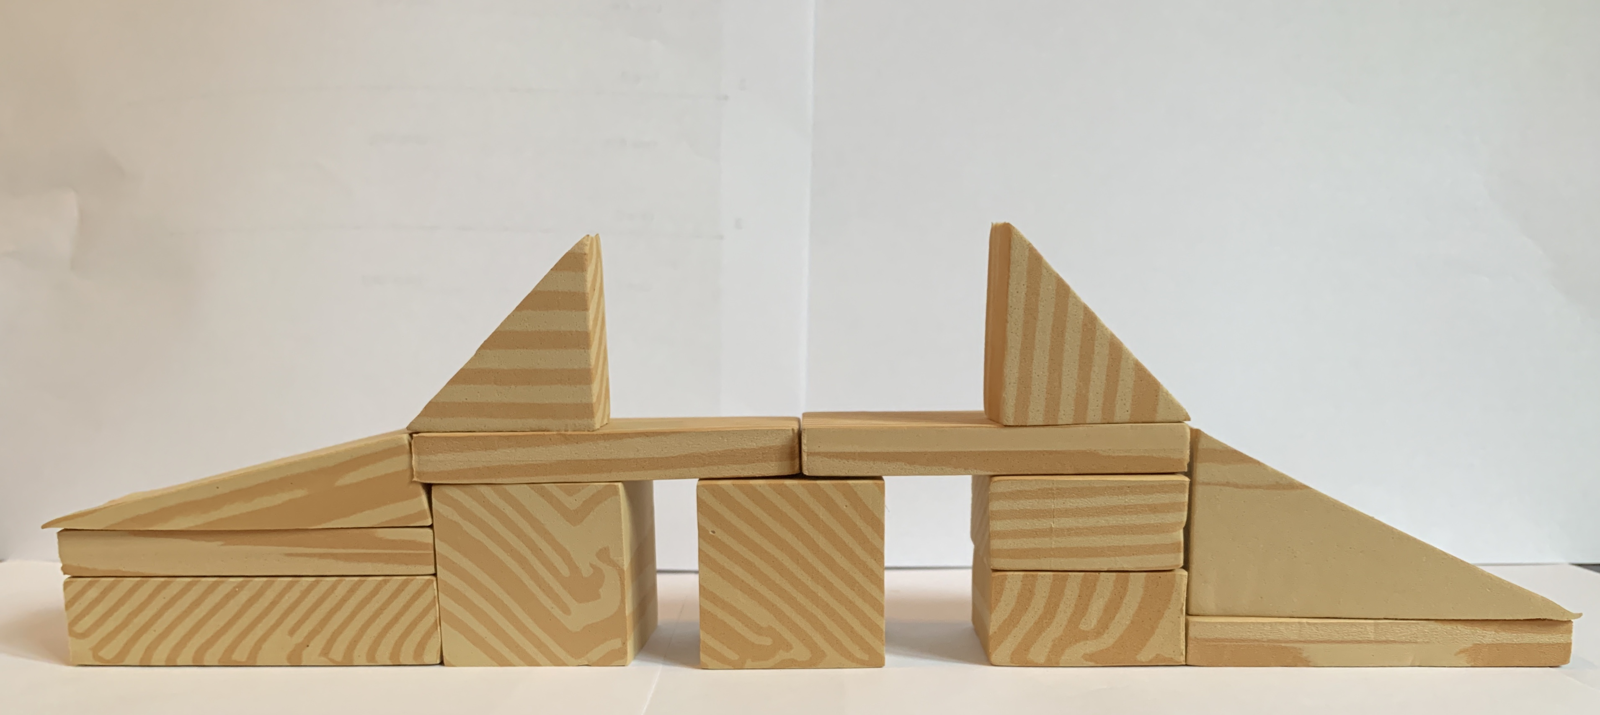
© CC BY 2021 Illustrative Mathematics®

