Lesson 11: How Do You Solve Story Problems?
- Let’s solve story problems.

Warm-up: What Do You Know About Story Problems?
What do you know about story problems?

11.1: How Many Seeds?
- Diego gathered 42 orange seeds. Jada gathered 16 apple seeds. How many more seeds did Diego gather than Jada? Show your thinking.
- 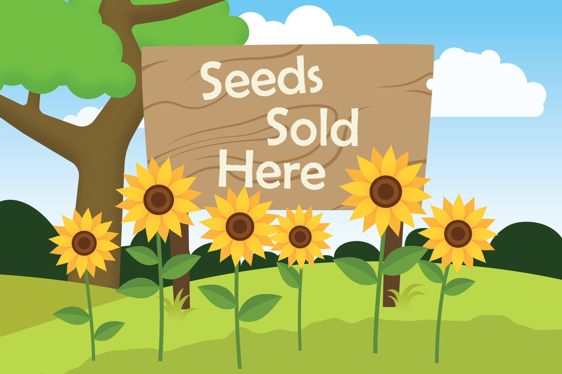

11.2: The Seeds of Greatness
Solve each story problem. Show your thinking.
- Lin had 31 sunflower seeds. She gave Priya 15 seeds. How many seeds does Lin have now?
- Noah used yellow and blue corn seeds to make a design. He used 37 seeds altogether. He used 28 yellow seeds. How many blue seeds did he use?
- Elena gathered 50 pumpkin seeds. Andre collected 23 fewer pumpkin seeds than Elena. How many seeds did Andre collect?
© CC BY 2021 Illustrative Mathematics®

