Lesson 15: Reasoning About Angles (Part 2)

Standards Alignments
Addressing | 4.G.A.1, 4.MD.C.7

Teacher-facing Learning Goals
- Represent angle relationships and solve for unknown angle measurements.

Student-facing Learning Goals
- Let’s figure out missing angle measurements.

Lesson Purpose
The purpose of this lesson is to use known angles to reason about unknown angles and write equations to reason about unknown angles.
In this lesson, students use what they know about angles and their measurements to solve problems that are increasingly more complex and abstract. To find measurements of unknown angles, students need to look for structure in the diagrams, reason about the relationships of the angles (including writing equations to represent the relationships), and perform addition, subtraction, and sometimes division.
The problems in the lesson can be solved in more than one way and in different orders, but a small handful of the angles can only be quantified after the values of some other angles are known. Students pay attention to the process and explain why sometimes a certain sequence is necessary.
This lesson has a Student Section Summary.

Access for:

Students with Disabilities
- Representation (Activity 1)

English Learners
- MLR8 (Activity 1)

Instructional Routines
How Many Do You See? (Warm-up), MLR4 Information Gap (Activity 2)

Materials to Copy
- Info Gap: Whole Bunch of Angles (groups of 2): Activity 2

Lesson Timeline
Warm-up | 10 min
Activity 1 | 15 min
Activity 2 | 20 min
Lesson Synthesis | 10 min
Cool-down | 5 min

Teacher Reflection Question
As you finish up this unit, reflect on the norms and activities that have supported students’ development as thinkers. How have students grown in their ability to reason more abstractly and logically? What instructional strategies or routines worked well in supporting this development? What will you continue to do and improve on in Unit 7, and what will you adjust?

Cool-down
(to be completed at the end of the lesson) 5min
Heart to Heart

Standards Alignments
Addressing | 4.G.A.1, 4.MD.C.7

Student-facing Task Statement
Find the measurement of each labeled angle. Show your reasoning.
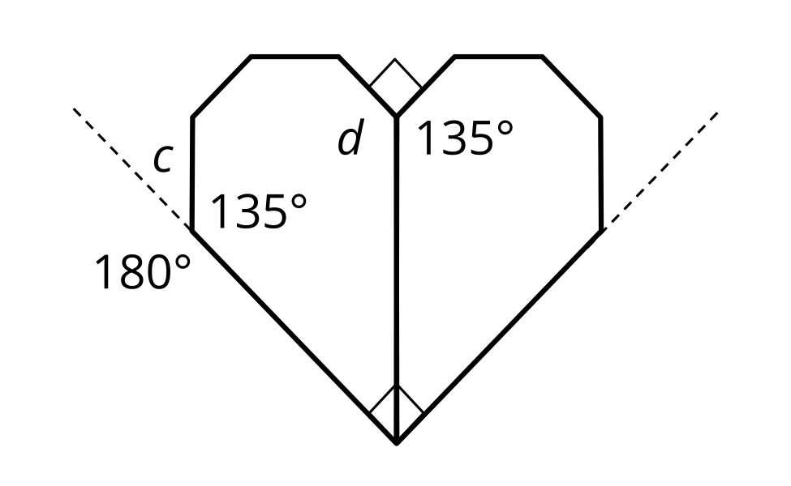

Student Responses
The measure of angle $c$ is ${45}^{∘}$ and that of angle $d$ is ${135}^{∘}$. Sample reasoning:
- Angle $c$ and the ${135}^{∘}$ angle together make a straight angle, which is ${180}^{∘}$, so the measure of $c$ is $180−135$, which is 45.
- Angle $d$, the right angle, and the ${135}^{∘}$ angle make ${360}^{∘}$. $90+135=225$ and $360−225=135$.

