Unit 9 Lesson 8: Measurement Error (Part 1)

1 How Long Are These Pencils? (Optional)

Student Task Statement
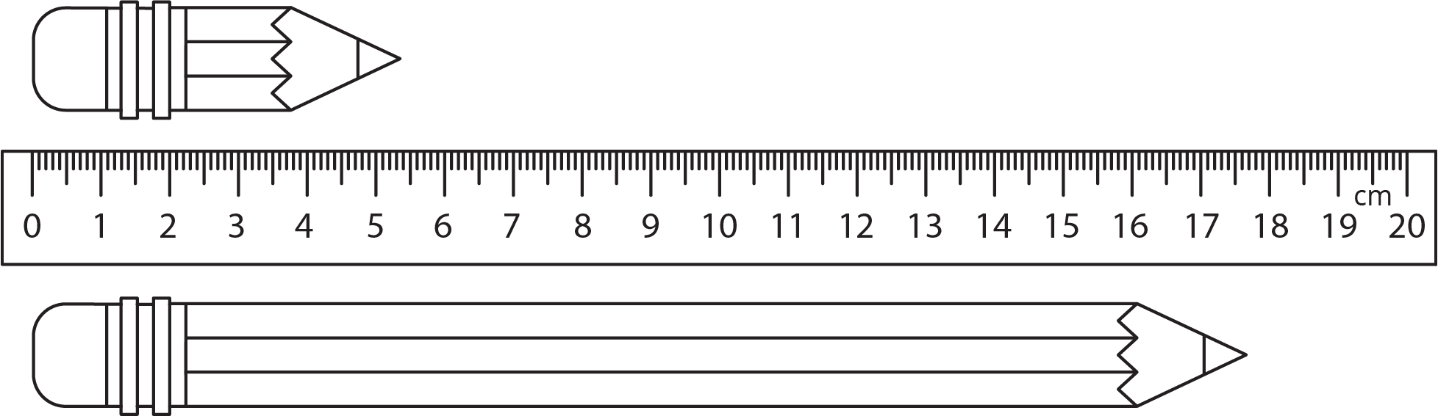
- Estimate the length of each pencil.
- How accurate are your estimates?
- For each estimate, what is the largest possible percent error?

2 How Long Are These Floor Boards? (Optional)

Student Task Statement
A wood floor is made by laying multiple boards end to end. Each board is measured with a maximum percent error of 5%. What is the maximum percent error for the total length of the floor?
© CC BY Open Up Resources. Adaptations CC BY IM.

