Lesson 10: Introduce the 10-frame
- Let’s make and use 10-frames.

Warm-up: Notice and Wonder: Fingers and 5-frames
What do you notice?
What do you wonder?

10.1: Introduce 10-frames
Cut out and glue the 5-frames to make each number.

10.3: Centers: Choice Time
Choose a center.
Shake and Spill
Counting Collections
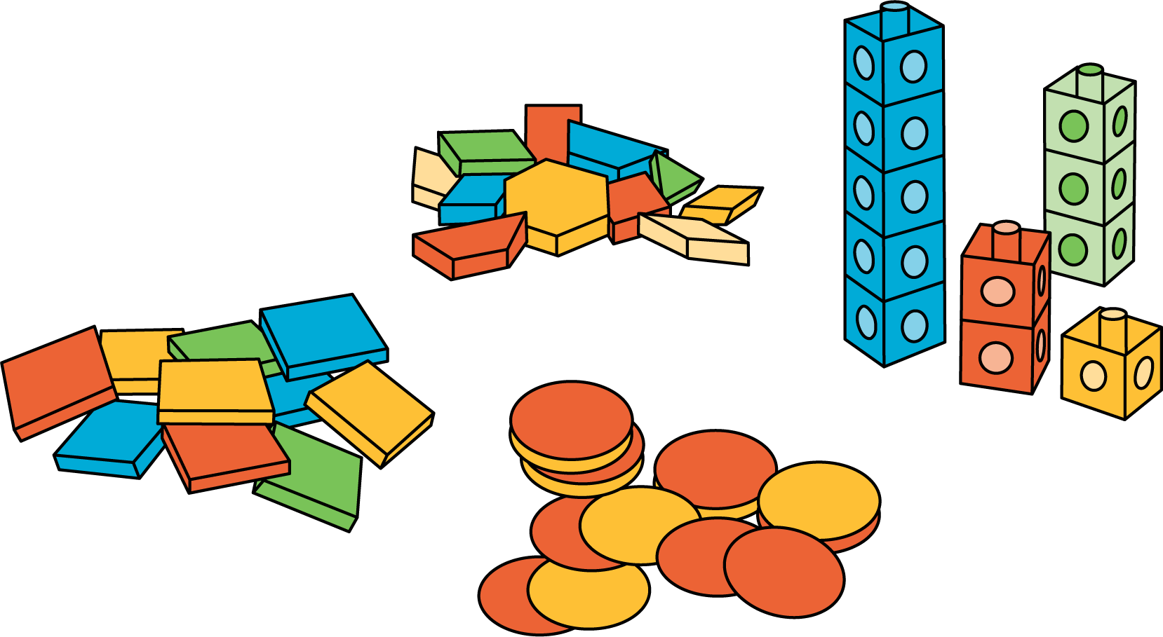
Roll and Add
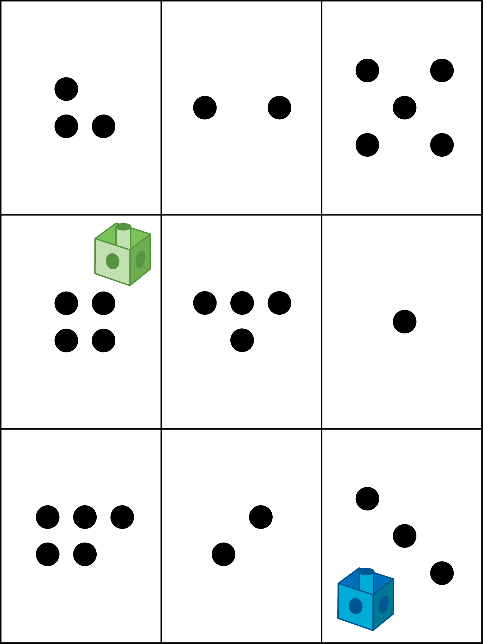
© CC BY 2021 Illustrative Mathematics®

