Lesson 1: Build Shapes
- Let’s use one kind of pattern block to make shapes.

Warm-up: How Many Do You See: Triangles
How many do you see?
How do you see them?
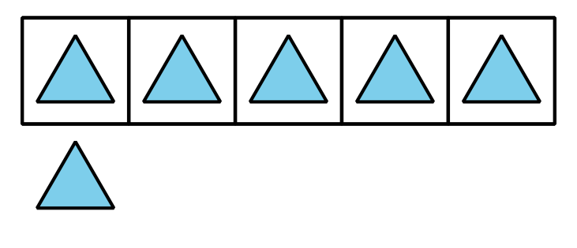
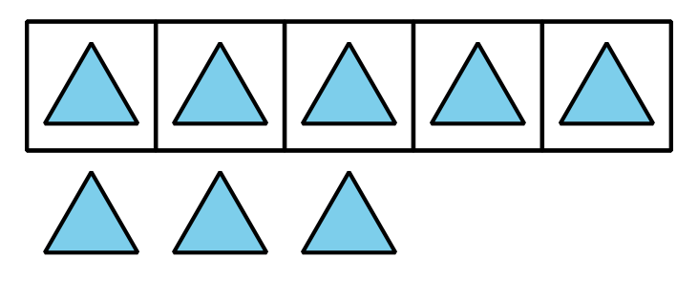
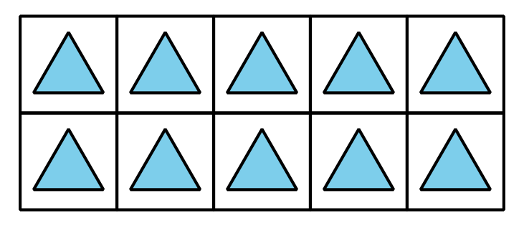
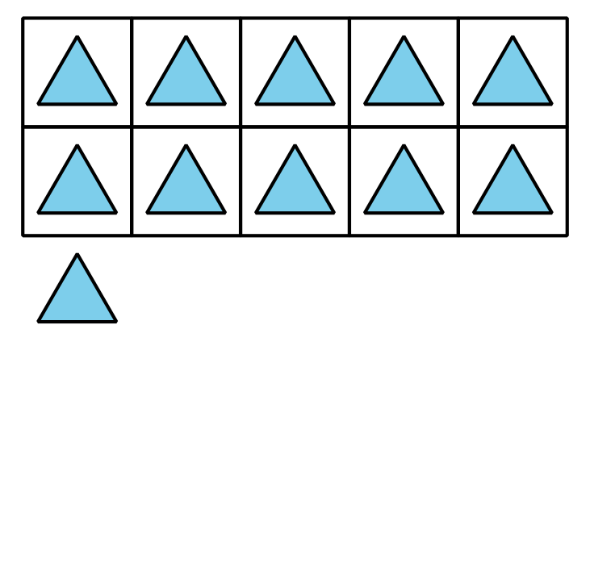

1.3: Centers: Choice Time
Choose a center.
Geoblocks
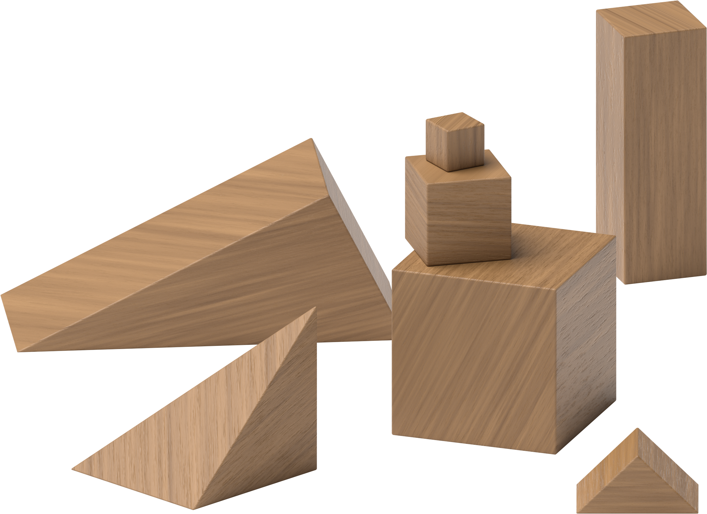
Grab and Count
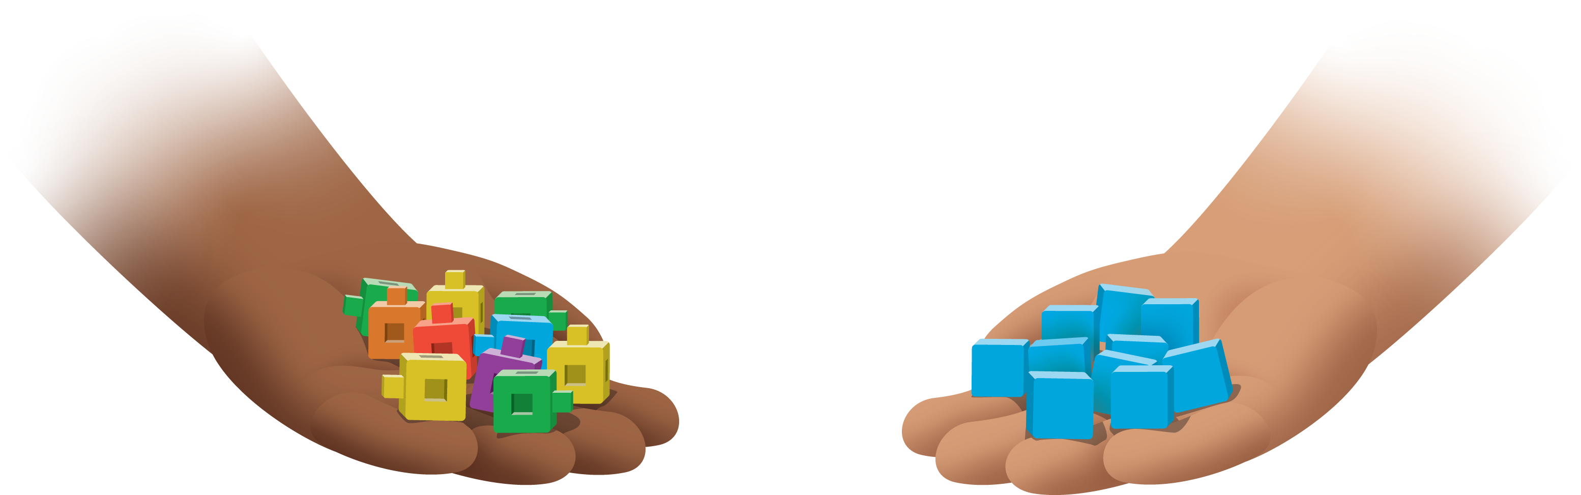
Find the Pair
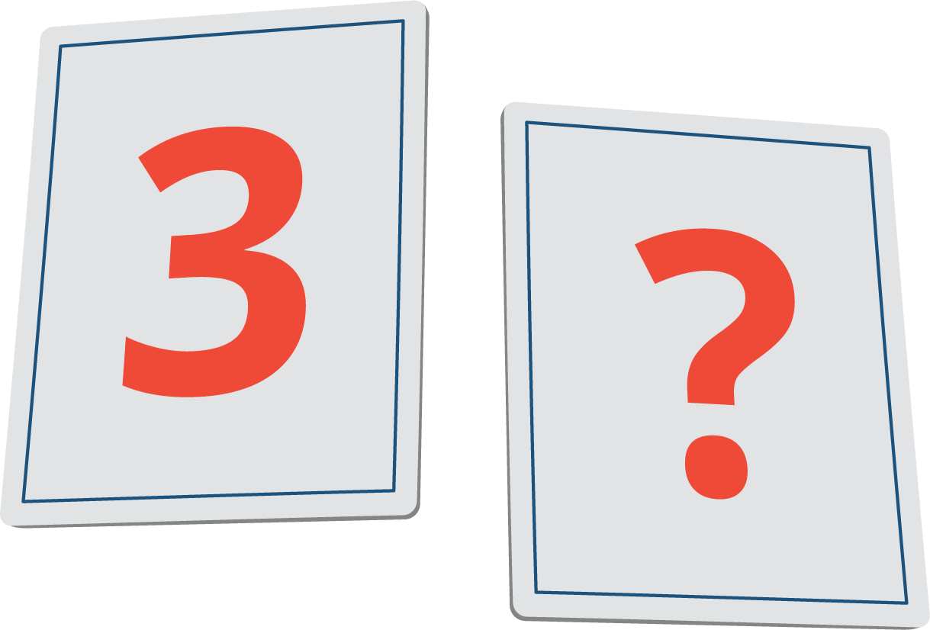
© CC BY 2021 Illustrative Mathematics®

