Unit 8 Lesson 12: Make Dot Images

WU How Many Do You See: Dots in Different Colors (Warm up)

Student Task Statement
How many do you see?
How do you see them?
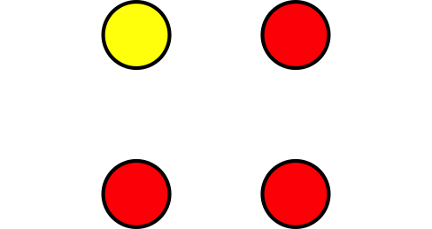
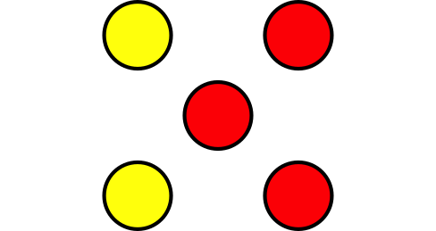

1 Make Your Own Dot Images

Student Task Statement

2 How Many Dots Do You See?

Student Task Statement

3 Centers: Choice Time

Student Task Statement
Choose a center.
5-frames
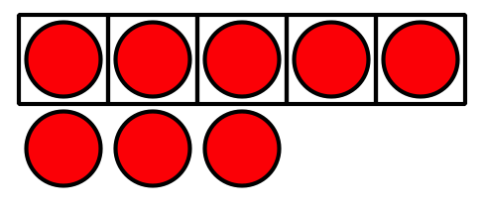
Roll and Add
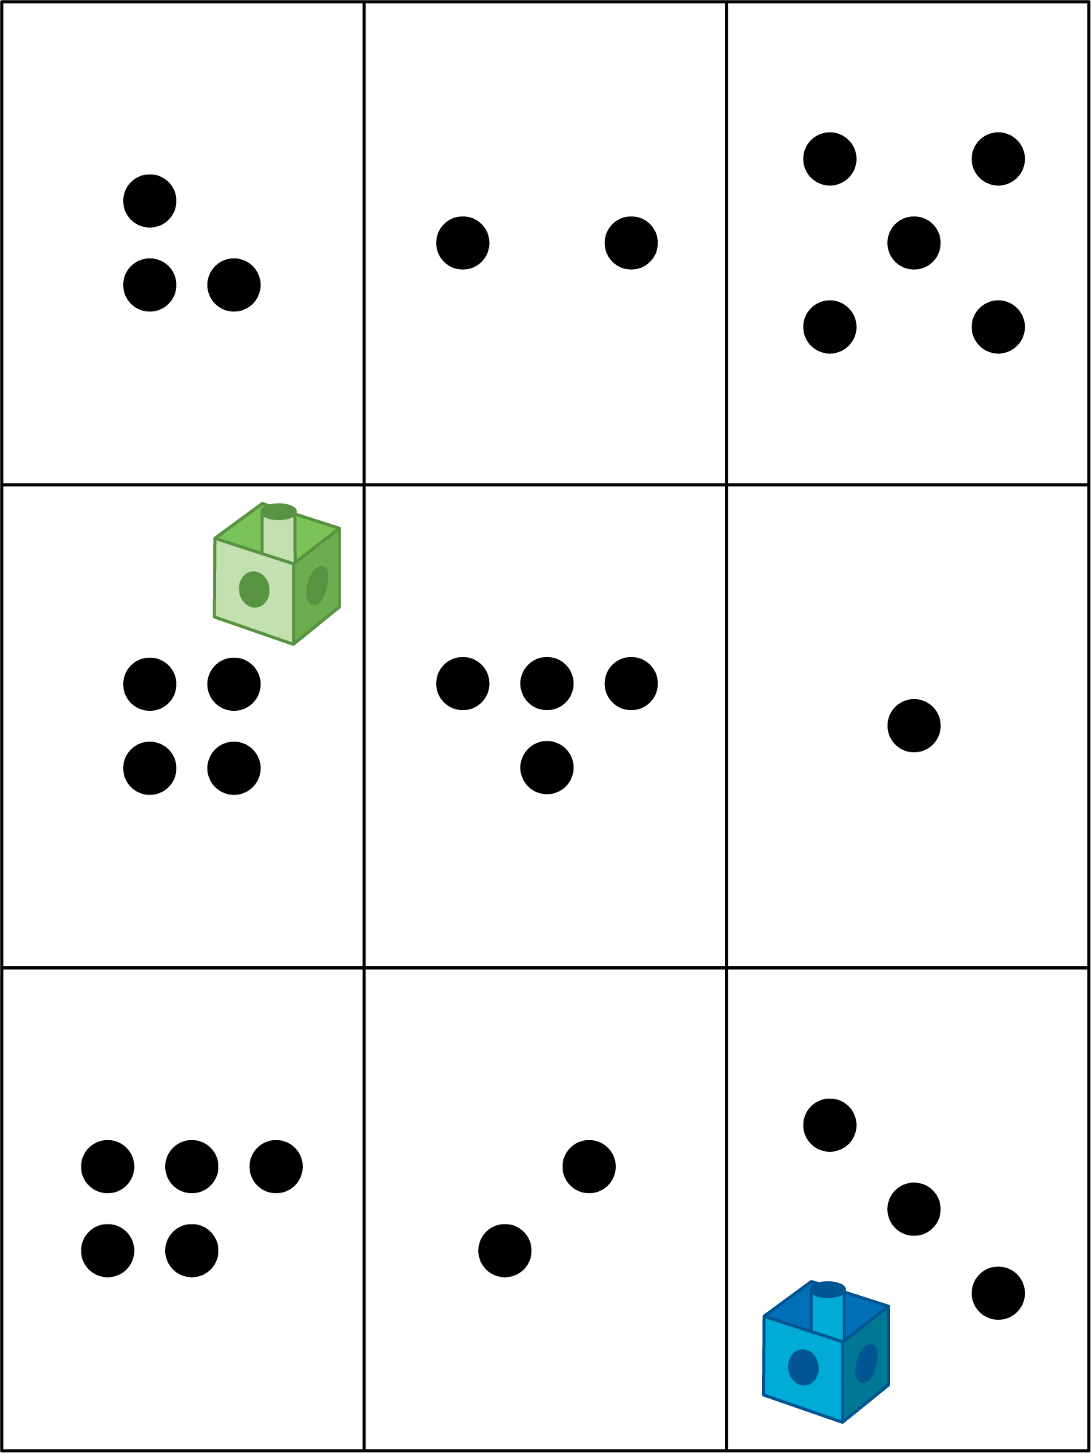
Bingo
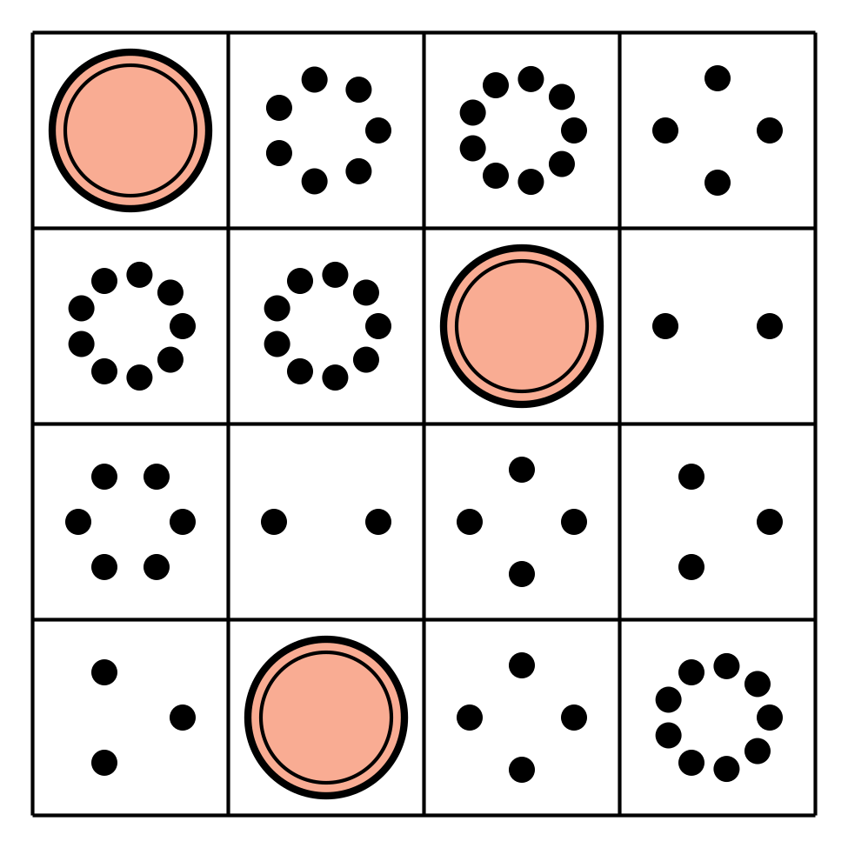
Geoblocks
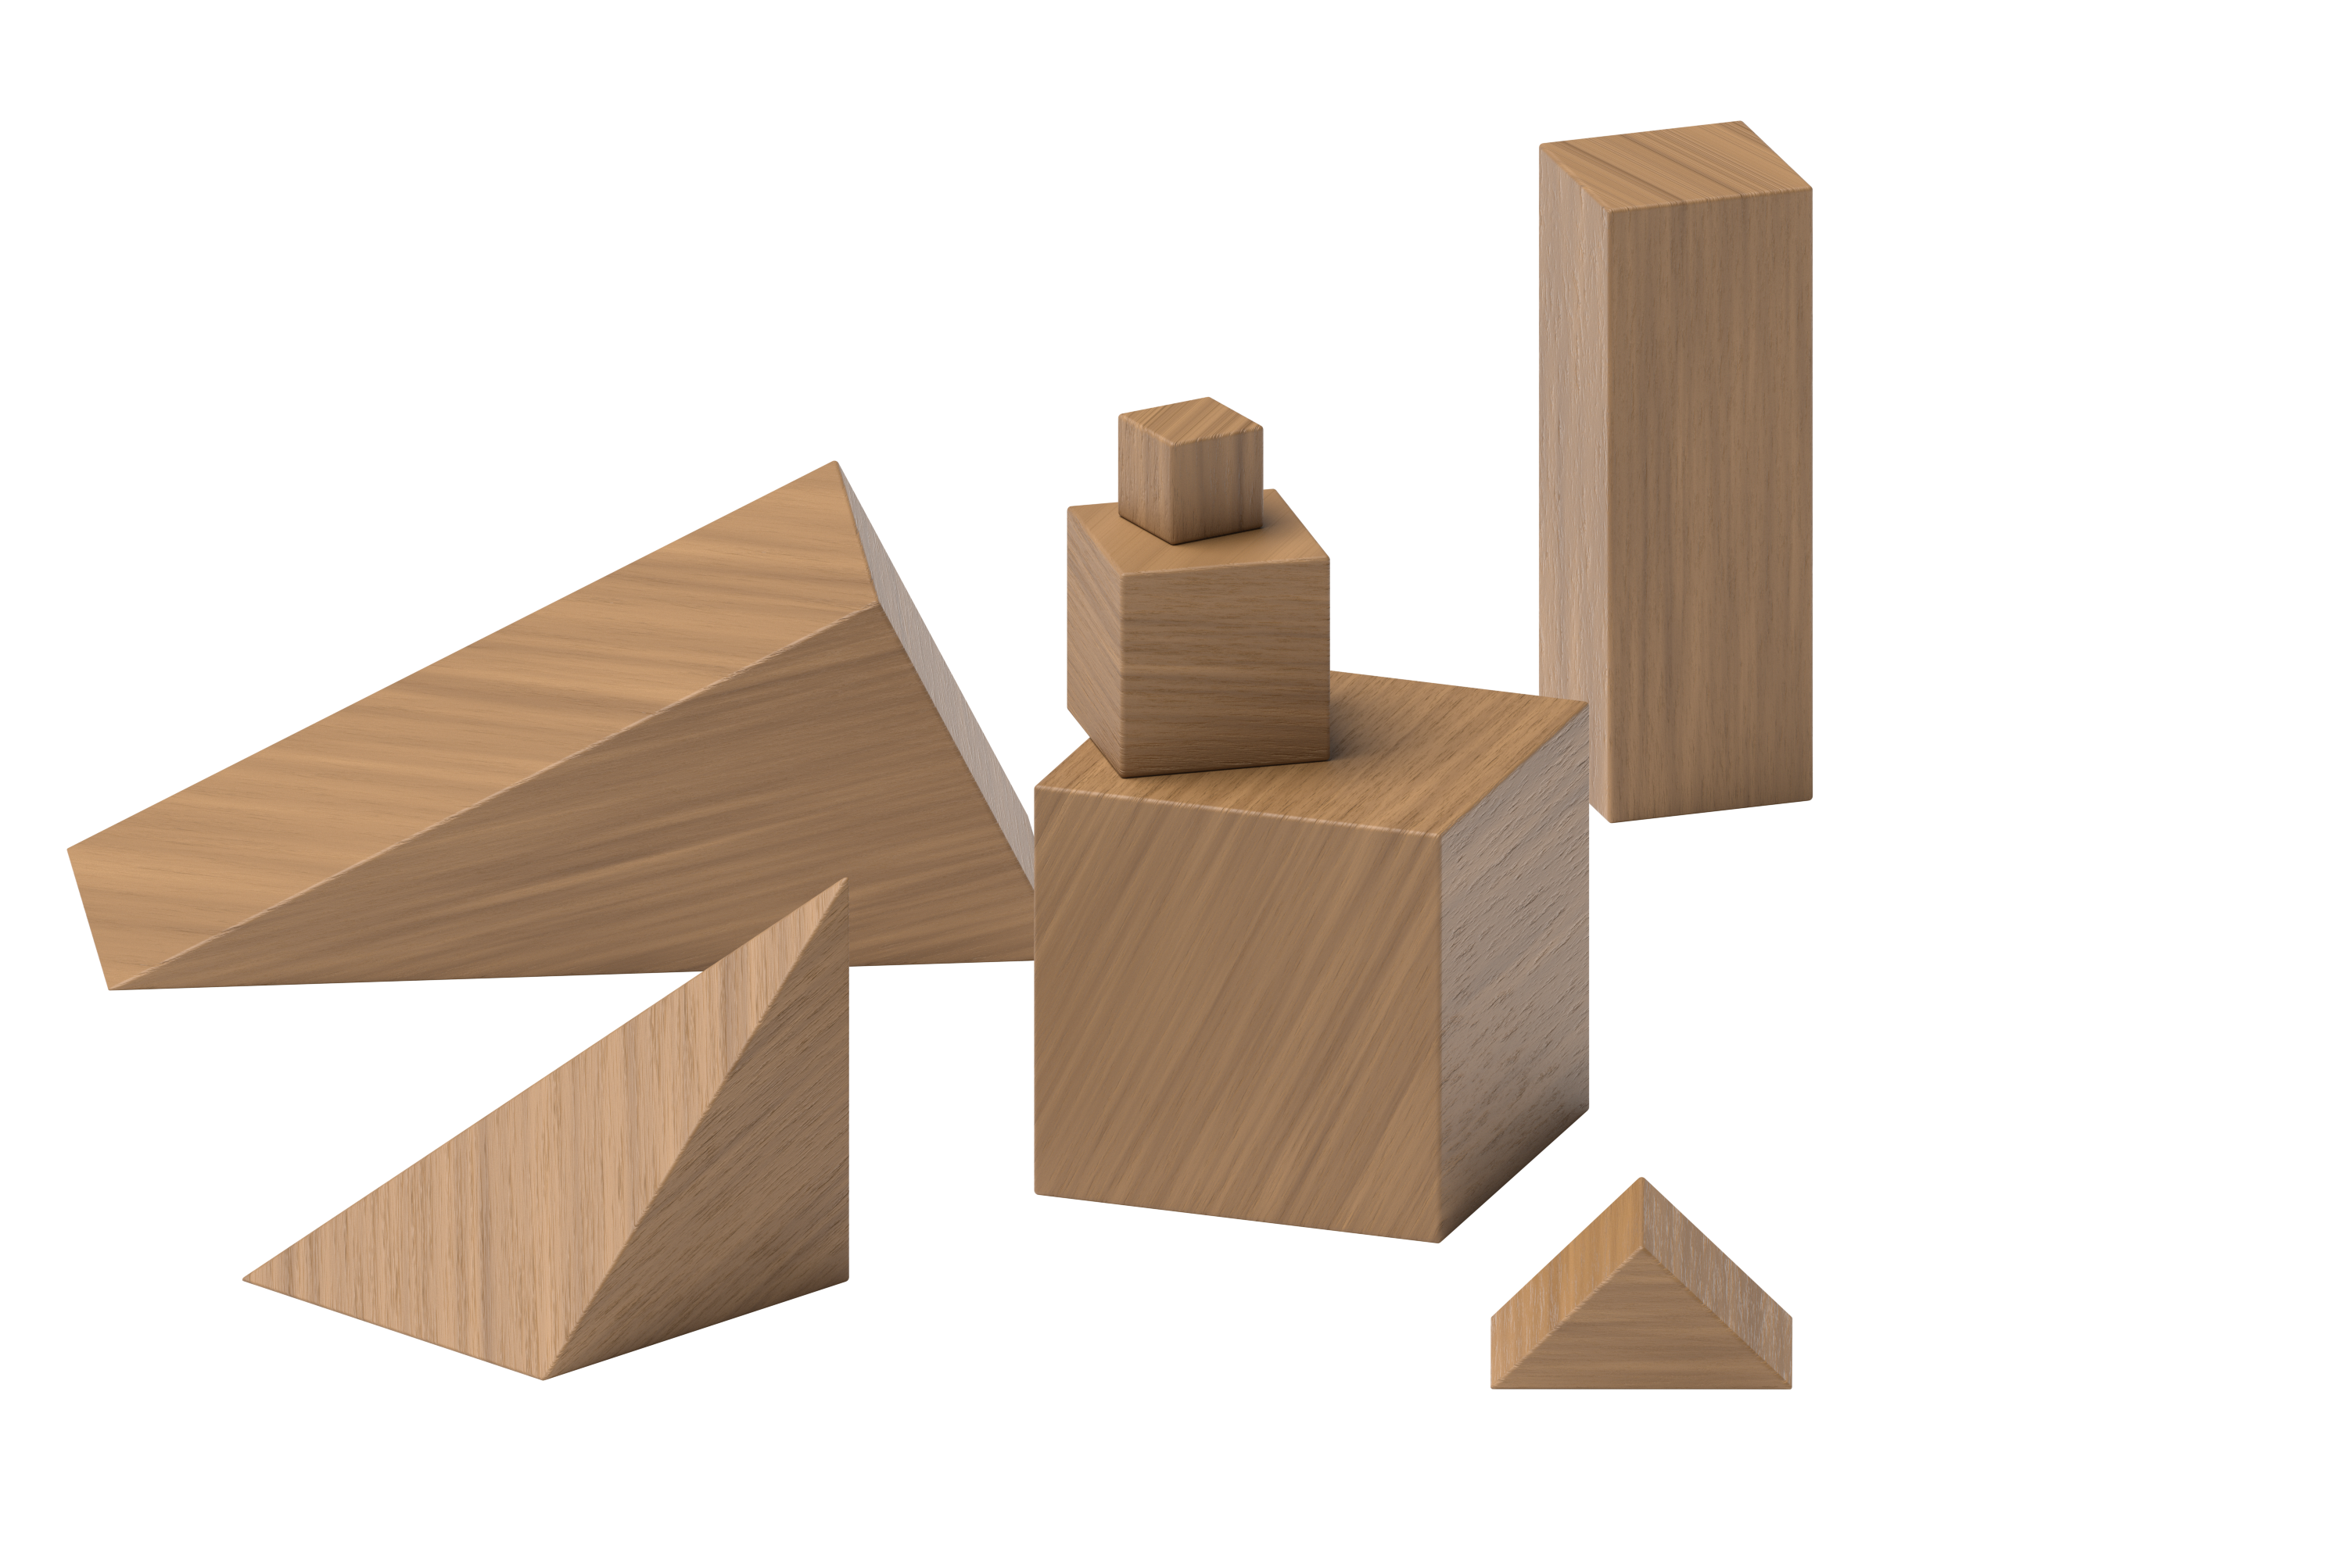
Find the Value of Expressions
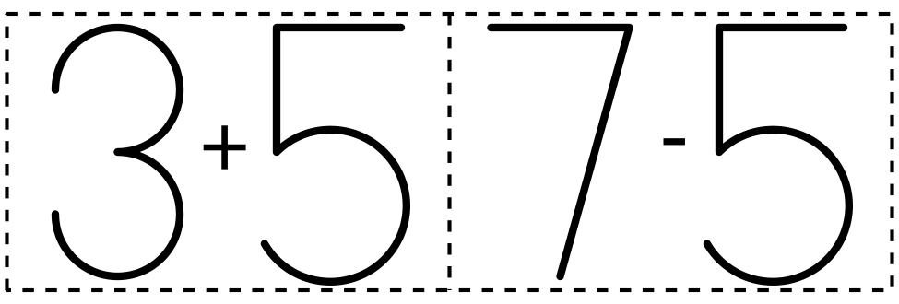

Images for Activity Synthesis
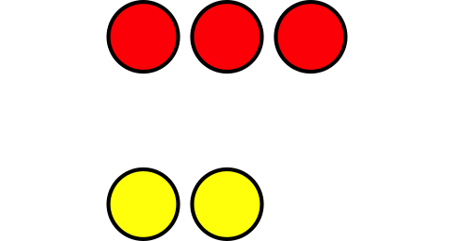
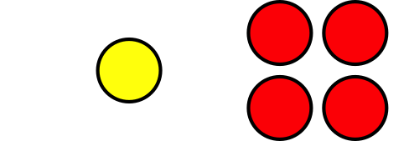
© CC BY 2021 Illustrative Mathematics®

