Lesson 9: You Ate the Whole Thing
- Let’s talk about the whole.

Warm-up: Number Talk: What's the Sum?
Find the value of each expression mentally.
- $20+10+10+5$
- $30+25$
- $35+15$
- $15+25+15$

9.1: Pizza to Share
Clare’s friends were going to share a pizza. The image shows how they cut the pizza.
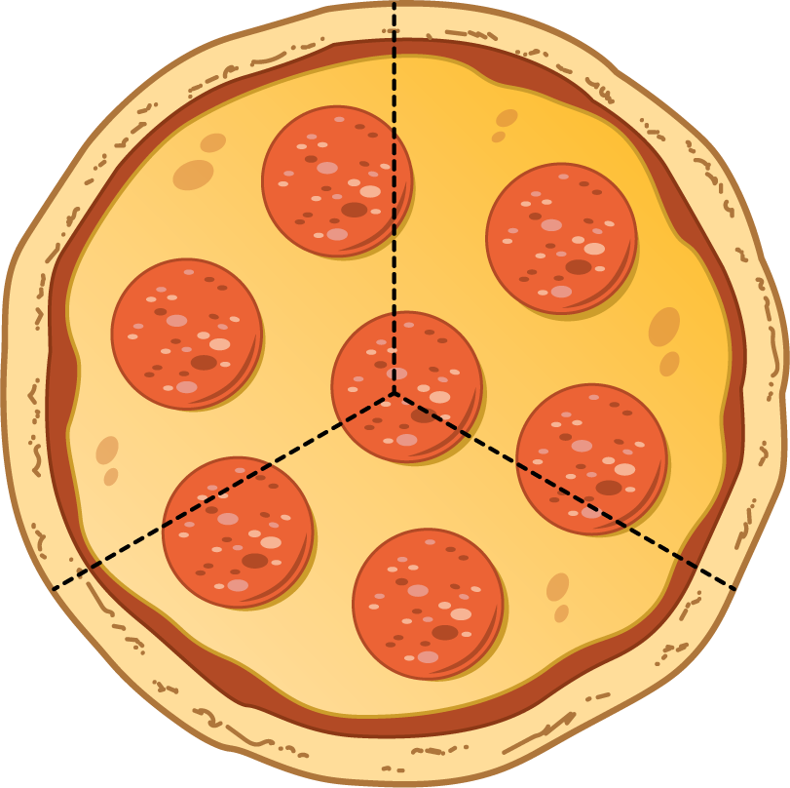
- Clare ate 3 slices and her friends got upset with her.
  - Why are her friends upset?
  - How many thirds did Clare eat?
  - How much of the pizza was left?
- Pizza Parts
- Group
- Priya
- Han
- Diego
  - Priya will eat ________________________ of the pizza.
  - Together they will eat ________________________ of the pizza.
- Pizza Parts
- 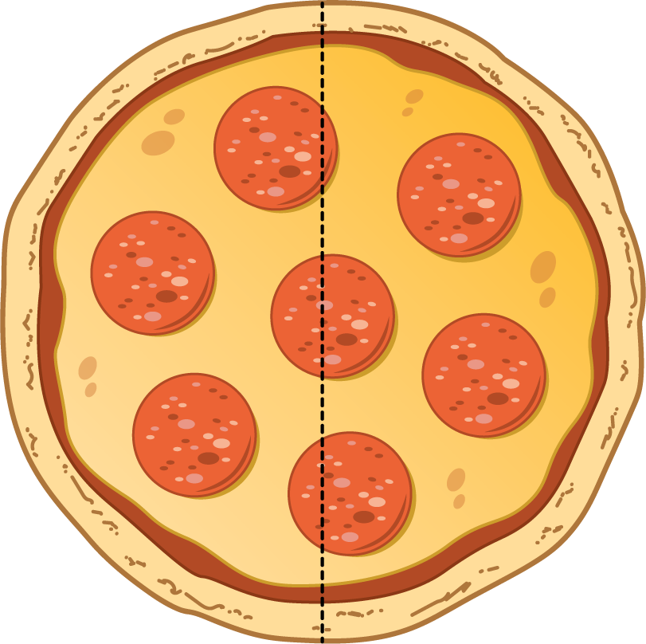
- Group
- Jada
- Mai
  - Each girl will eat ______________________ of the pizza.
  - Together they will eat ________________________ of the pizza.
- Pizza Parts
- 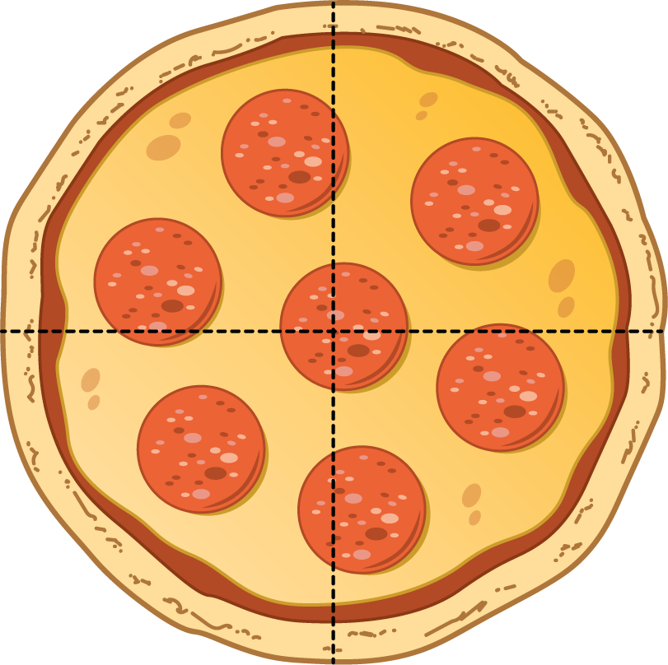
- Group
- Elena
- Tyler
- Lin
- Kiran
  - How much pizza will each child eat? ________________________
  - How much pizza will they eat in all? ________________________

9.2: Equal Shares of the Pie
Write the letter of each image next to the matching story.
A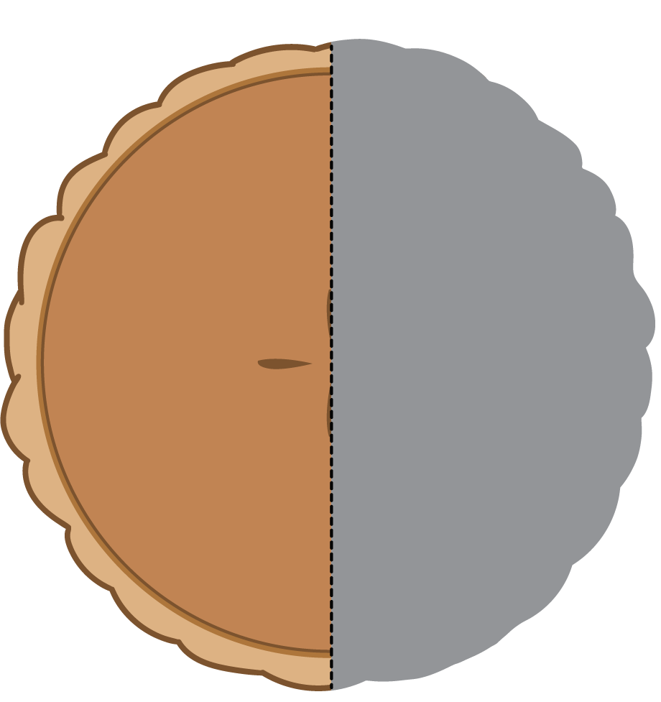
B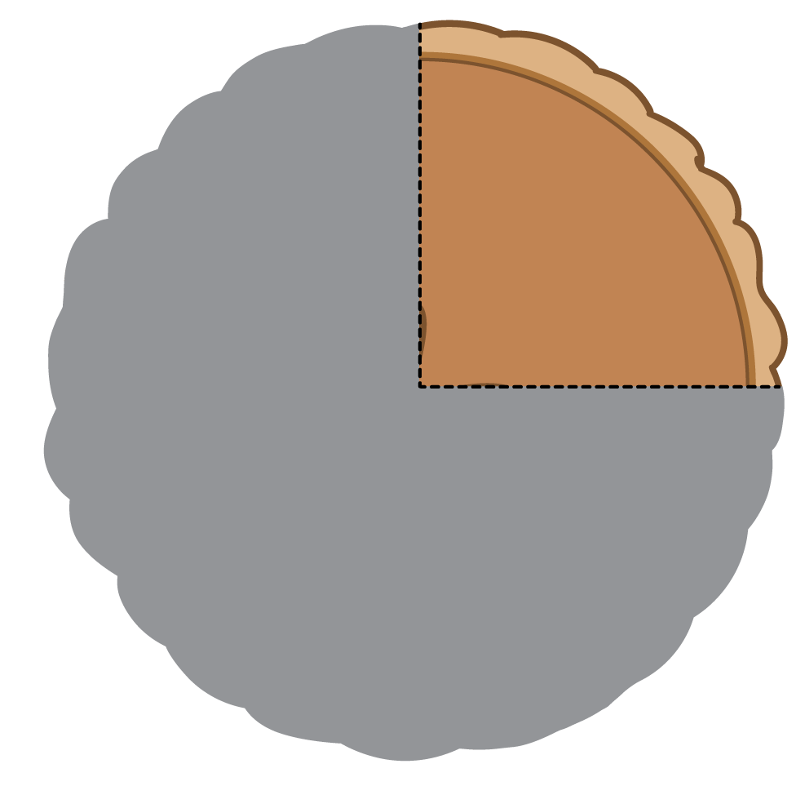
C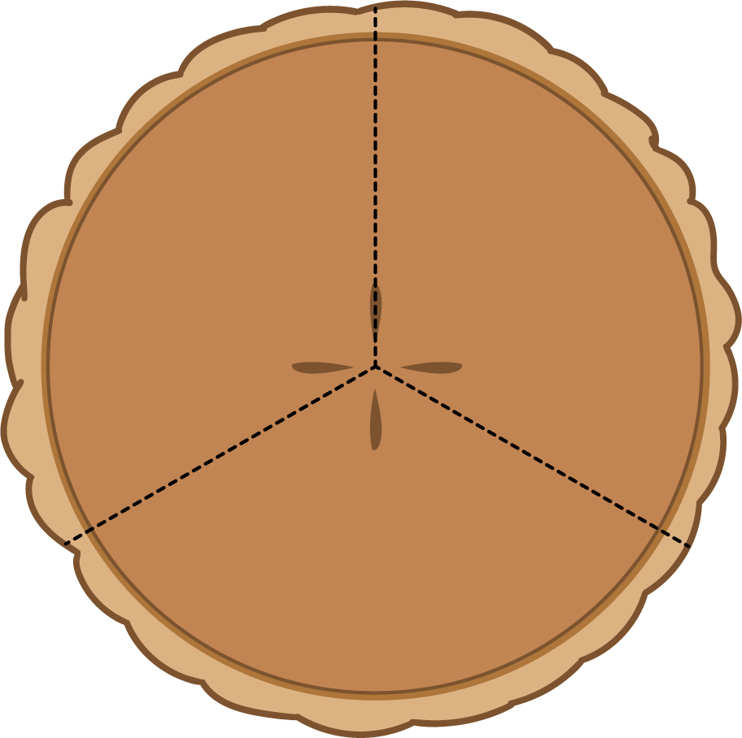
D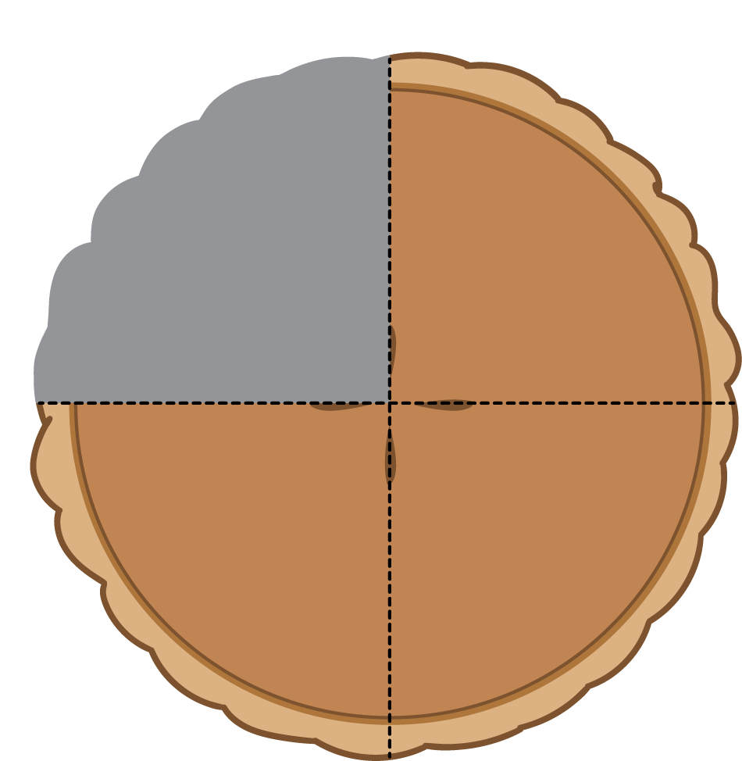
- Noah ate most of the pie. He left a quarter of the pie for Diego. __________
- Lin gave away a half of her pie and kept a half of the pie for herself. __________
- Tyler cut a pie into four equal pieces. He ate a quarter of the pie. __________
- Mai sliced the pie to share it equally with Clare and Priya. __________
  - How much of the pie will they each get? a _________________
  - How much of the pie will they eat in all? _________________
- Now you try.
  - Partition the circle into four equal pieces.
  - Shade in a quarter of the circle red.
  - Shade in the rest of the circle blue.
- How much of the circle is shaded? _____________________________

  - Partition the circle into 2 equal pieces.
  - Shade one half of the circle blue.
  - Color the other piece yellow.
- How much of the circle is yellow? ________________________
- How much of the circle is shaded? ________________________

Section Summary
Section Summary
We have learned a lot about composing and decomposing shapes. Sometimes the pieces make up a whole shape, but all of the pieces are not the same size. Sometimes the whole is partitioned into equal pieces and they have special names. We practiced partitioning shapes into halves, thirds, and fourths. We learned that halves, thirds, and fourths of the same shape can look different. We learned that we can say the whole shape is 2 halves, 3 thirds, 4 fourths, or 4 quarters.
How can you use halves, thirds, fourths, or quarters to describe the pieces of these shapes? How can you use halves, thirds, fourths, or quarters to describe the whole shape?
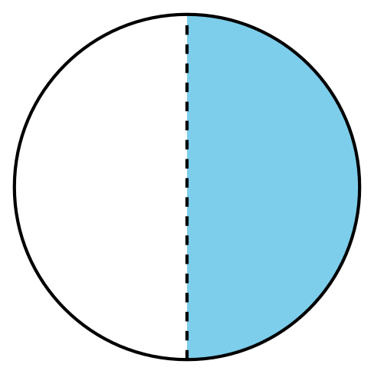
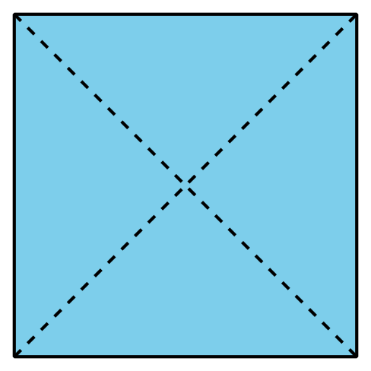
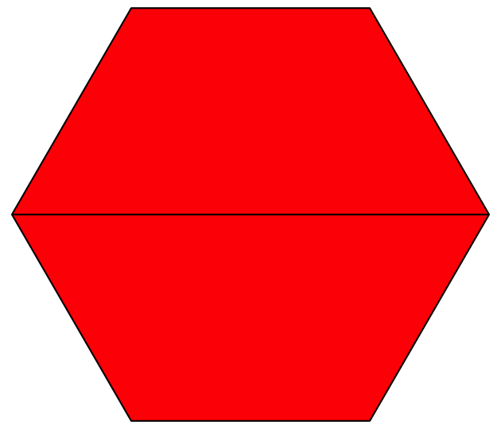
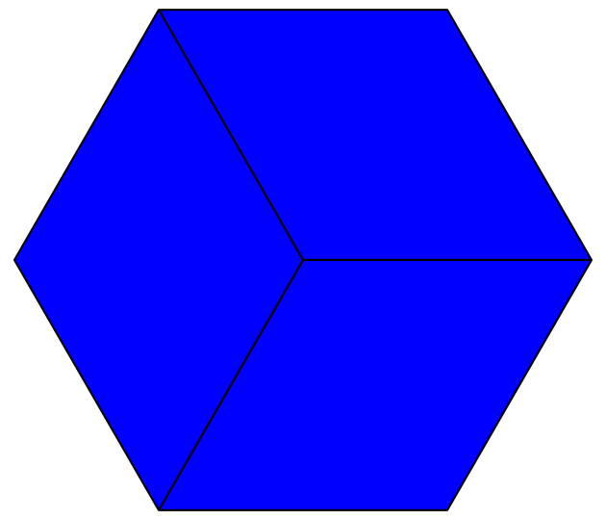
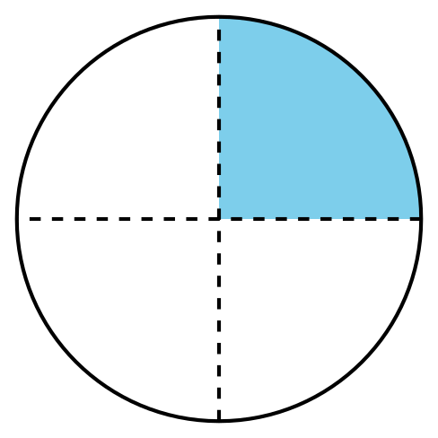
© CC BY 2021 Illustrative Mathematics®

