Unit 8 Lesson 1: Can You Share?

WU Notice and Wonder: Sharing is Caring (Warm up)

Student Task Statement
What do you notice? What do you wonder?
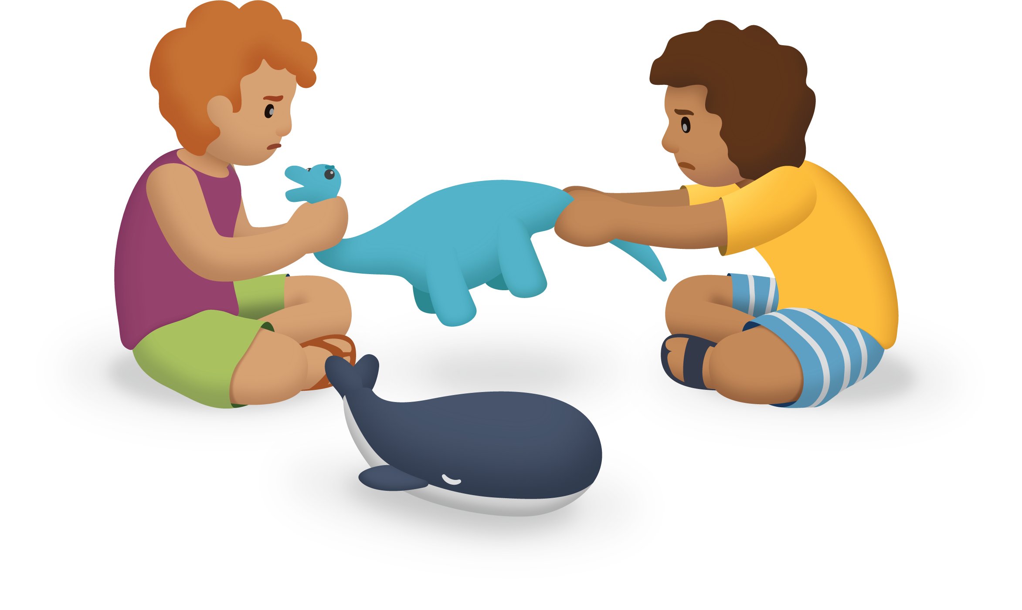

1 My Fair Share

Student Task Statement
Choose a container of counters. Share the counters equally with your partner. Then complete the table to show the total number of objects and how many you each received.
total | my share | my partner’s share | number of leftovers

Activity Synthesis
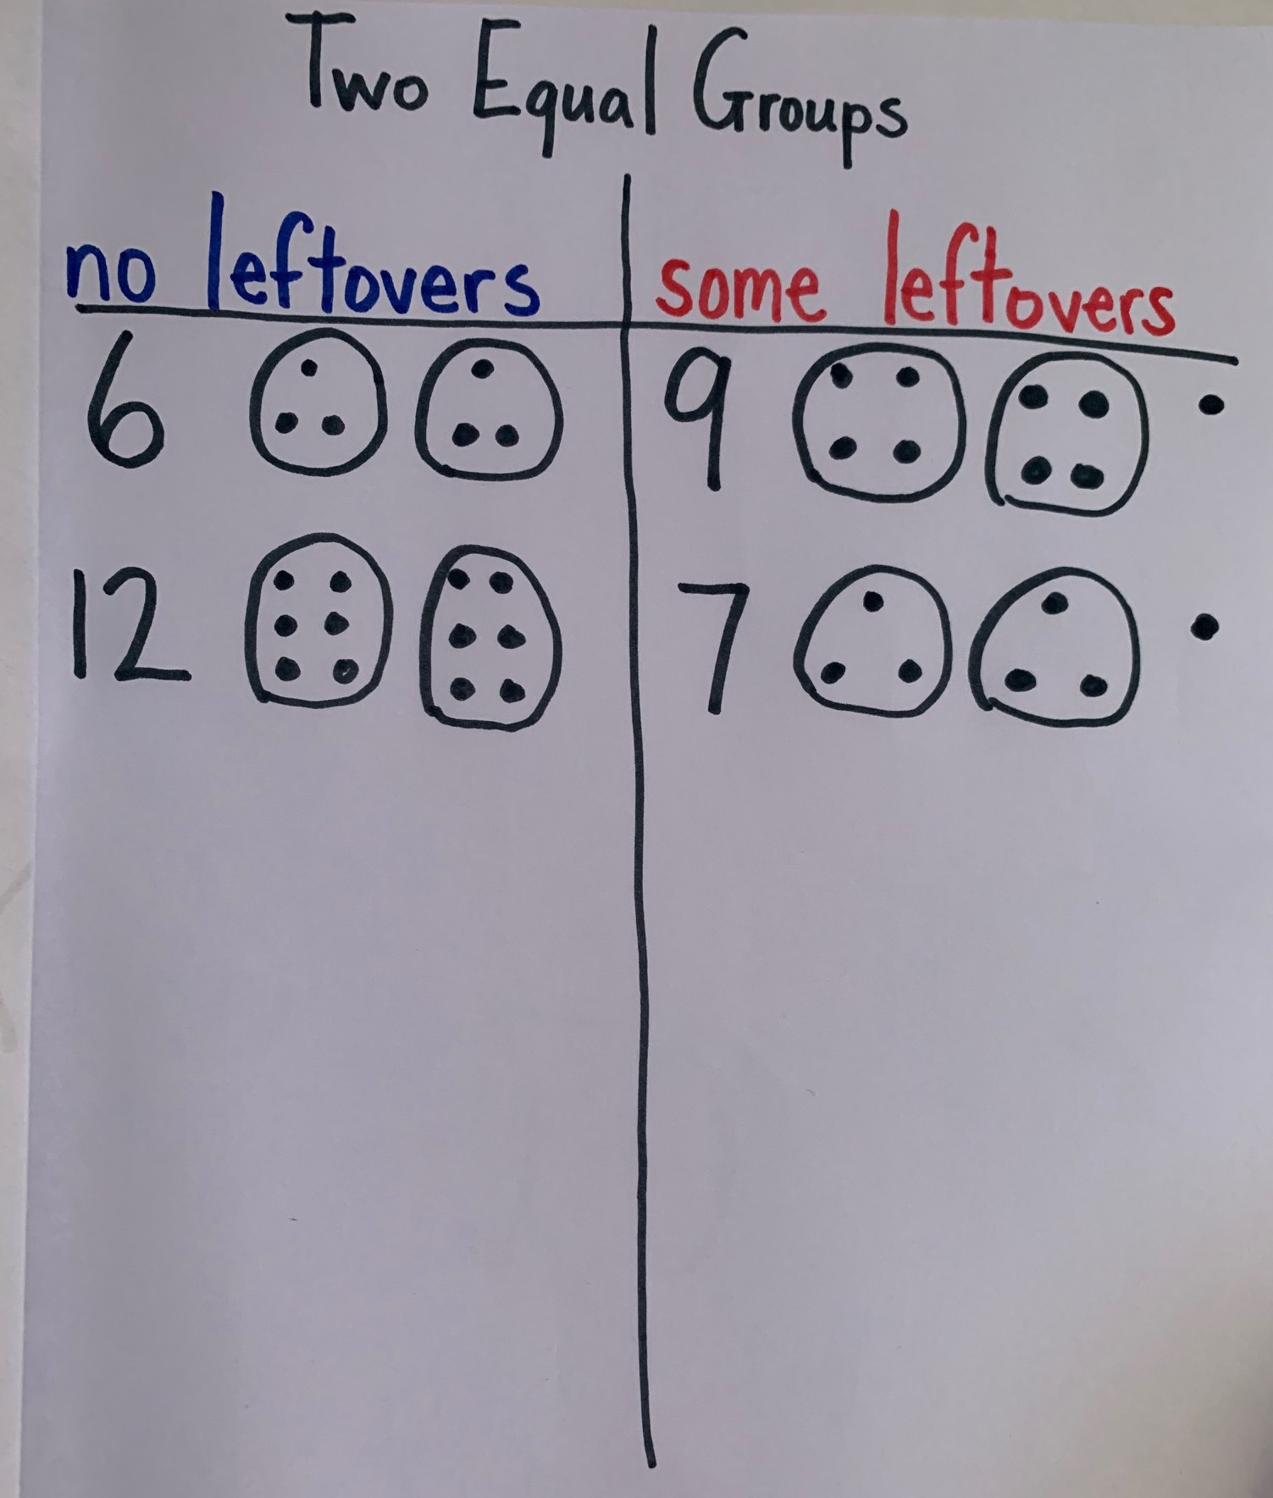

2 Share the Marbles

Images for Launch

Student Task Statement
Andre has a collection of 17 marbles. He wants to play a game with his sister. They both need to start with the same number of marbles and they want to use as many as they can.
- How many marbles would Andre and his sister get? Would there be any marbles left out of the game? Show your thinking.
- What if Andre had 18 marbles? How many would each person get? Would there be any marbles left out? Show your thinking.
- What if Andre had 20 marbles? How many would each person get? Would there be any marbles left out?

Activity Synthesis

Images for Activity Synthesis
A
B
C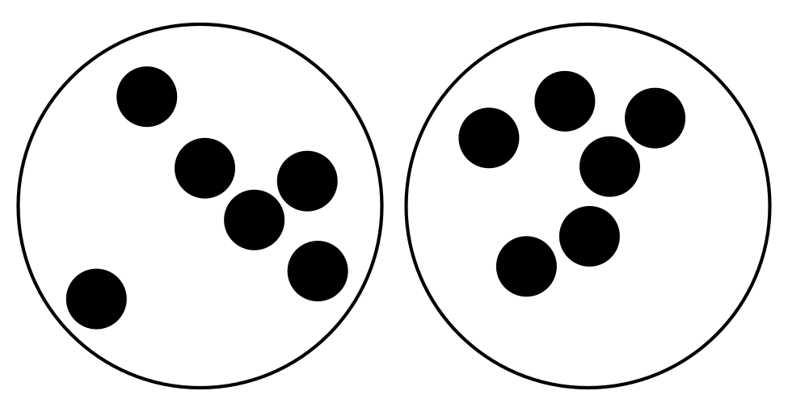
© CC BY 2021 Illustrative Mathematics®

