Lesson 3: Shapes That Are Flat
- Let’s sort flat shapes and explain how we sorted.

Warm-up: Which One Doesn’t Belong: All the Shapes
Which one doesn’t belong?
A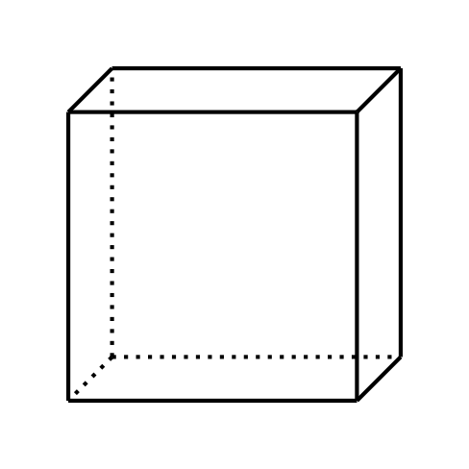
B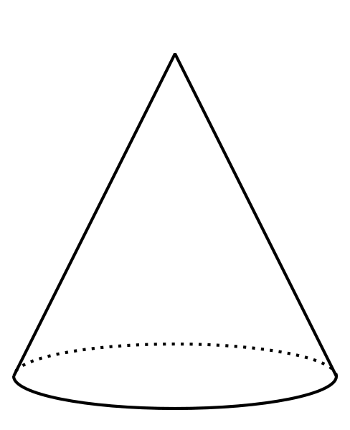
C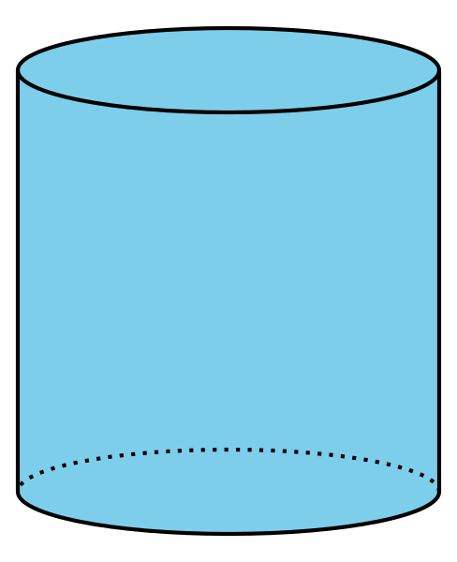
D

3.2: Shape Sort Gallery Walk
Group 1: They sorted
Group 2: They sorted
Group 3: They sorted
© CC BY 2021 Illustrative Mathematics®

