Unit 7 Lesson 16: Subtract Within 1,000

WU True or False: Equations Based on Place Value (Warm up)

Student Task Statement
Decide if each statement is true or false. Be prepared to explain your reasoning.
- 2 hundreds $+$ 3 tens $+$ 4 ones $=$ 2 hundreds $+$ 3 tens $+$ 14 ones
- 2 hundreds $+$ 3 tens $+$ 4 ones $=$ 1 hundred $+$ 13 tens $+$ 4 ones
- 1 hundred $+$ 13 tens $+$ 4 ones $=$ 1 hundred $+$ 12 tens $+$ 14 ones

1 Jada’s Thinking

Student Task Statement
Lin’s diagram:
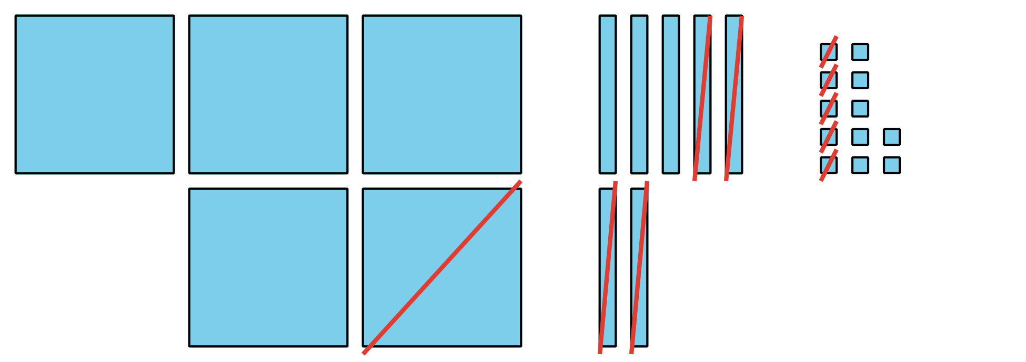
Jada’s equations:
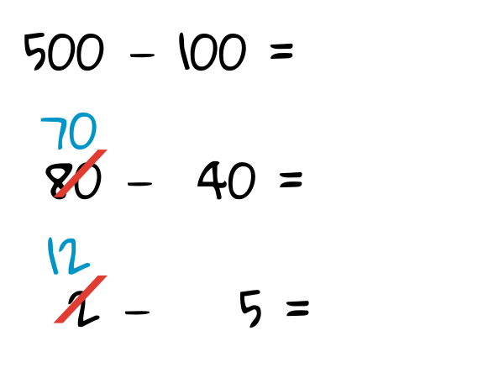

  - Discuss how Jada’s equations match Lin’s diagram.
  - Finish Jada’s work to find the value of $582−145.$
- Jada is thinking about how to find the value of $402−298.$
  - Jada says she knows a way to count on to find the difference. She showed her thinking using a number line.
  - 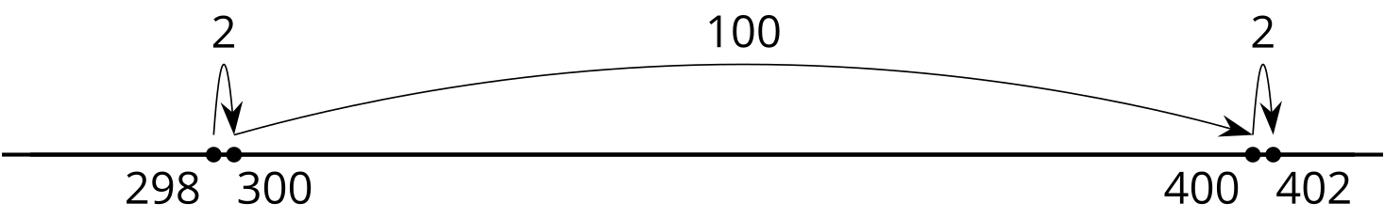
  - Explain Jada’s thinking.
  - Jada says you can’t decompose to find the value of $402−298$ because there aren’t any tens. Do you agree with Jada? Use base-ten blocks, diagrams, or other representations to show your thinking.

2 Find It Your Way

Student Task Statement
Find the value of each expression in a way that makes sense to you. Show your thinking. Organize it so it can be followed by others.
- $535−214$
- $700−589$
- $683−398$
- $918−608$
- $735−457$
- $602−487$
© CC BY 2021 Illustrative Mathematics®

