Unit 6 Lesson 3: Equations for Functions

1 A Square’s Area (Warm up)

Student Task Statement
Fill in the table of input-output pairs for the given rule. Write an algebraic expression for the rule in the box in the diagram.
input | output
8
2.2
$12\frac{1}{4}$
$s$

2 Diagrams, Equations, and Descriptions

Student Task Statement
Record your answers to these questions in the table provided.
- Match each of these descriptions with a diagram:
  - the circumference, $C$, of a circle with radius, $r$
  - the distance in miles, $d$, that you would travel in $t$ hours if you drive at 60 miles per hour
  - the output when you triple the input and subtract 4
  - the volume of a cube, $v$ given its edge length, $s$
- Write an equation for each description that expresses the output as a function of the input.
- Find the output when the input is 5 for each equation.
- Name the independent and dependent variables of each equation.
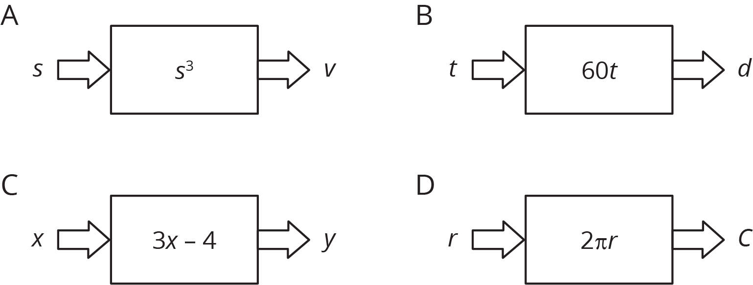
description | a | b | c | d
diagram
equation
input = 5
output = ?
independent
variable
dependent
variable

3 Dimes and Quarters

Student Task Statement
Jada had some dimes and quarters that had a total value of $12.50. The relationship between the number of dimes, $d$, and the number of quarters, $q$, can be expressed by the equation $0.1d+0.25q=12.5$.
- If Jada has 4 quarters, how many dimes does she have?
- If Jada has 10 quarters, how many dimes does she have?
- Is the number of dimes a function of the number of quarters? If yes, write a rule (that starts with $d=$...) that you can use to determine the output, $d$, from a given input, $q$. If no, explain why not.
- If Jada has 25 dimes, how many quarters does she have?
- If Jada has 30 dimes, how many quarters does she have?
- Is the number of quarters a function of the number of dimes? If yes, write a rule (that starts with $q=$...) that you can use to determine the output, $q$, from a given input, $d$. If no, explain why not.

Activity Synthesis
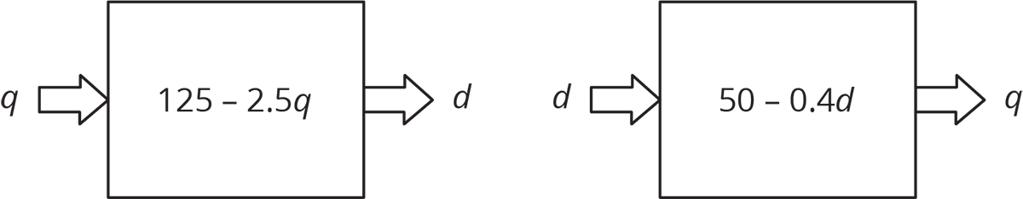
© CC BY Open Up Resources. Adaptations CC BY IM.

