## Unit 5 Lesson 3: Changing Elevation

### 1 That's the Opposite (Warm up)

#### Student Task Statement

1. Draw arrows on a number line to represents these situations:​
   1. The temperature was -5 degrees. Then the temperature rose 5 degrees.
   * A number line with 21 evenly spaced tick marks. 
   * ​
   1. A climber was 30 feet above sea level. Then she descended 30 feet.
   * A number line with 21 evenly spaced tick marks. 
   * ​
2. What’s the opposite?
   1. Running 150 feet east.
   2. Jumping down 10 steps.
   3. Pouring 8 gallons into a fish tank.

### 2 Cliffs and Caves

#### Student Task Statement

1. A mountaineer is climbing on a cliff. She is 400 feet above the ground. If she climbs up, this will be a positive change. If she climbs down, this will be a negative change.
   1. Complete the table.

|  |  |  |  |
| --- | --- | --- | --- |
|  | * + starting elevation (feet) | * + change (feet) | * + final elevation (feet) |
| * + A | * + +400 | * + 300 up |  |
| * + B | * + +400 | * + 150 down |  |
| * + C | * + +400 | * + 400 down |  |
| * + D | * + +400 |  | * + +50 |

* + 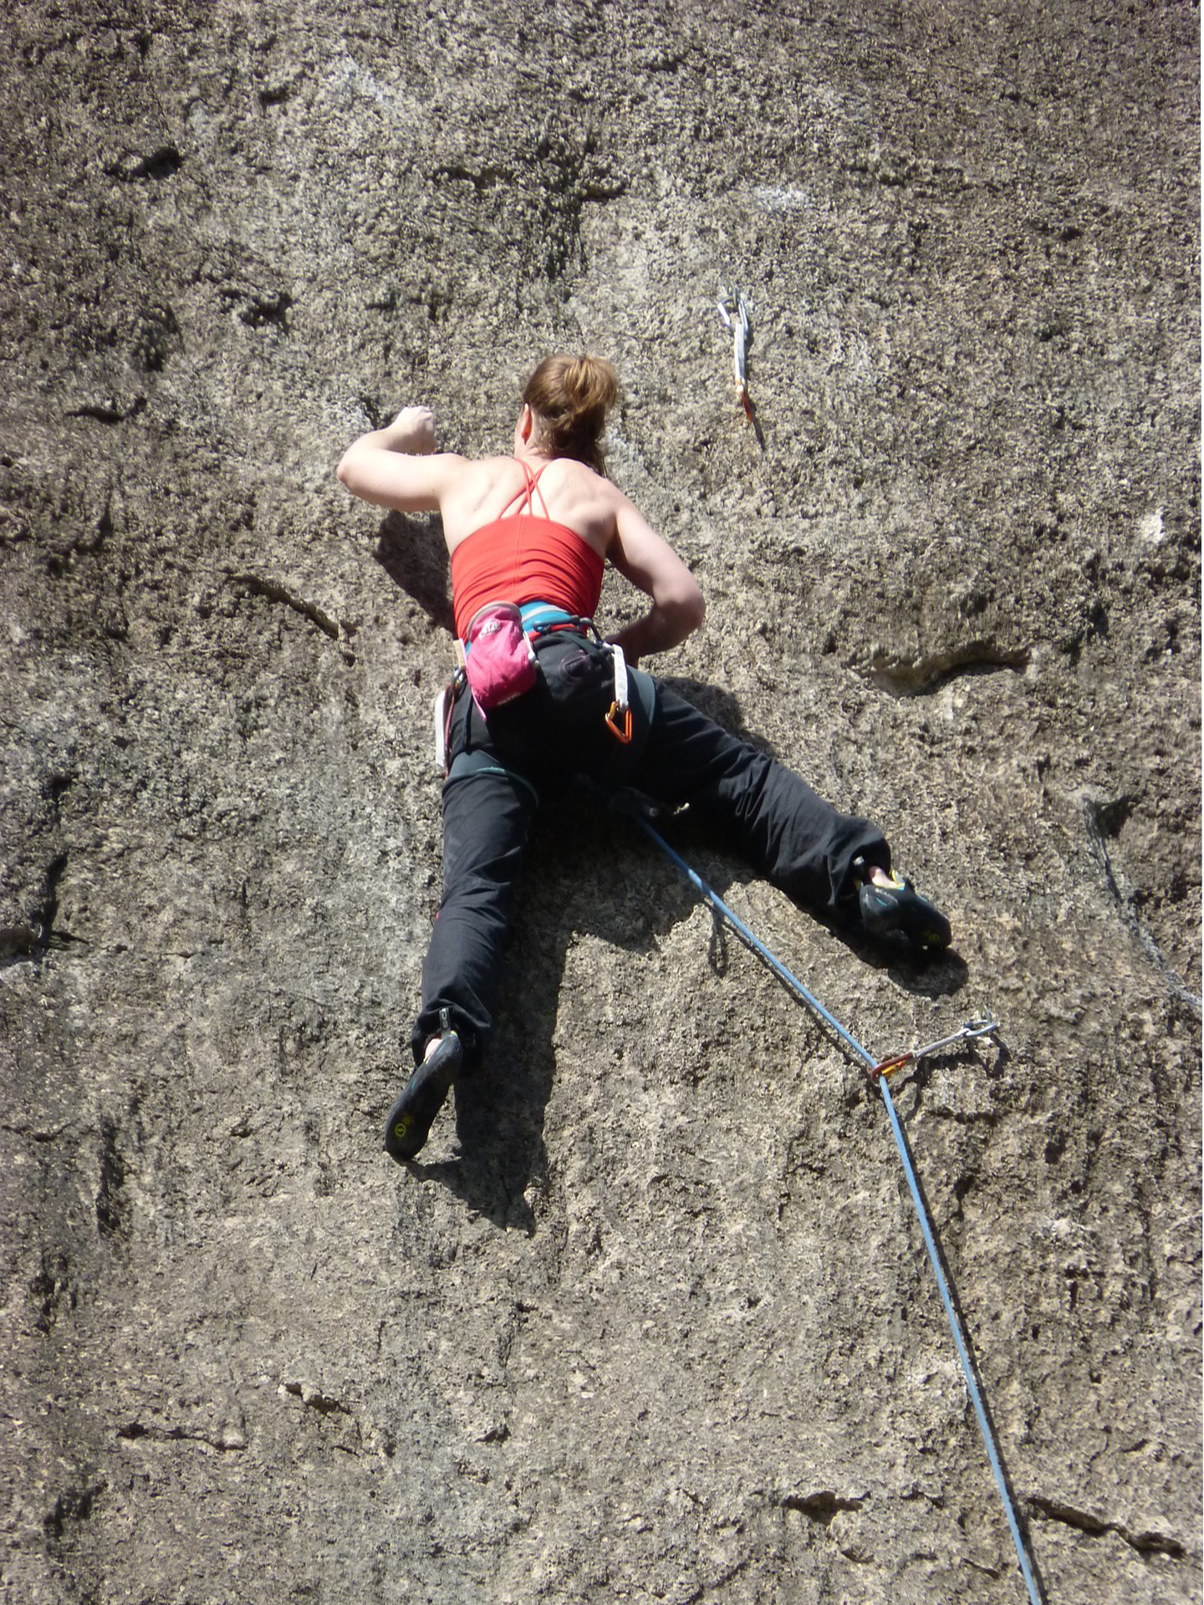
  1. Write an addition equation and draw a number line diagram for B. Include the starting elevation, change, and final elevation in your diagram.
  + A number line with 21 evenly spaced tick marks. 
  + ​

1. A spelunker is down in a cave next to the cliff. If she climbs down deeper into the cave, this will be a negative change. If she climbs up, whether inside the cave or out of the cave and up the cliff, this will be a positive change.
   1. Complete the table.

|  |  |  |  |
| --- | --- | --- | --- |
|  | * + starting elevation (feet) | * + change (feet) | * + final elevation (feet) |
| * + A | * + -200 | * + 150 down |  |
| * + B | * + -200 | * + 100 up |  |
| * + C | * + -200 | * + 200 up |  |
| * + D | * + -200 | * + 250 up |  |
| * + E | * + -200 |  | * + -500 |

* 1. Write an addition equation and draw a number line diagram for C and D. Include the starting elevation, change, and final elevation in your diagram.
  + A number line with 21 evenly spaced tick marks. 
  + ​
  + A number line with 21 evenly spaced tick marks. 
  + ​
  1. What does the expression tell us about the spelunker? What does the value of the expression tell us?

### 3 Adding Rational Numbers

#### Student Task Statement

Find the sums.

### 4 School Supply Number Line (Optional)

#### Student Task Statement

Your teacher will give you a long strip of paper.

Follow these instructions to create a number line.

1. Fold the paper in half along its length and along its width.
2. Unfold the paper and draw a line along each crease.
3. Label the line in the middle of the paper 0. Label the right end of the paper and the left end of the paper .
4. Select two objects of different lengths, for example a pen and a gluestick. The length of the longer object is and the length of the shorter object is .
5. Use the objects to measure and label each of the following points on your number line.
6. Complete each statement using <, >, or =. Use your number line to explain your reasoning.
   1. _____
   2. _____
   3. _____
   4. _____
   5. _____



© CC BY Open Up Resources. Adaptations CC BY IM.