Unit 4 Lesson 15: Evaluating Expressions with Exponents

1 Revisiting the Cube (Warm up)

Student Task Statement
Based on the given information, what other measurements of the square and cube could we find?
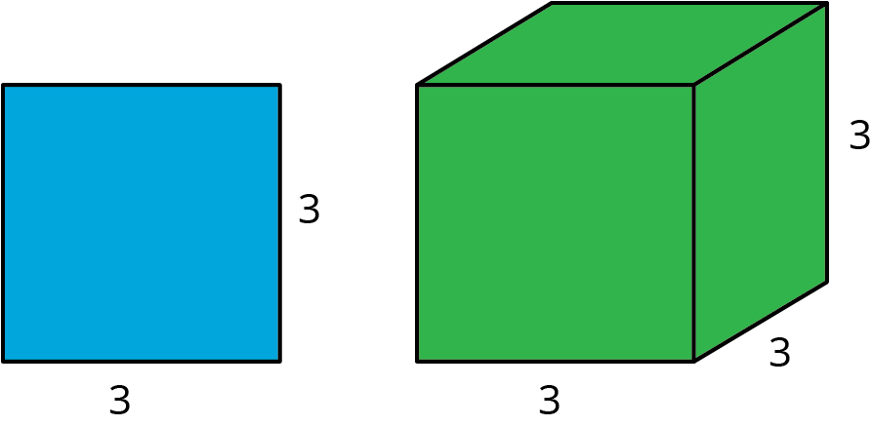

2 Calculating Surface Area

Student Task Statement
A cube has side length 10 inches. Jada says the surface area of the cube is 600 in², and Noah says the surface area of the cube is 3,600 in². Here is how each of them reasoned:
Jada’s Method:
$6⋅{10}^{2}$
$6⋅100$
$600$
Noah’s Method:
$6⋅{10}^{2}$
${60}^{2}$
$3,​600$
Do you agree with either of them? Explain your reasoning.

3 Row Game: Expression Explosion

Student Task Statement
Evaluate the expressions in one of the columns. Your partner will work on the other column. Check with your partner after you finish each row. Your answers in each row should be the same. If your answers aren’t the same, work together to find the error.
column A | column B
$5^{2}+4$ | $2^{2}+25$
$2^{4}⋅5$ | $2^{3}⋅10$
$3⋅4^{2}$ | $12⋅2^{2}$
$20+2^{3}$ | $1+3^{3}$
$9⋅2^{1}$ | $3⋅6^{1}$
$\frac{1}{9}⋅{\left(\frac{1}{2}\right)}^{3}$ | $\frac{1}{8}⋅{\left(\frac{1}{3}\right)}^{2}$

© CC BY Open Up Resources. Adaptations CC BY IM.

