Lesson 2: Say It with Decimals
Let’s use decimals to describe increases and decreases.

2.1: Notice and Wonder: Fractions to Decimals
A calculator gives the following decimal representations for some unit fractions:
$\frac{1}{2}=0.5$
$\frac{1}{3}=0.3333333$
$\frac{1}{4}=0.25$
$\frac{1}{5}=0.2$
$\frac{1}{6}=0.1666667$
$\frac{1}{7}=0.142857143$
$\frac{1}{8}=0.125$
$\frac{1}{9}=0.1111111$
$\frac{1}{10}=0.1$
$\frac{1}{11}=0.0909091$
What do you notice? What do you wonder?

2.2: Repeating Decimals
- Use long division to express each fraction as a decimal.
- $\frac{9}{25}$
- $\frac{11}{30}$
- $\frac{4}{11}$
- What is similar about your answers to the previous question? What is different?
- Use the decimal representations to decide which of these fractions has the greatest value. Explain your reasoning.

Are you ready for more?
One common approximation for $π$ is $\frac{22}{7}$. Express this fraction as a decimal. How does this approximation compare to 3.14?

2.3: More and Less with Decimals
- Match each diagram with a description and an equation.
- Diagrams:
- 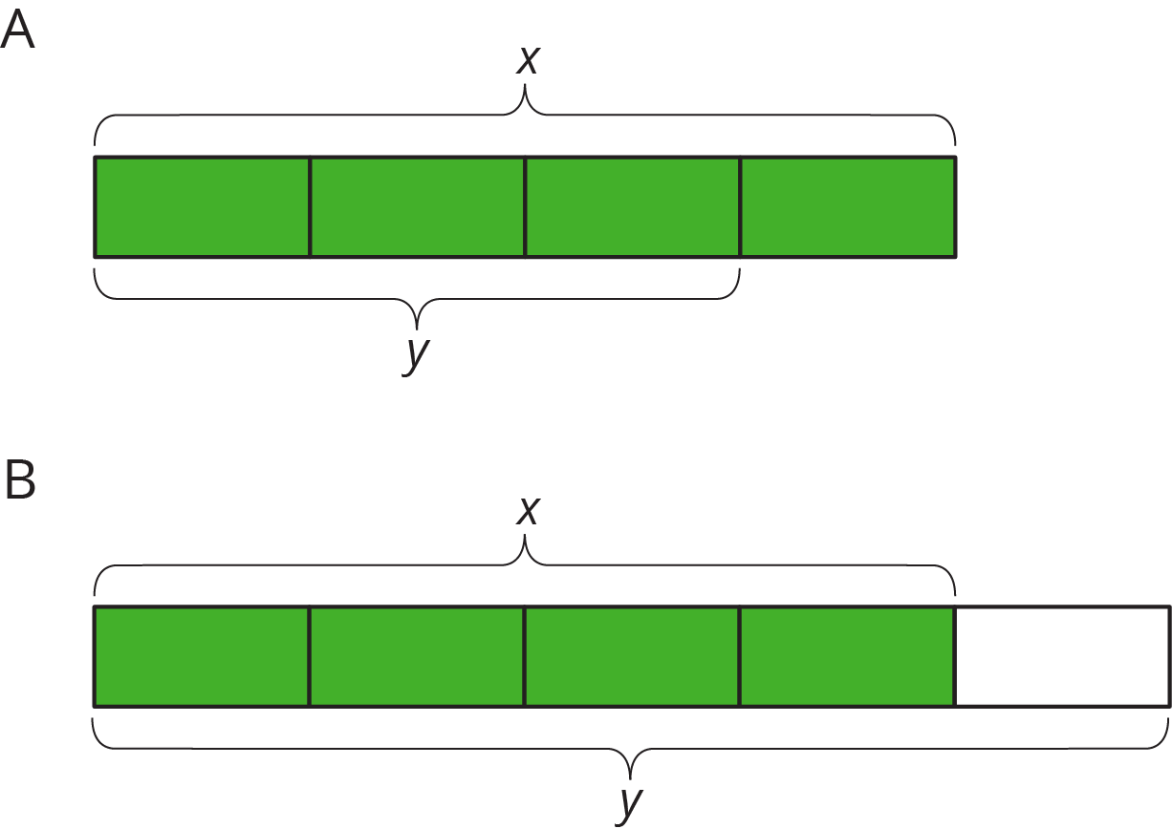
- Descriptions:
- An increase by $\frac{1}{4}$
- An increase by $\frac{1}{3}$
- An increase by $\frac{2}{3}$
- A decrease by $\frac{1}{5}$
- A decrease by $\frac{1}{4}$
- Equations:
- $y=1.\overset{¯}{6}x$
- $y=1.\overset{¯}{3}x$
- $y=0.75x$
- $y=0.4x$
- $y=1.25x$
- Draw a diagram for one of the unmatched equations.

2.4: Card Sort: More Representations
Your teacher will give you a set of cards that have proportional relationships represented 2 different ways: as descriptions and equations. Mix up the cards and place them all face-up.
Take turns with a partner to match a description with an equation.
- For each match you find, explain to your partner how you know it’s a match.
- For each match your partner finds, listen carefully to their explanation, and if you disagree, explain your thinking.
- When you have agreed on all of the matches, check your answers with the answer key. If there are any errors, discuss why and revise your matches.

Lesson 2 Summary
Long division gives us a way of finding decimal representations for fractions.
For example, to find a decimal representation for $\frac{9}{8}$, we can divide 9 by 8.
1.12589.0008.0_001.00080_0200160_04040_0
So $\frac{9}{8}=1.125$.
Sometimes it is easier to work with the decimal representation of a number, and sometimes it is easier to work with its fraction representation. It is important to be able to work with both. For example, consider the following pair of problems:
- Priya earned $x$ dollars doing chores, and Kiran earned $\frac{6}{5}$ as much as Priya. How much did Kiran earn?
- Priya earned $x$ dollars doing chores, and Kiran earned 1.2 times as much as Priya. How much did Kiran earn?
Since $\frac{6}{5}=1.2$, these are both exactly the same problem, and the answer is $\frac{6}{5}x$ or $1.2x$. When we work with percentages in later lessons, the decimal representation will come in especially handy.
© CC BY Open Up Resources. Adaptations CC BY IM.

