Unit 5 Lesson 1: Understanding Proportional Relationships

1 Notice and Wonder: Two Graphs (Warm up)

Student Task Statement
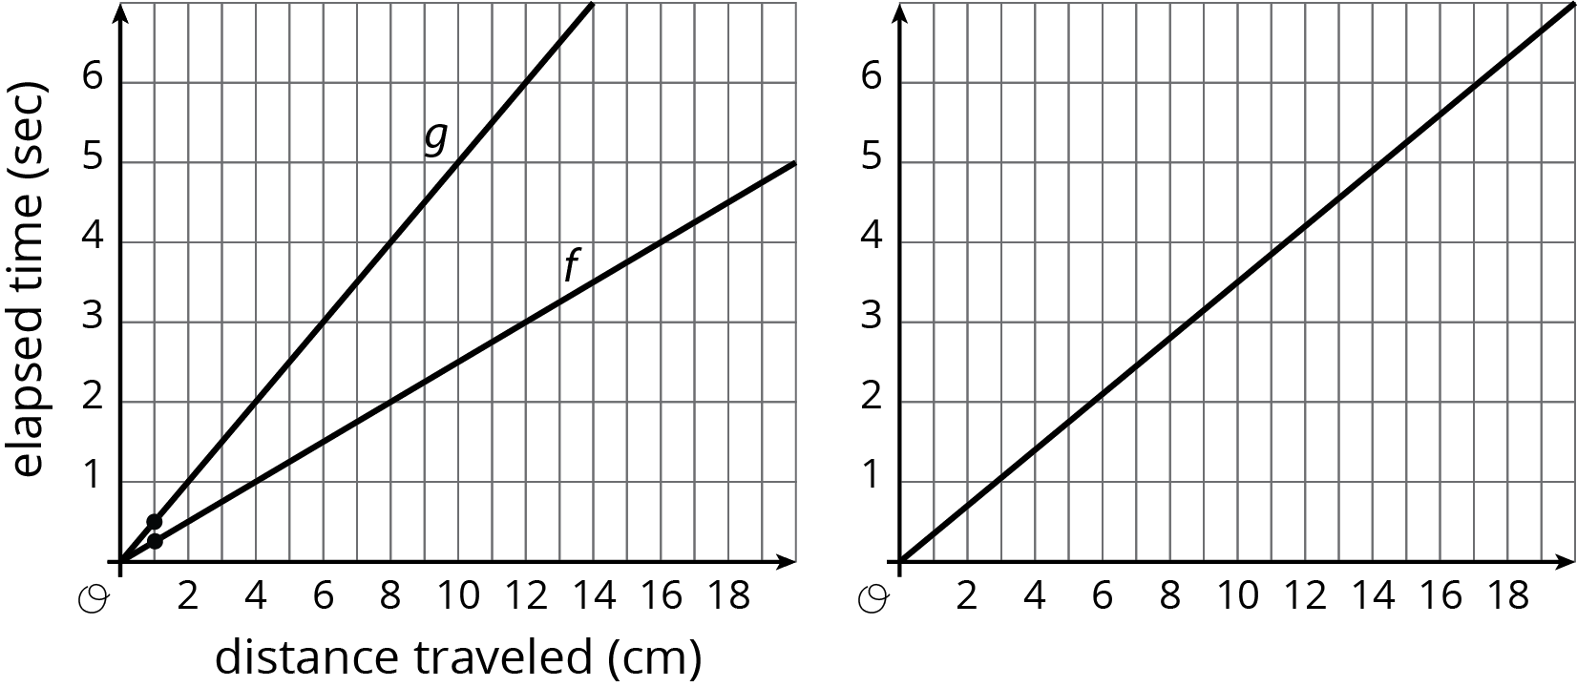
What do you notice? What do you wonder?

2 Moving Through Representations

Student Task Statement
A ladybug and ant move at constant speeds. The diagrams with tick marks show their positions at different times. Each tick mark represents 1 centimeter.
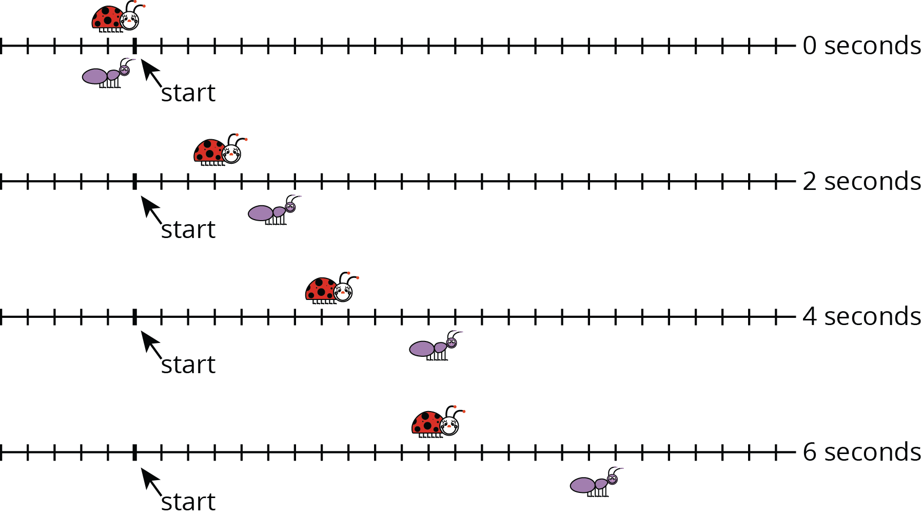
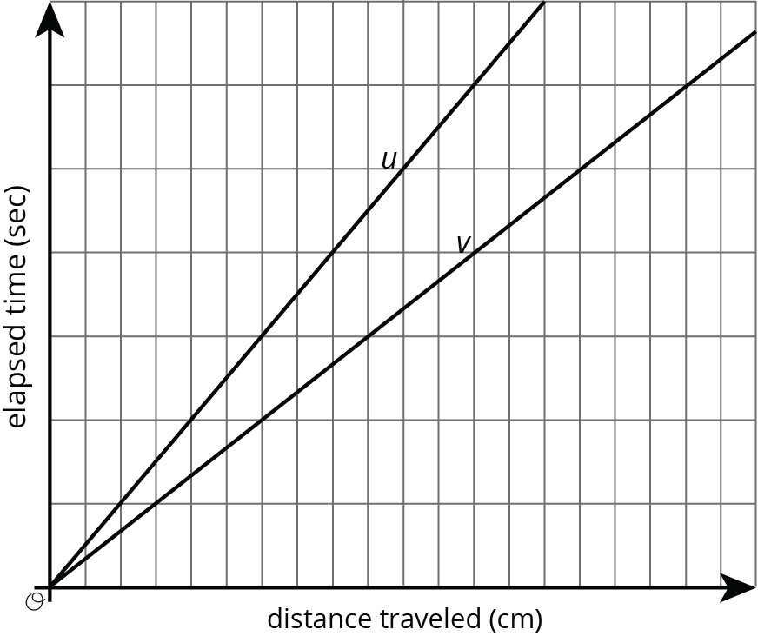
- Lines $u$ and $v$ also show the positions of the two bugs. Which line shows the ladybug’s movement? Which line shows the ant’s movement? Explain your reasoning.
- How long does it take the ladybug to travel 12 cm? The ant?
- Scale the vertical and horizontal axes by labeling each grid line with a number. You will need to use the time and distance information shown in the tick-mark diagrams.
- Mark and label the point on line $u$ and the point on line $v$ that represent the time and position of each bug after traveling 1 cm.

3 Moving Twice as Fast

Student Task Statement
Refer to the tick-mark diagrams and graph in the earlier activity when needed.
- Imagine a bug that is moving twice as fast as the ladybug. On each tick-mark diagram, mark the position of this bug.
- Plot this bug’s positions on the coordinate axes with lines $u$ and $v$, and connect them with a line.
- Write an equation for each of the three lines.

Images for Activity Synthesis
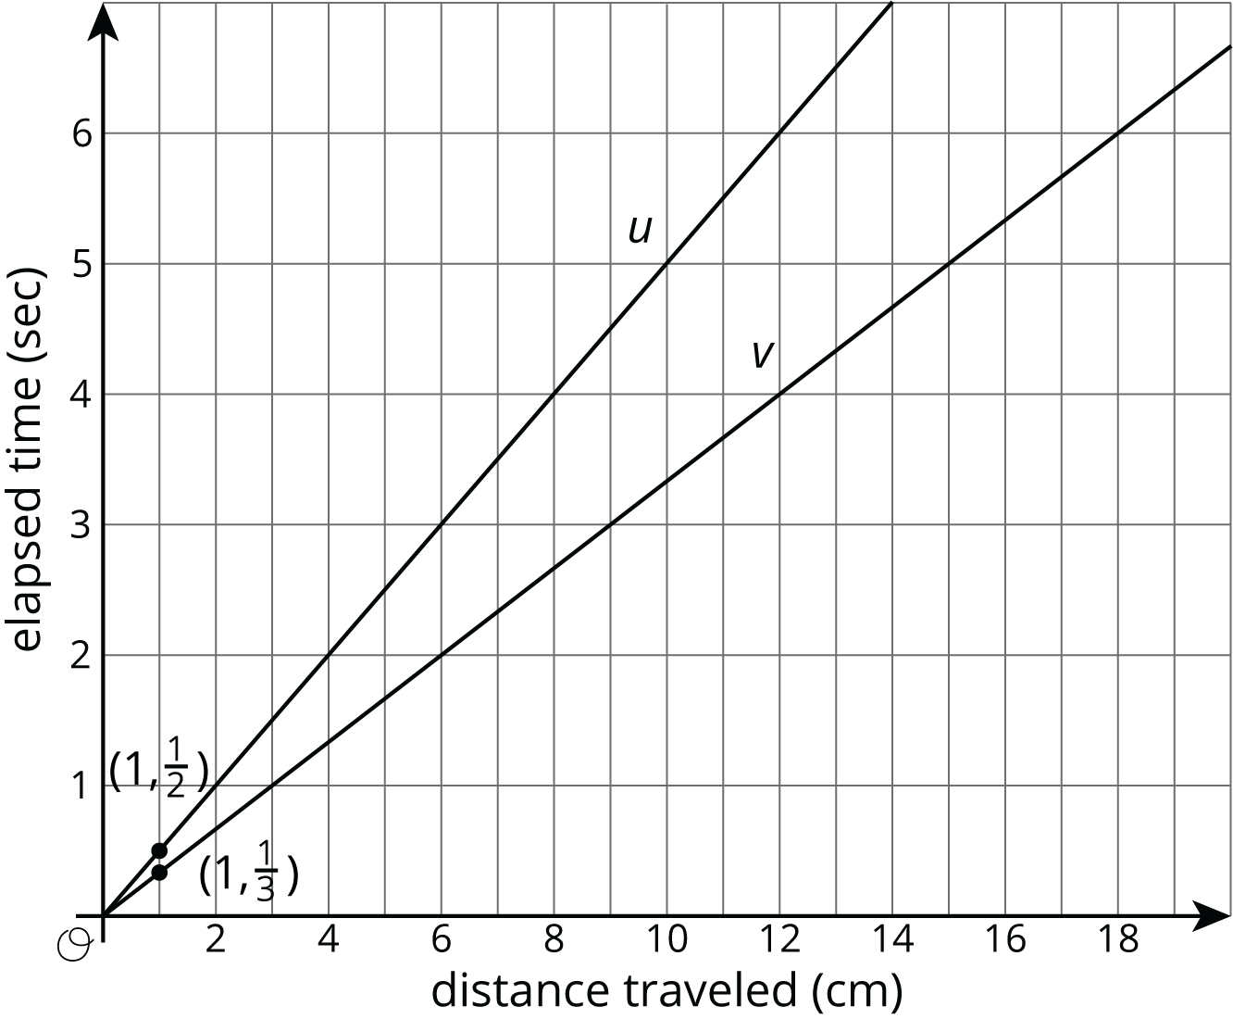
© CC BY Open Up Resources. Adaptations CC BY IM.

