Lesson 2: More or Fewer Pattern Blocks
- Let’s figure out if there are more triangle pattern blocks or trapezoid pattern blocks.

2.3: Introduce Pattern Blocks, Place the Last Pattern Block
Choose a center.
Pattern Blocks
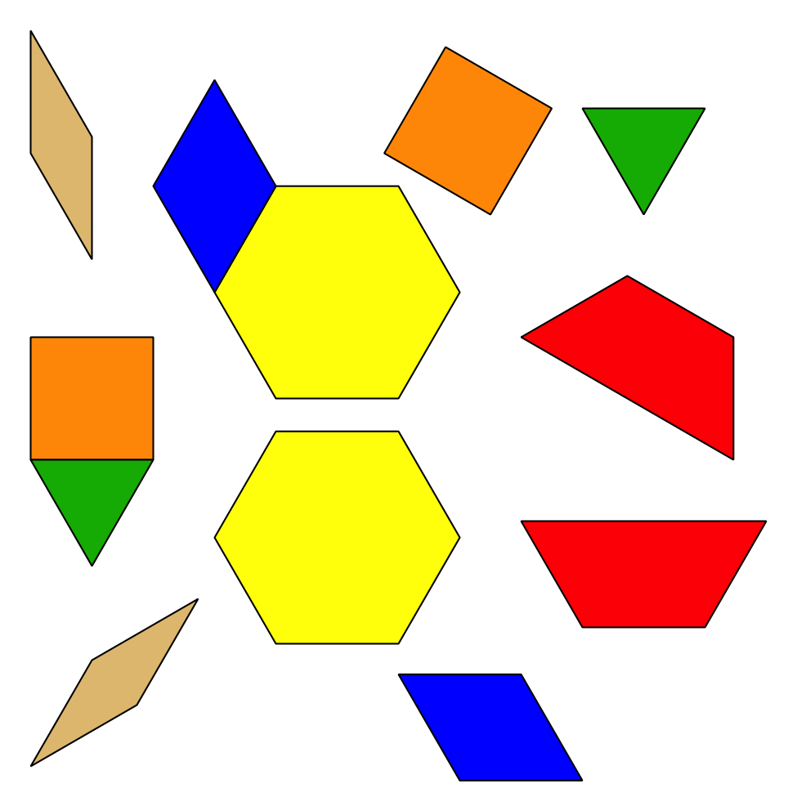
Geoblocks
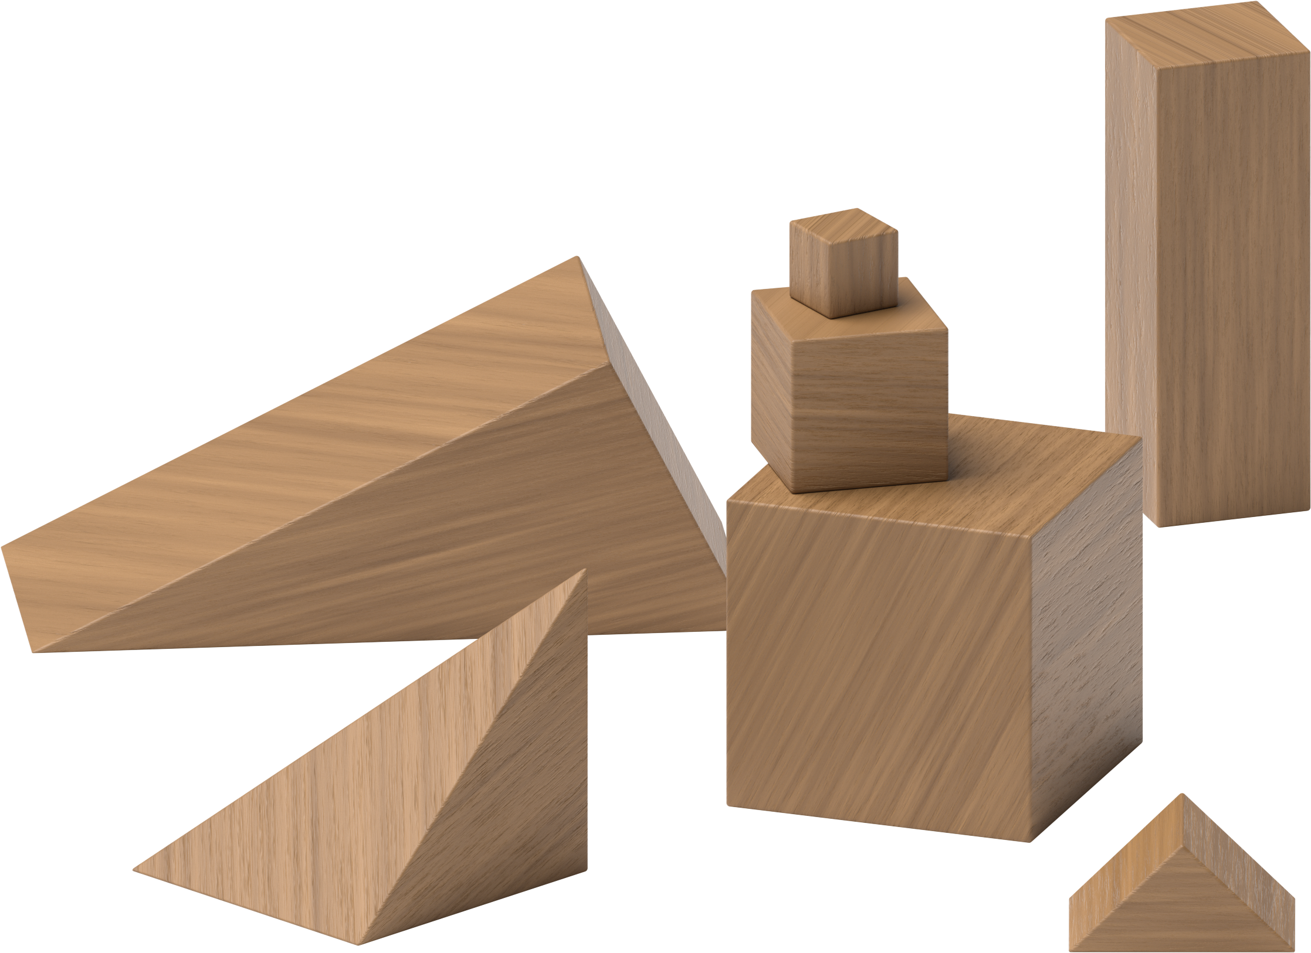
Grab and Count
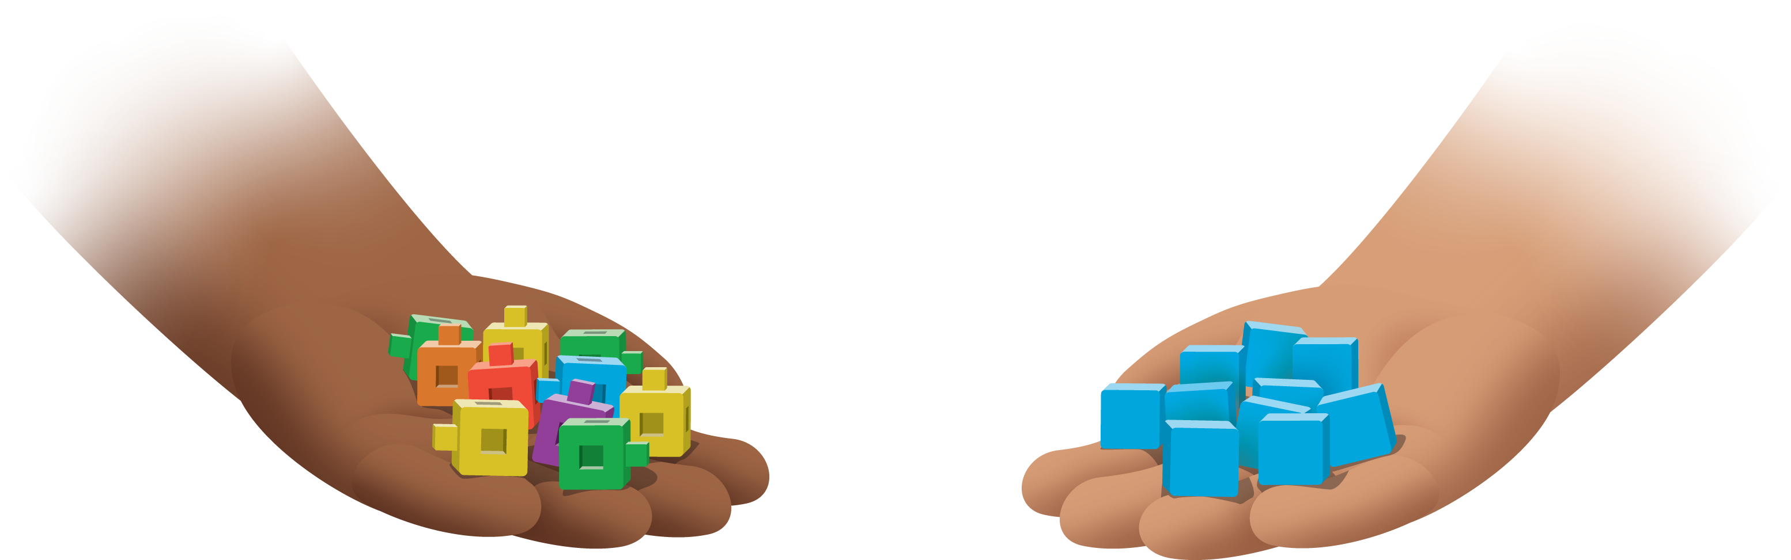
Find the Pair
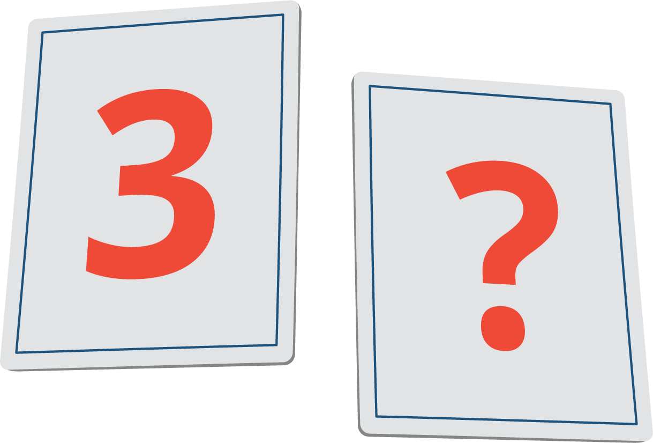
© CC BY 2021 Illustrative Mathematics®

