Unit 4 Lesson 17: Logarithmic Functions

1 Which One Doesn’t Belong: Functions (Warm up)

Student Task Statement
Which one doesn’t belong? Be prepared to explain your reasoning.
$f\left(x\right)=4⋅{\left(0.75\right)}^{x}$
$g\left(x\right)=4⋅e^{\left(0.75x\right)}$
$h\left(x\right)=\left(0.75\right)⋅4^{x}$
$j\left(x\right)=4⋅logx$

2 How Long Will It Take?

Student Task Statement
A colony of 1,000 bacteria doubles in population every hour.
- Explain why we can write $h=\log_{2}x$ to represent the number of hours, $h$, it takes for the one thousand bacteria to reach a population of $x$ thousand.
- Complete the table with the corresponding values of $h$.
- $x$ (thousands) | - 1 | - 2 | - 4 | - 8 | - 16 | - 50 | - 80
- $h$ (hours)
- Plot the pairs of values on the coordinate plane. Make two observations about the graph.
- 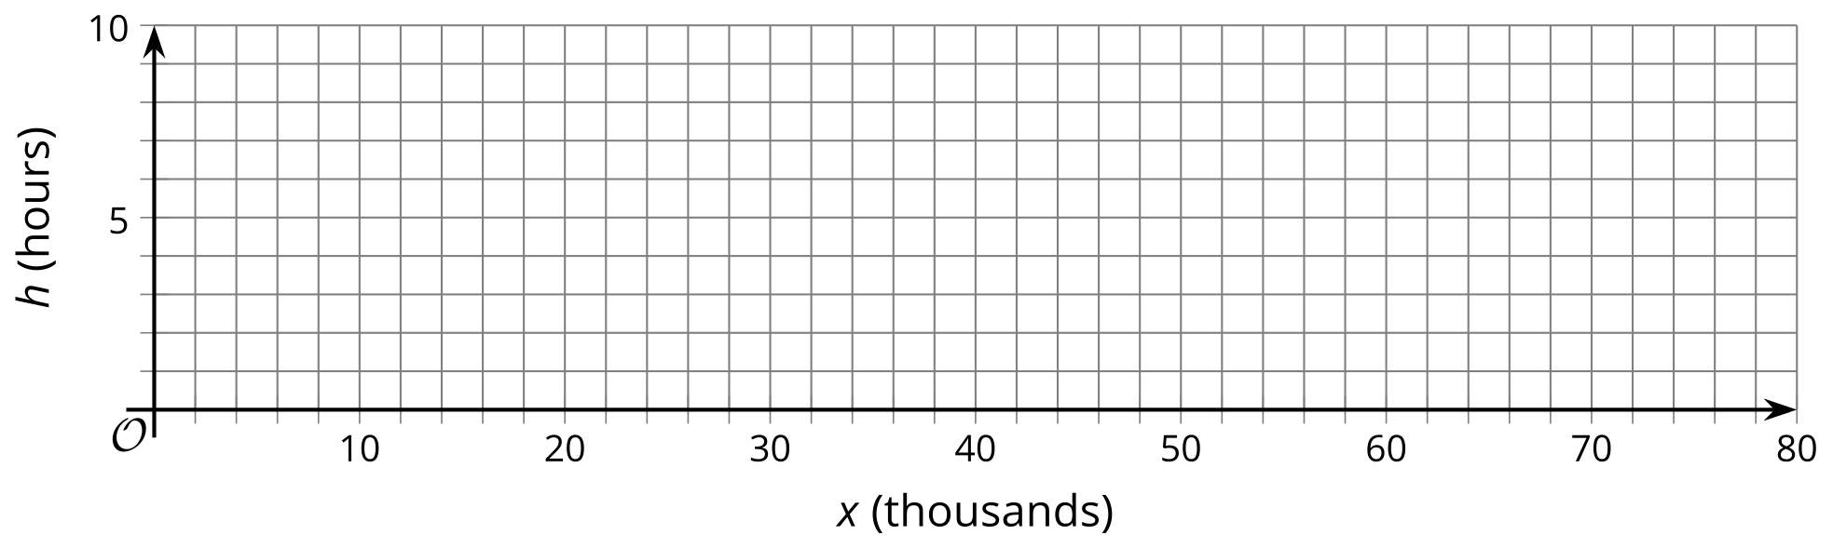
- Use the graph to estimate the missing values in the table.
- $x$ (thousands) | - 10 | - 24 | - 72
- $h$ (hours)

3 Another Logarithmic Function

Student Task Statement
Earlier we saw that $h=\log_{2}x$ represents the number of hours for 1 thousand bacteria, doubling every hour, to reach a population of $x$, in thousands.
- Suppose the function $d$, defined by $d\left(x\right)=\log_{10}x$, represents the number of days it takes 1 thousand of another species of bacteria to reach a population of $x$, in thousands. How is this population of bacteria growing?
- Graph $d$ using graphing technology. Make two observations about the graph.
- Use your graph to estimate the values of $d\left(50\right)$ and $d\left(20,​000\right)$. (Adjust your graphing window as needed.) Explain what each value means in this situation.
- Estimate or find the population after 5 days.
© CC BY 2019 by Illustrative Mathematics®

